**Tableau**

**Follow:** 365 Data Science channel.

Versions of Tableau?

In 2013 and 2014 Tableau was there however it was basic one. In 2018 they have introduced tableau with lot more features which is useful.

* 2017(start)
* 2018.3 (Called as best version)
* 2019 (Introduce data Modelling)
* 2020 (Data Modelling Synchronize with server) or 10.5

Q1 what is Tableau?

Ans Tableau is a Business Intelligence Tool which help us to analyse the data in the form of Visual manner, may be a graph, chart, report, map etc.

Q2 What are the different type of Product offered by Tableau?

1. Tableau Desktop

Both Tools are used to create Reports

1. Tableau Online
2. Tableau Server

These 3 Tools are used to Publish the report.

1. Tableau Reader
2. Tableau Public (Free and save all data online, not on Desktop)

Tableau Reader is used to read only and mostly used for End user.

Q3 From how many databases Tableau can connect to?

Ans Tableau can connect to more than 50 different databases:

1. Spreadsheet
2. Database
3. Bigdata
4. Cloud Application
5. Cloud Database

Q4 Where we can Publish these reports?

1. Desktop
2. Tablet
3. Mobile

It is compatible with all the above and we can adjust the layout and size according to the requirement.

Q5 How Tableau recognize data?

Ans Tableau recognize data in 2 ways:

1. **Dimensions**: The things remain constant is called Dimensions.

**For ex: Name, Passport no. etc**

* 1. **Text, date or Geographical things comes under this.**
  2. **Dimensions: Blue colour pills**
  3. **Dimensions: Discrete (Show separate value)**

1. **Measures** : The things which keep on changing is called measures.

For ex : Height, weight

* 1. **Numbers, Figures and Float value or we can calculated fields.**
  2. **Measures:** Green Colour pills
  3. **Measures:** Continuous (It shows aggregate value)

**With the help of these we can create different type of Charts.**

**Q6 How many types of Charts Tableau supports?**

Ans It support 25 different charts(24 available in Table and 1 Doughnut chart which we create manually):

1. Bar Chart
2. Stacked Chart
3. Pie chart
4. Line chart
5. Scattered Chart
6. Bubble chart
7. Word Map
8. Tree Maps
9. Water fall chart
10. India Map
11. US Map
12. Basic Funnel chart, Advance Funnel Chart etc.

Q7 Why we use Tableau?

Ans

* Speed: It has a great speed.
* User friendly
* Beautiful and Interactive Dashboard
* Direct connection: with multiple database.
* Easy Publishing and Sharing
* Growing Market (**Gartner** is one of the companies which analyse diff type of BI tools: Tableau is one of the best tools to work with.

**Q8 When we import the dummy data from Excel or other database, how window look like and what we call it.**

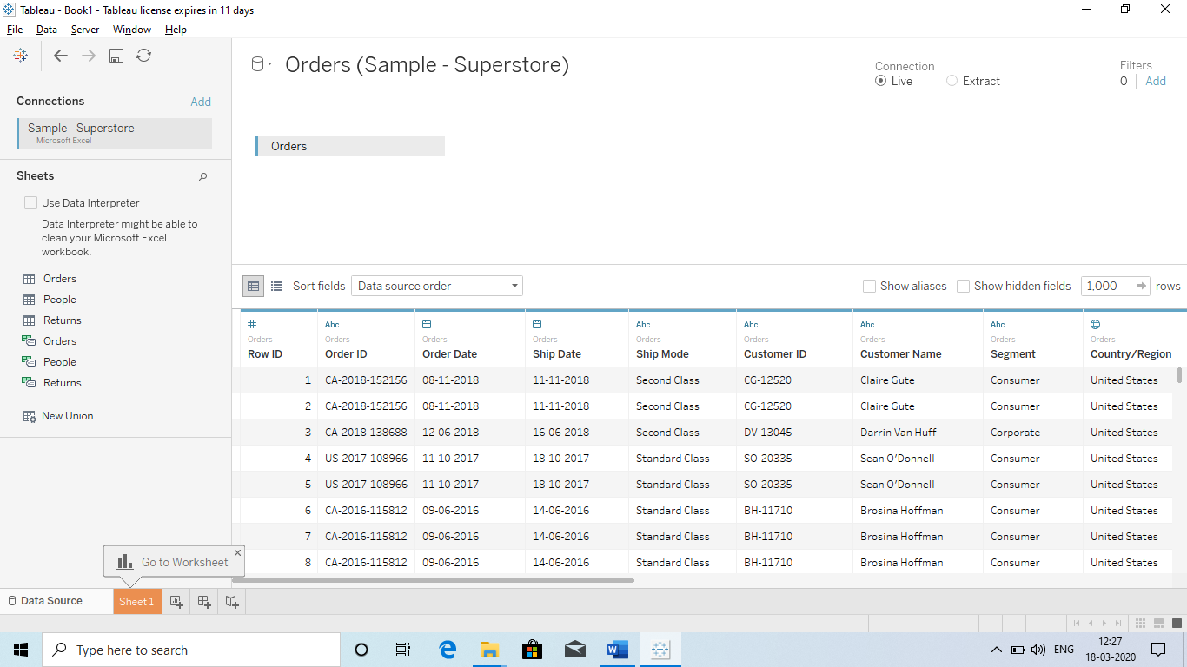

**Rows : Variables**

**Column header: Observation**

Data Source window

Connecting Window

Data Modelling window

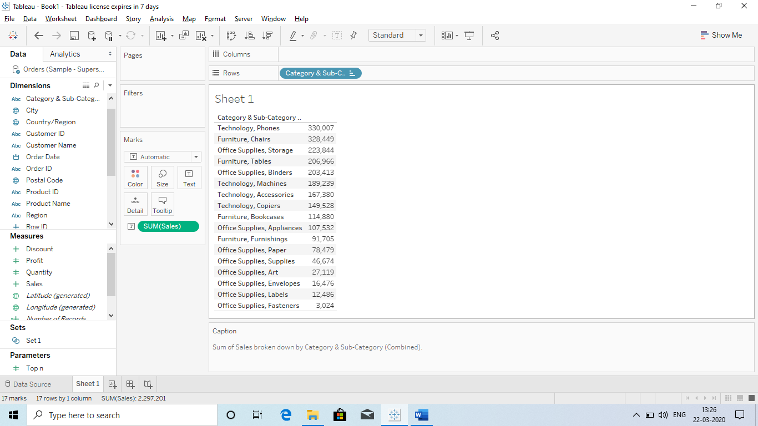

We can hide all these CARDS or SHELF or Tittle and bring it back by “**worksheet tab”**.

Search option to search Fields

This will show us all the Maps available in the Tableau.

New Story

New Dashboard

These all are called CARDS

These all are called SHELF

Q9 Difference between a Database and Data source?

Ans Library = Database

Books = Data source

**Collection of data sources if called Data base.**

Q10 How many data sources and data base we can connect in single use?

Ans 32 Tables / data source : It means the maxi, of 32 tables in the data Source window.

If we have 30 database and 3 data sources than how will connect to that.

Ans we will convert 3 data sources into a single database and then we have total of 31 database.

So it will create 31 tables.

Please look into the snap shot, what is DATABASE AND WHAT IS DATA SOURCE?

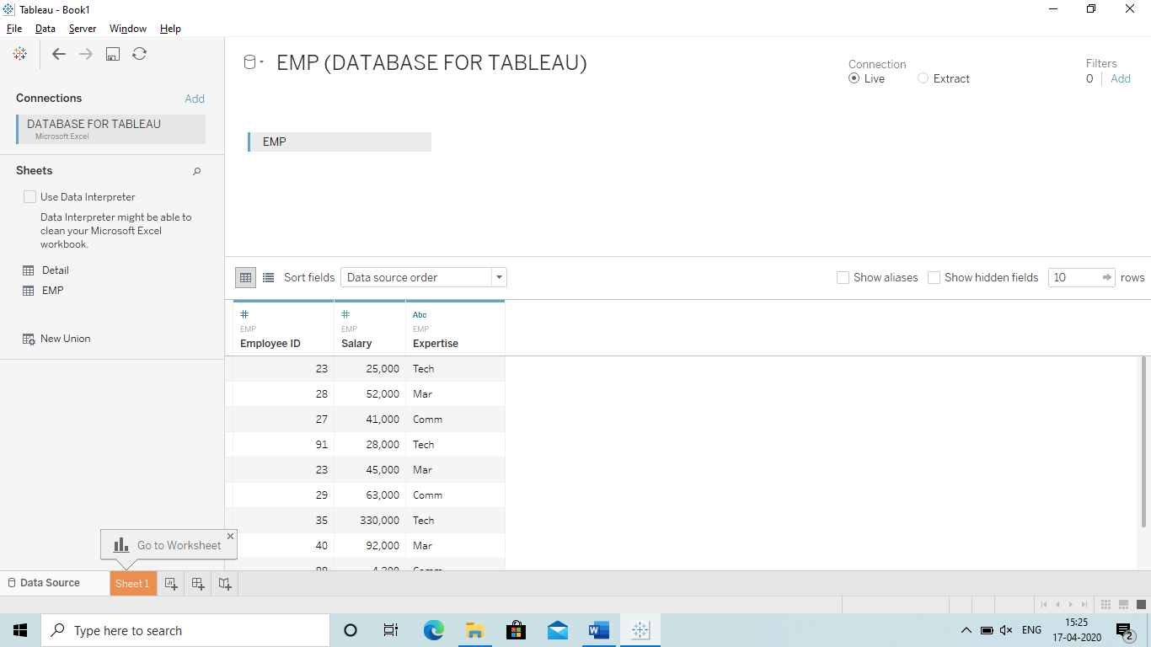

Data Source. We can connect to 32 data source in a single go.

Database: Collection of Data source is called Data base. We can change the name of the database.

**Q Basic Terminology used in Tableau:**

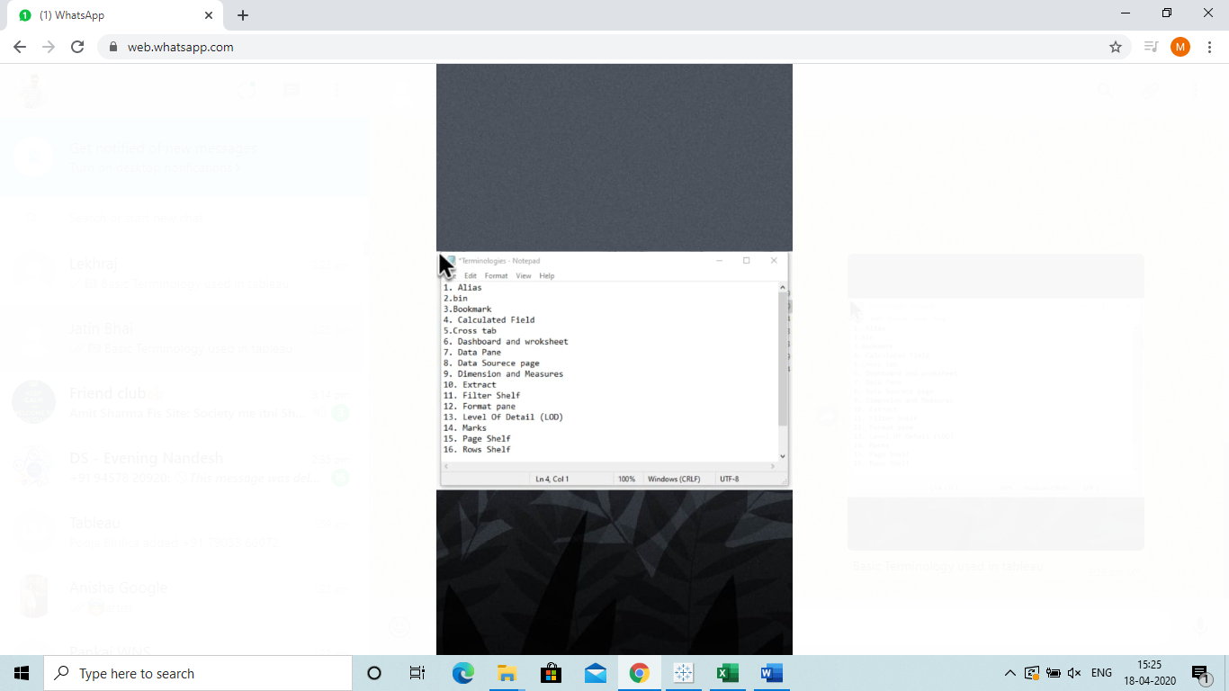

**1.Alias : This is used to give name like we assign a variable.**

**2.Bin: Bin is a collection of Measures**

**3.Bookmarks: These are same as we have in Webpages and they are saved in C drive : Format (.tbm)**

**4.Calculated Fields: These are fields which are created from the existing filed so that we can use them in our reports to make is more efficient.**

**5.Crosstab: It means table view in Tablue.**

**6.Dashboard and worksheets**

**7.Data Pane: Left hand side in the worksheet**

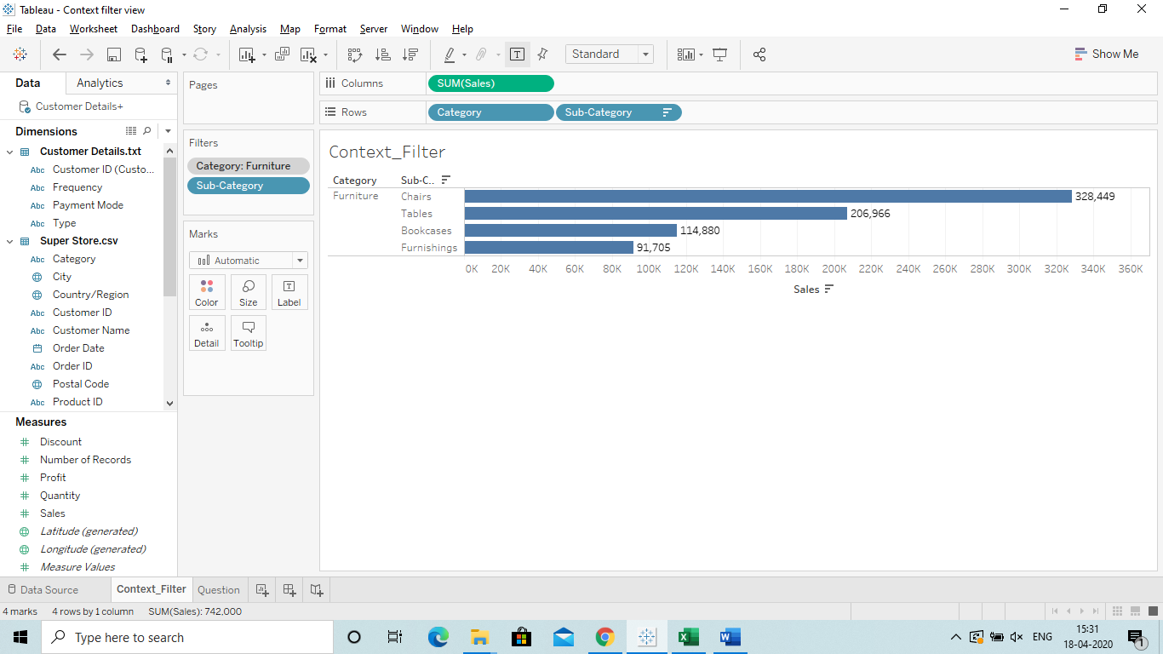

**8.Data source page**

**9.Dimension and Measure**

**10.Extraxt**

**11.Filter Shelf**

**12.Format Pane**

**13.Level of Details**

**14.Marks**

**15.Page Shelf**

**16.Rows Shelf**

Q11 How Tableau is better than Power BI?

Ans

**Power BI** | **Tableau**

Space

* If data is less than 10 GB | If data is more than 10 GB

Multiple DataSo

* Multiple Data sources less in Power BI | Multiple Data sources More in Tableau

Clean Interprete

* Clean Interpreter is not available to clean the data automatically | Clean Interpreter available to clean the data automatically.

|

|

|

|

|

|

|

|

|

|

Q What is Live and Extract/static data?

Ans

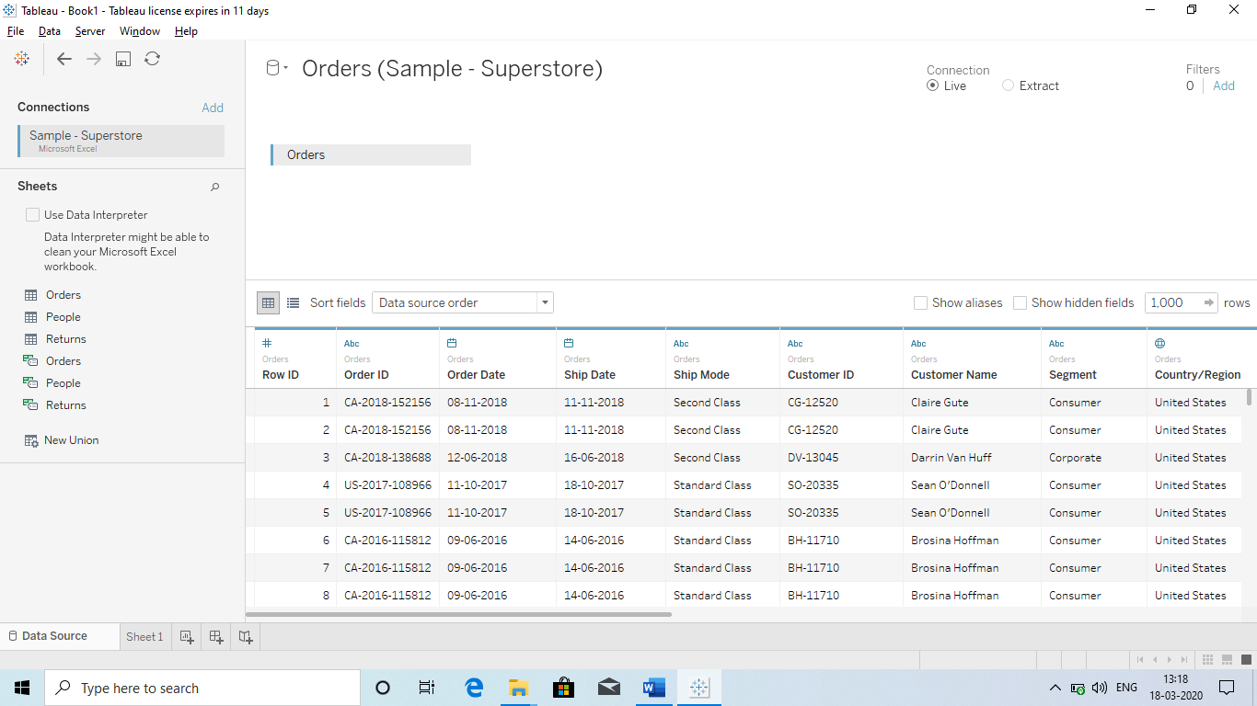

Live Data: It means the data is connect live with the tableau.

(Whenever we update the data in Source file: Live will automatically update the data. Just click on Extract data in the worksheet and refresh the data.

Extract/Static: It means Snapshot of a data and it is not live from a server or a file and make Analysis.

When we Extract the data, any changes in the file will not be updated since we are working on the Snapshot of the file or on Static data.

Q Can we refresh data while using a Extract method?

Ans Yes we can by the following method:

* Go to Worksheet – lefttop( worksheet) -Extract – Refresh. 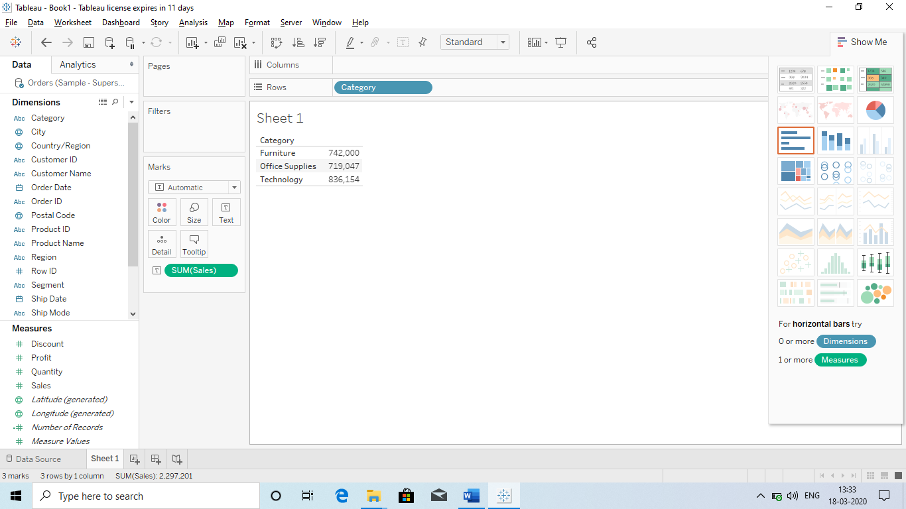

Q How to know the data is live or Extract?

Ans

See above the same Snapshot :

* There is 1 cylinder : **LIVE**
* If there are 2 cylinder : **Extract**

**Q How many data type in Tableau?**

Ans We have 6 type of data:

1. Number : #
2. Abc : Text, String
3. Date :
4. Geographic : (Globe type Picture) Like : Country, State, city.
5. Boolean : T/F (True/False)
6. Date&Time : Date and time.

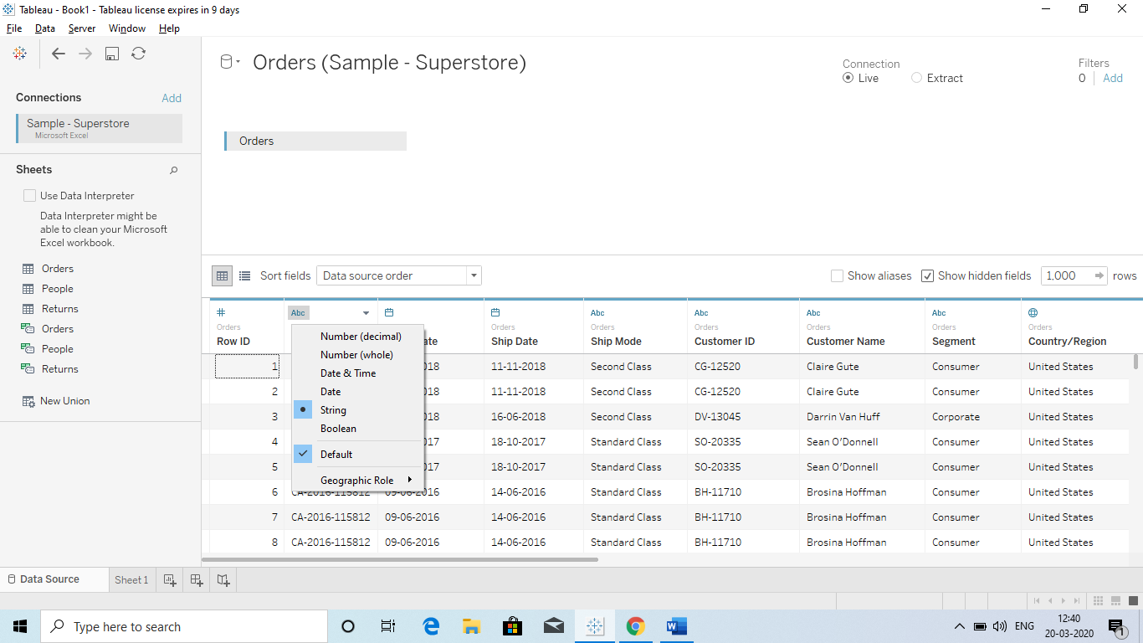

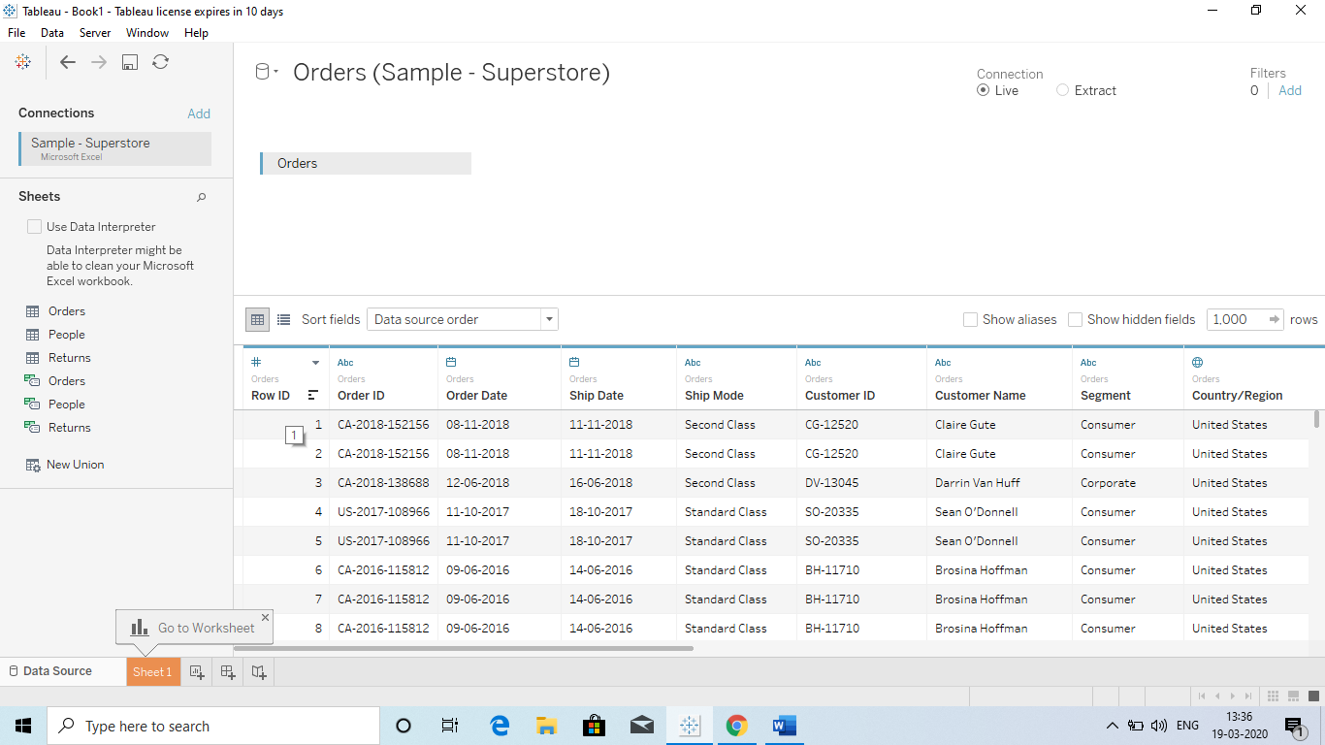

**Q What is View Data?**

Ans. When we import an Excel file than we can see the desired no of Rows by clicking on the **sheet name** on the left hand side (View data). We can change the no of rows from the Top to check the view.

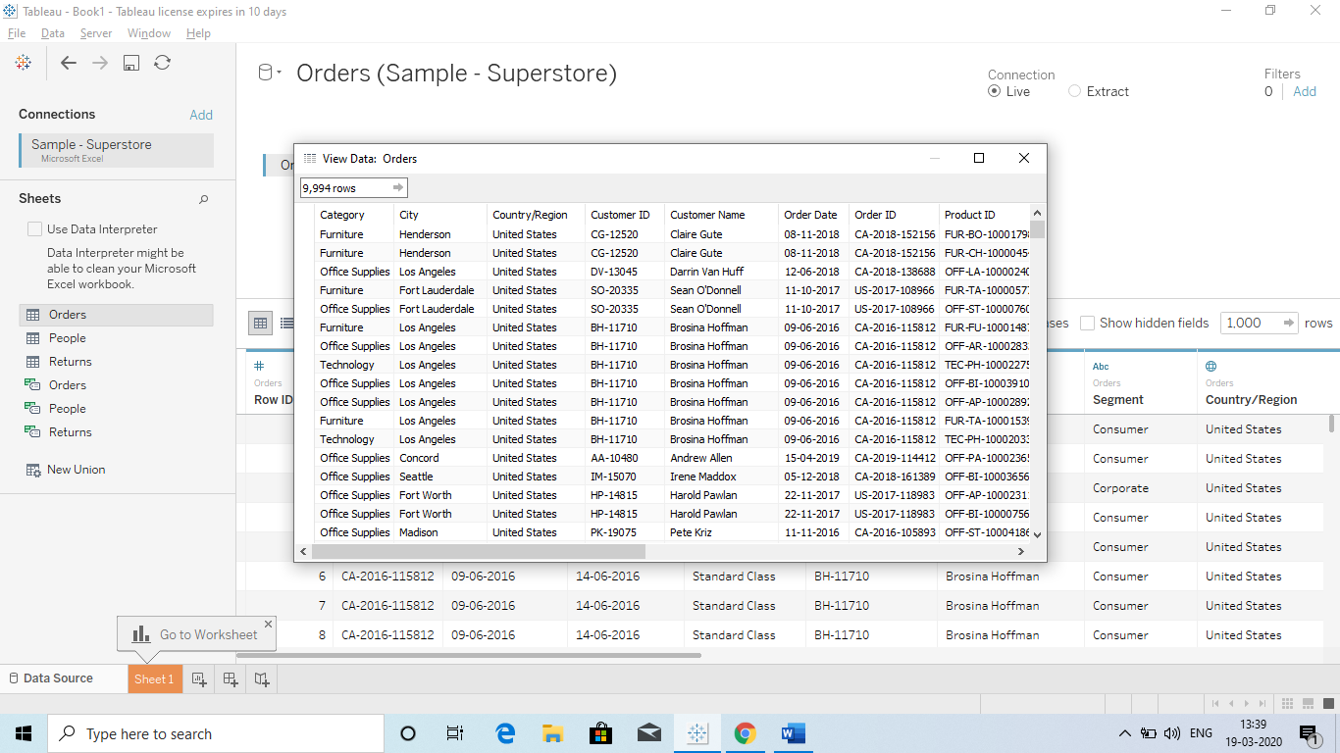

We can change the no of rows we want to see. Like if we need just 10 line: 10 (Enter)

**Hide or Unhide:**

We can hide a Column by clicking on the column and select the hide option or unhide option.

**To Hide a Row: Just select the row and then right click – select hide.**

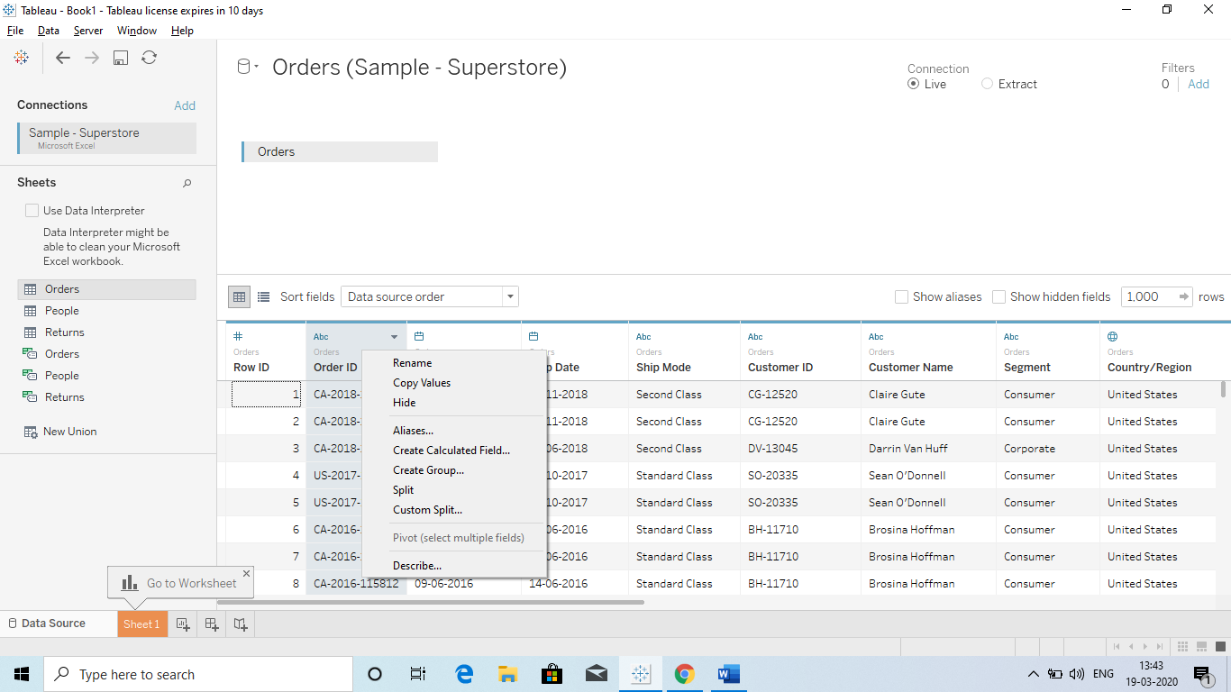

**To check the hidden Row:**

Just click on show hidden field. When we click on show hidden field the Column will appear and we can unhide the column.

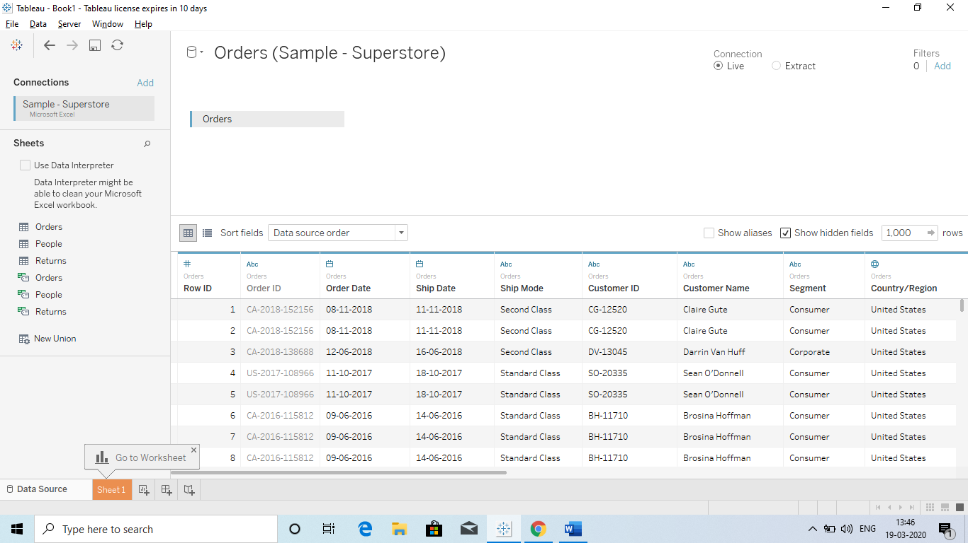

Hidden Tab

**Q How we can do Column Formatting?**

1. **Rename**
2. **Copy**
3. **Split : split values in two different Columns.**

**1.Rename**: Double click on the column name

Q If we want the original name then: Ans. We just have to click on the header and selct “**Reset Name”.**

**2.Copy:**

**1) Whole Column:** Just select the Column and rightclick – click on copy value

**2) Desired cell:** Just select the desired no of cells and ctr+c and paste it to the desired file(Excel)

**3) All data:** Just click CTRL+A and CTRL+C and than Paste it to desired file.

**3.Split:**

1) **Split:** Select the Column and select split for Automated

2) **Custom Split :** Provide the delimiter – **First, between or Last** and Apply

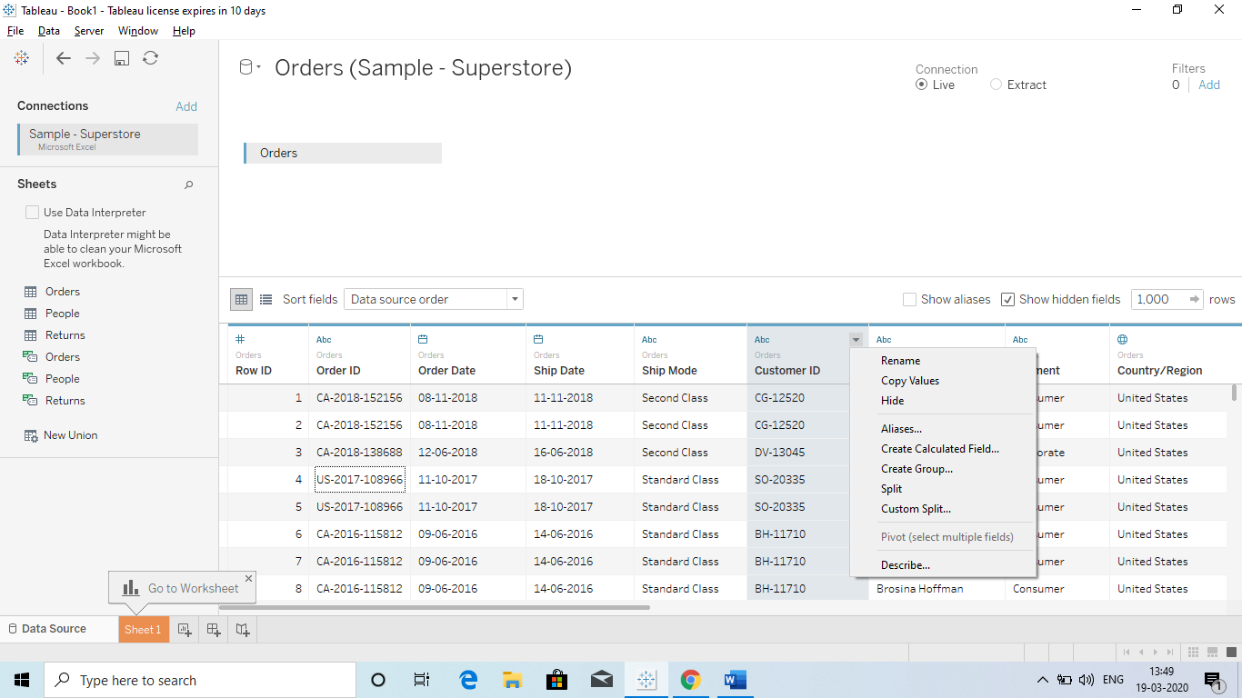

**Custom Split:**

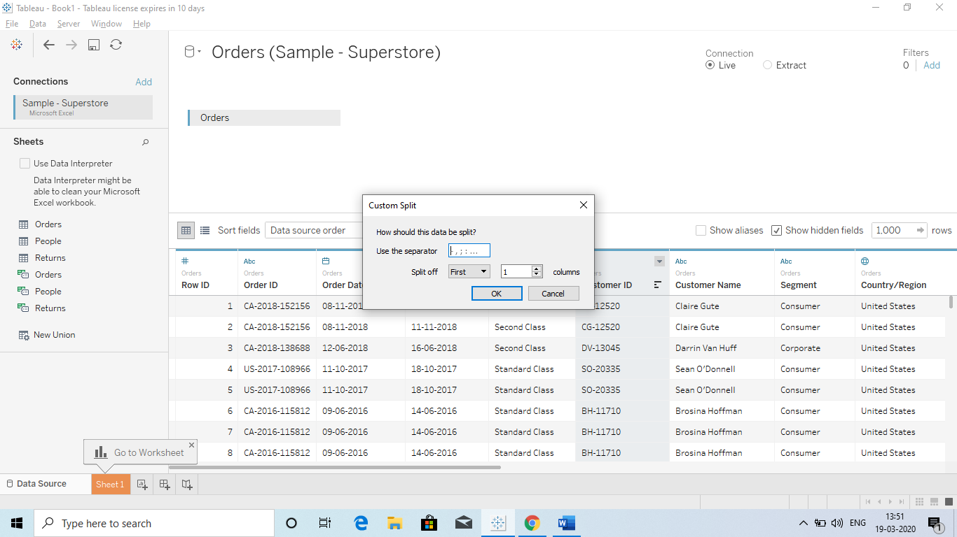

Choose First or last and All

Choose the Delimiter

**Q Sorting in Tableau?**

* Sort Column
* Sort Records
* Sort Tables: Right hand side of the column name we have : z like sign to sort.

We can do it with the help of **Sort Fields**.

* Ascending order
* Descending order

**IF we have a single table than use:**

1. A to Z Ascending order
2. Z to A Descending order

**IF we have 2 or more tables than use:**

1. A to Z Ascending per table.
2. Z to A Descending per table.

**IF you want to keep it as Original Data:**

Use Data source file

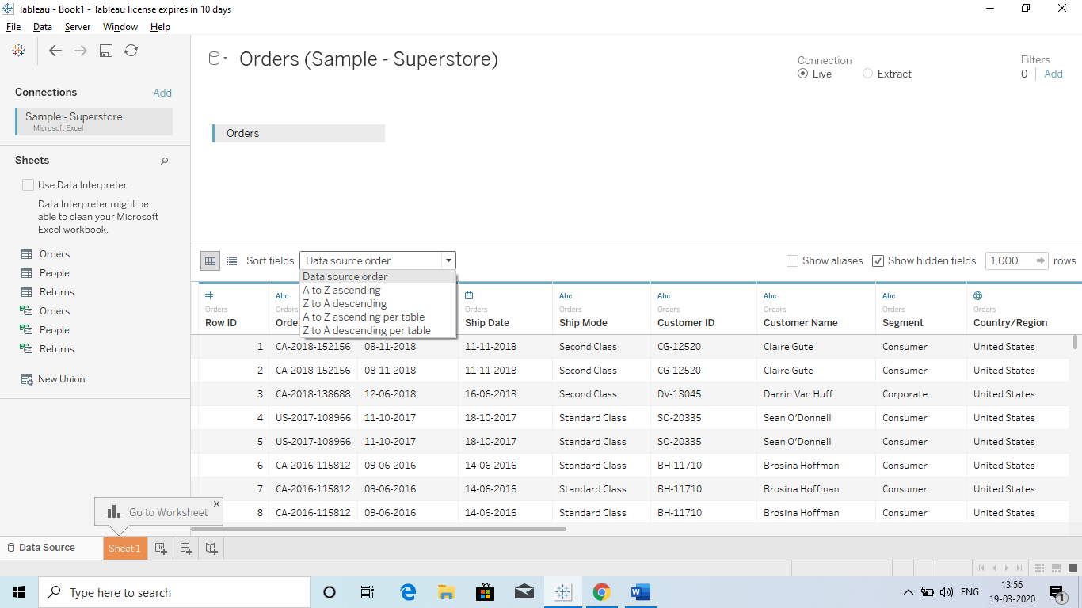

Q Drill Down and Hierarchies?

Ans we can drill down in any data with the help of **drag drop.**

Just we have drag the desired filed so that I hierarchy is created.

**Discrete:** It means a separate chart will be shown.

* Discrete Means = Dimensions
* Discrete colour = Blue
* Discrete : It means we get a separate data.
* If we pick a category from Dimension and Drag it to colour section we will get Different colours since it separate the values.

**Continuous:** It means the chart will be shown continuous.

* Continuous = Measure
* Continuous = Green
* Continuous we get an Aggregate value when we drag it to Rows column.
* When we drag it to the Color Box it will show the Blue colour from dark to light.

**Q Grouping? Ans We create Grouping so that we can compare a group with other.**

* **Group by Headers(Dashboard):** When we create a Bar chart then we can select the bars which we need to group. It will automatically create a group for them and we can use for comparison.
* **Group by Data window**
* **Group by Hierarchies**
* **Group by visual:** For ex if we have a scattered chart and we have different type of sub category. Just select the desired category on the scattered chart and then go to menu bar(up) and there is an option (like in mail we have attachment) – select that option and select Sub- Category. It will create a group of those category.

Q What is measure name and measure values?

Ans Whenever we connect Tableau to a datasource or import, there are some autogenerated fields which are created in our Tableau session.

There are 5 autogenerated fields: **( We can recognize since they are written in italic font)**

1. *Measure name (Dimensions field)*
2. *Latitude Generated (Measures field)*
3. *Longitude Generated (Measures field)*
4. *No of Records (Measures field)*
5. *Measures Value (Measures Filed)*

QQ) Why we use them?

Ans To get a Overview or Summary of Data:

* Ex: How much is the Total Quantity
* Total Sales
* Total Profit
* Total Discount etc

1. **No of Records** : It shows the total no of records in our datasource.
   1. For ex we have 52000 records in Excel sheet. So we will get the same no when we drag it.

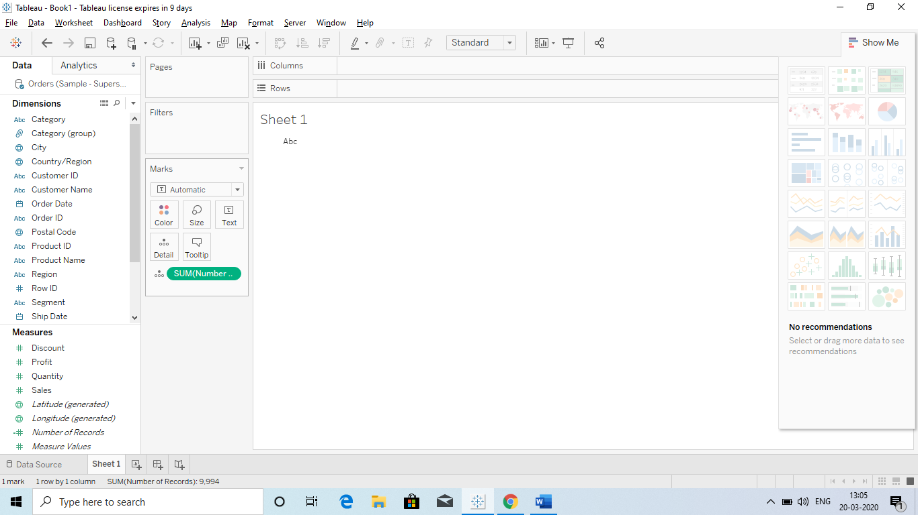

Drag it to the “Text” Box and it will show the total no of records.

Do Remember: “Darg to Text”

Drag it to here so that we will get the count of records

* 1. We can also check the bifurcation of records by dragging the categories in the Rows column

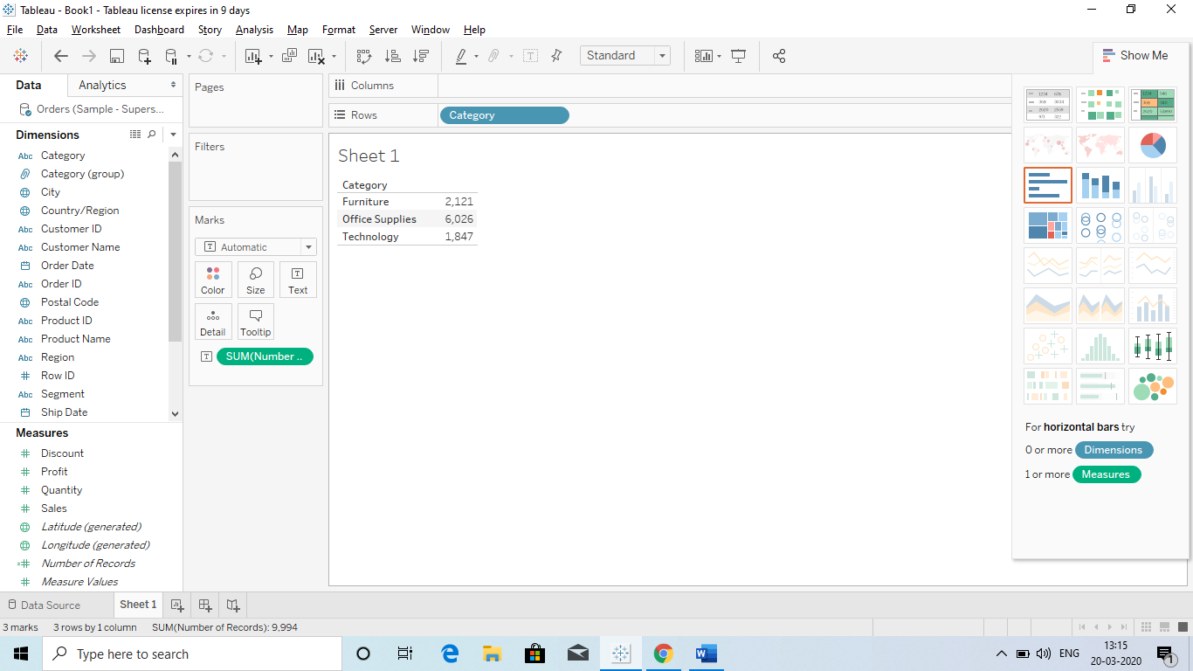

1. **Measure name:**
   1. Just drag measure name to the Rows and Drag the Measure Value in the Text Box : Output will be that we will get all the Summarize picture of Measures.

Or we can also **“Double Click on Measures Value”** and it automatically show a chart with details.

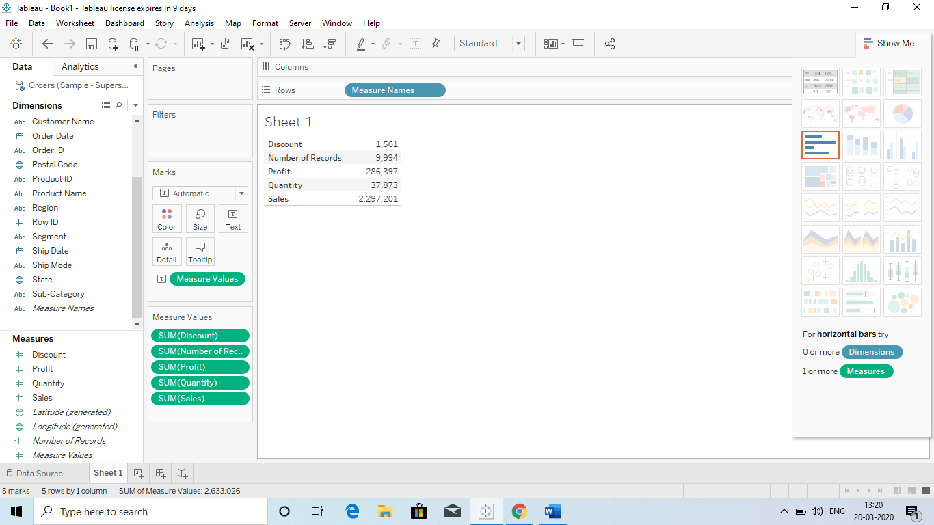

* Here it show how much discount is provided.
* No of Records
* What is Total Profit
* Total Quantity
* Total Sales

**Or Graphically when Double click:**

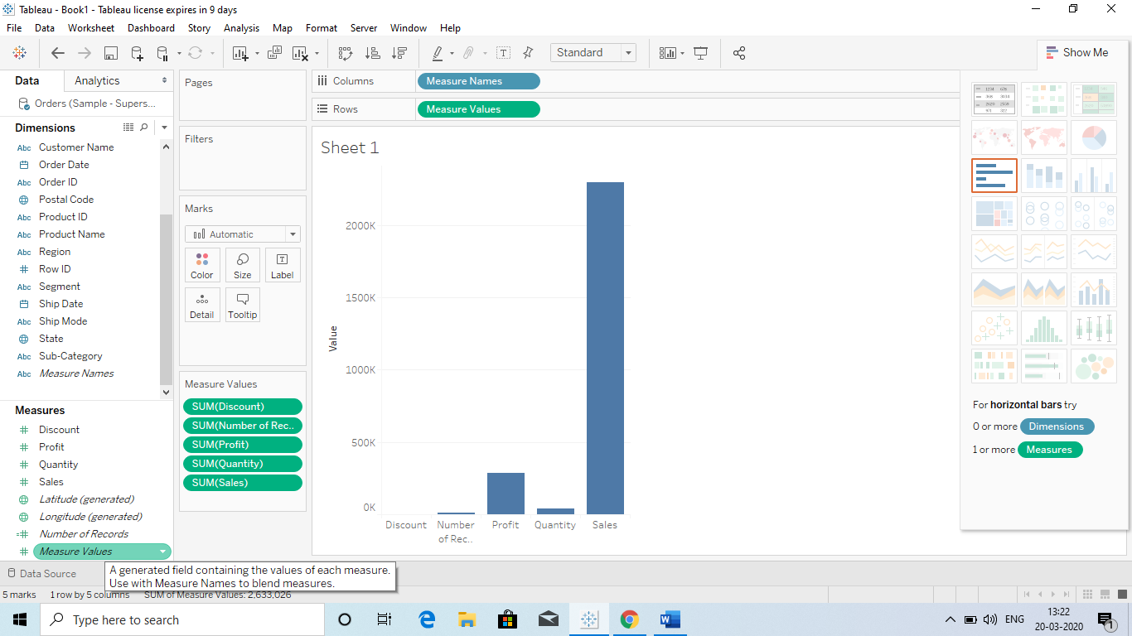

**When we Drag Measure value again to the Text it will show the no on the graphs.**

Q Use of Measure name and Measure Values?

Ans Measure name: When charts are failed to combine 3 fields together in a single chart than we use it.

Ex we have three things: Profits, sales and shipping cost and we need to compare them with Order date in a single chart.

Now if we Drag it separately to the Rows a separate chart will be shown. To resolve this problem what we can do is:

1. Drag the Order Date in Columns.
2. Drag the Measure name to Filter: It will give the option to remove the field from the measure which you do not want.
3. Than Drag the Measure Value to Row column.
4. Drag the Measure name to colour Box.

**Q Parameter using Filters and why we use Parameters?**

Ans The reason for using a dynamic parameter is that, the **USER** can input the range he want to see in the graph. EX: TOP 5 or Bottom 5.

How to use Parameter with filter:

1. Drag the Category from Dimension to filter and use edit in the filter.

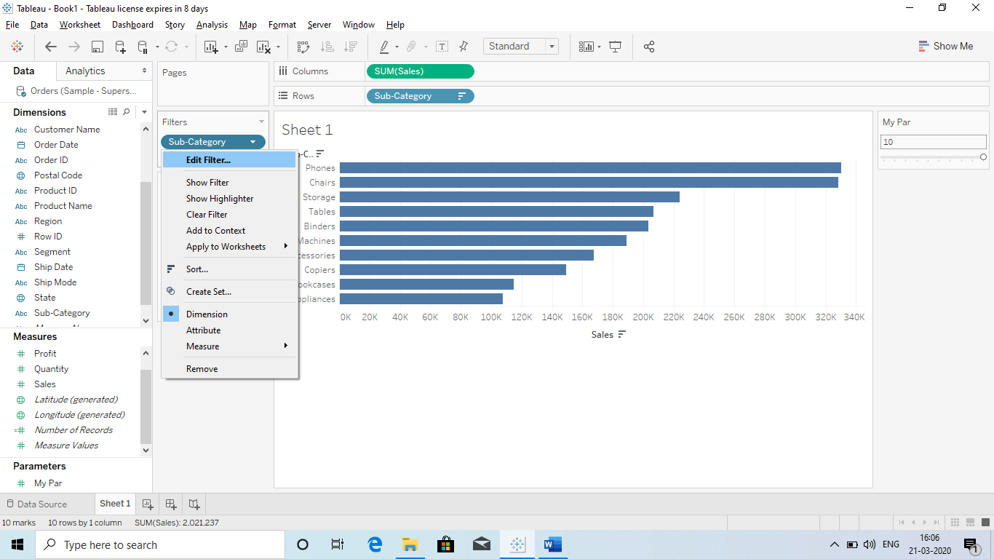

Click on the option to get further Parameter options.

1. Select the “TOP” option and go to by field and select **NEW Parameter.**

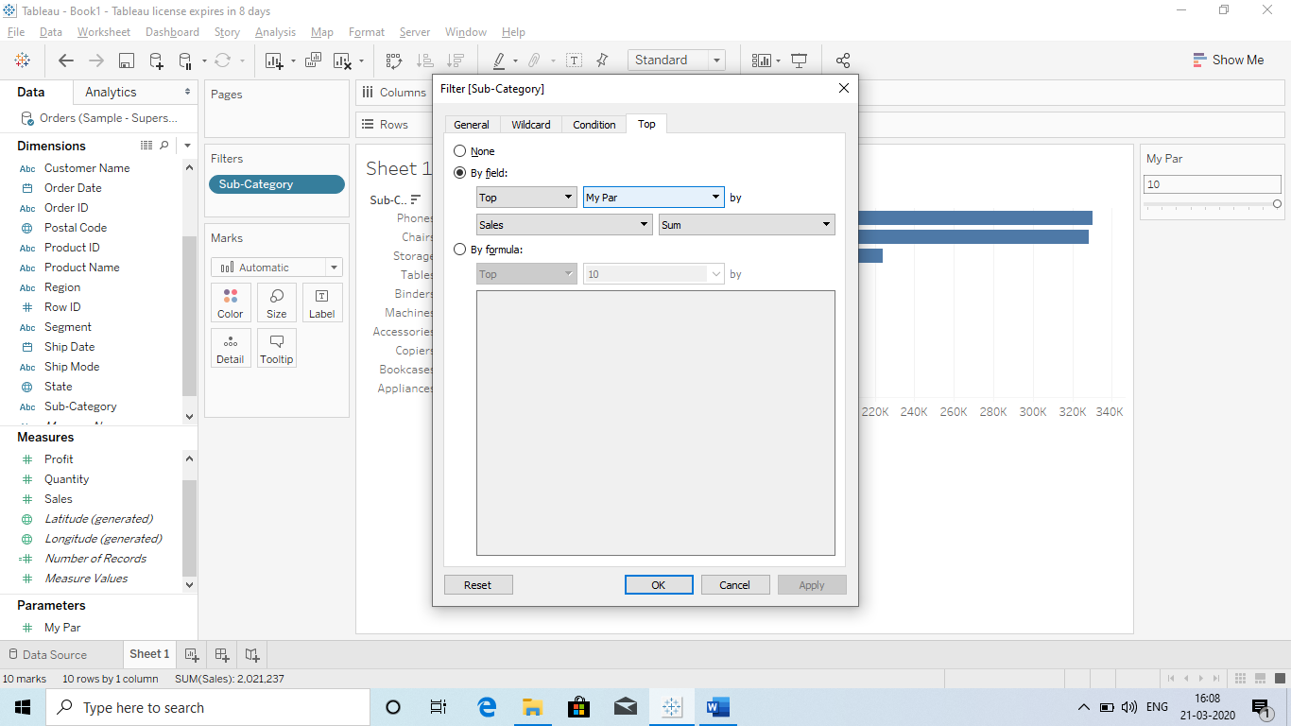

Step 4

Step 3

Step 2

Step 1 :Drag to Filter

**Q Parameter with Set?**

Ans To make the Parameter more dynamic and provide colour to the Parameter which are TOP or Bottom, then we need to create a set and join it with Parameter.

How we can create a set and use it with Parameter:

Step 1:

Select the SUB Catg and then select create – set:

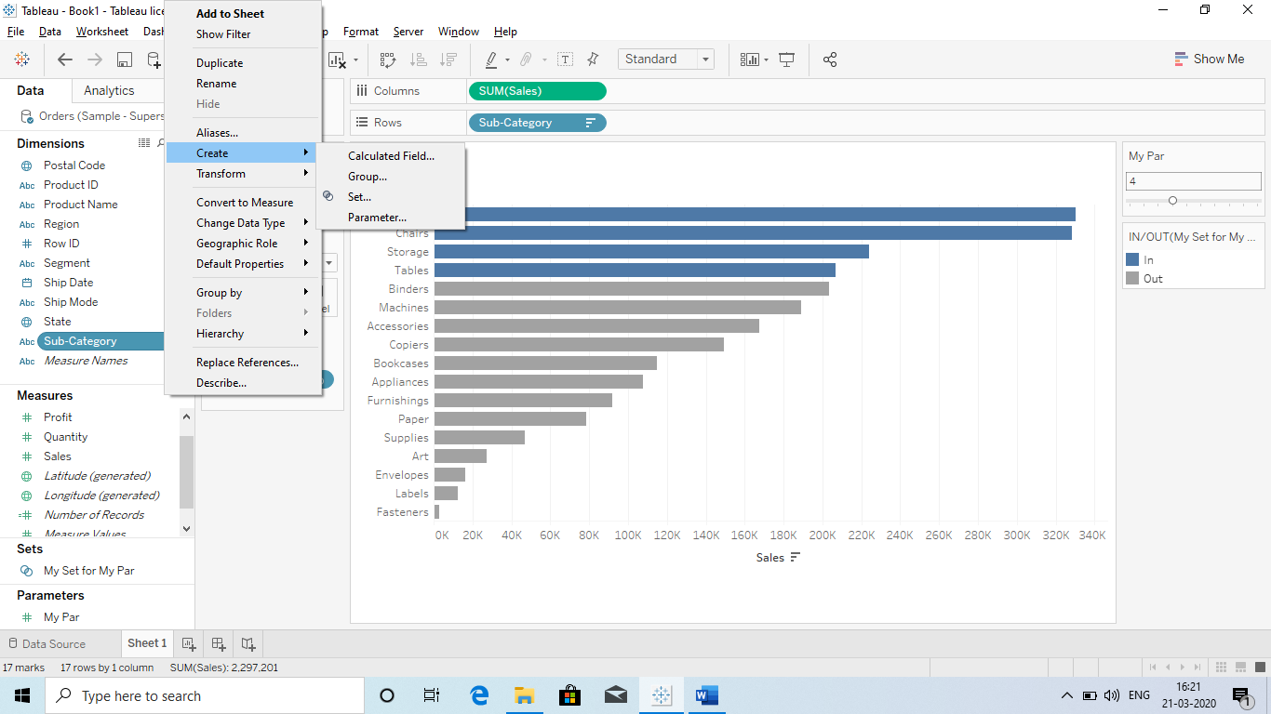

Then select TOP – Byfiled – My Par:

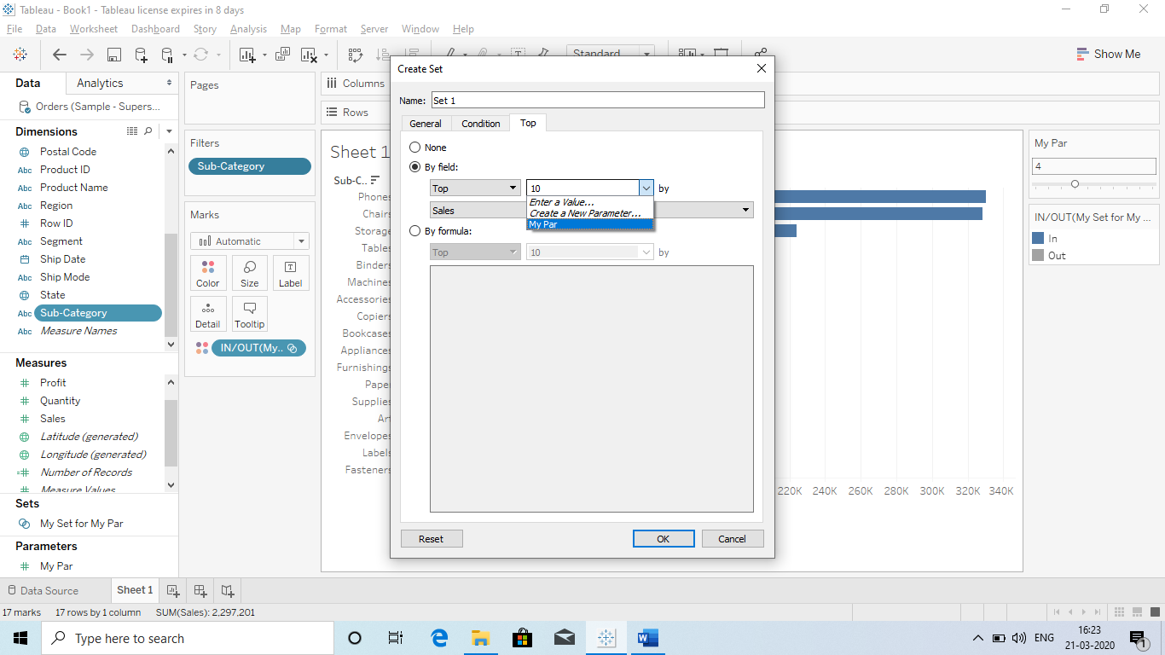

Than take the below step:

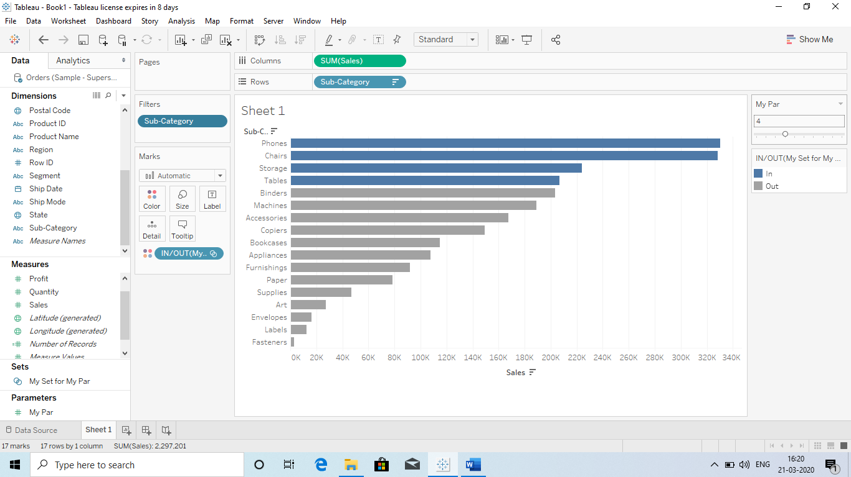

Also Remember to select all parameter So that you will get the exact picture shown above.

Drag My set to Colour so that only those field will be shown in colour which are selected in the Parameter scale

**Q What is Combine option and why we use combine option?**

Ans We use combine to merge 2 or more Dimensions provided so that we will get a clear pictures by combining both.

For ex: IF we have categories and sub categories and we need to get the maximum sales value after combining them.

So we will use combine option to do so, it will make the analyses easy.

**How:**

* **Select the Dimensions you want to combine.**
* **Then select create and combine (it will give you a new Dimension filed)**
* **Drag that field to the Row and Sales to the Text BOX.**
* **Then select sales and sort in Descending order.**

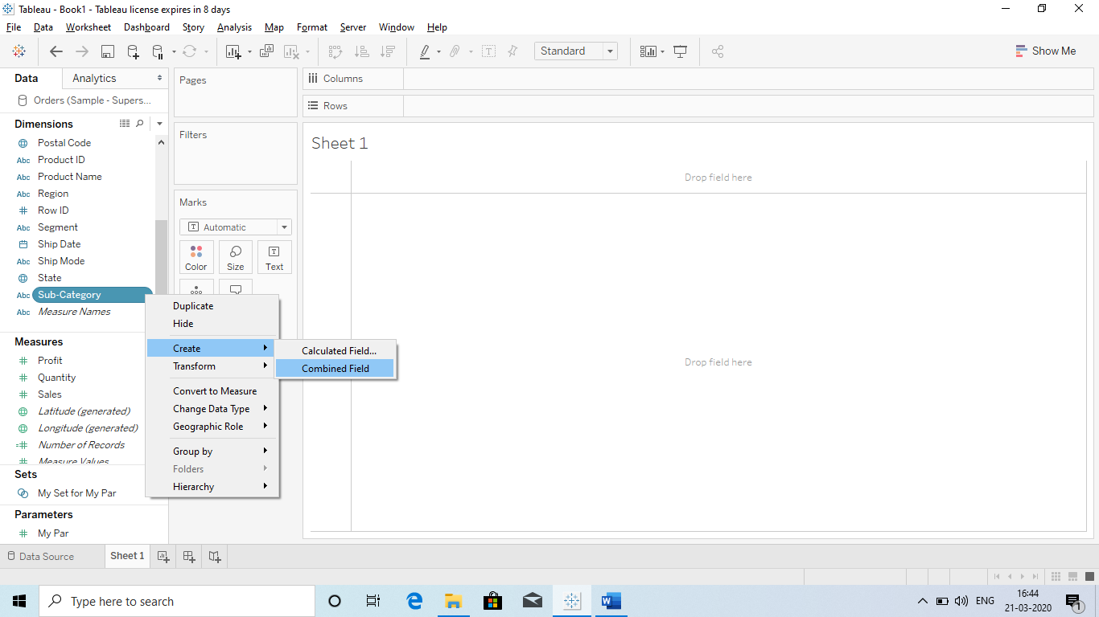

**Q) Title and Caption:**

We can change the title of the Graph or provide some name by double click on that.

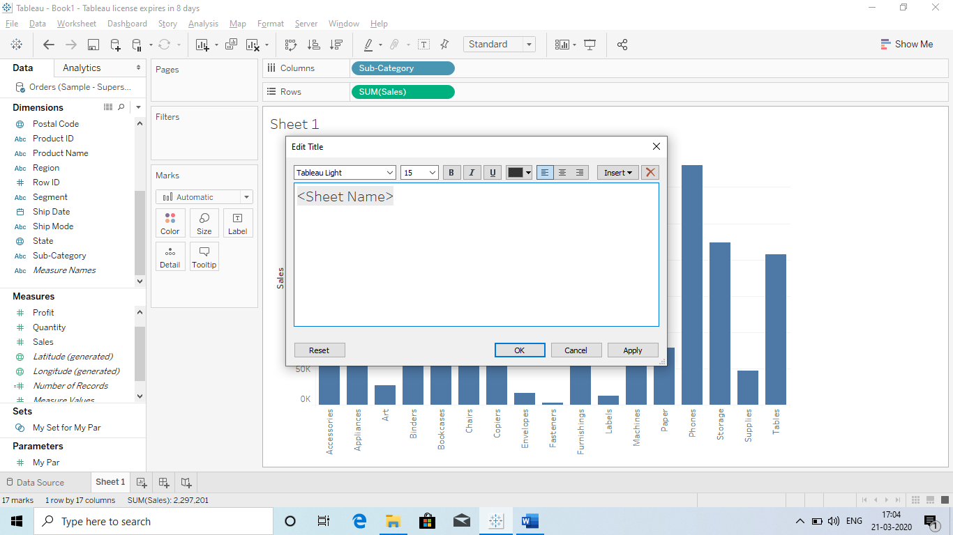

We can change the **Format of the Title**: means Colour of background:

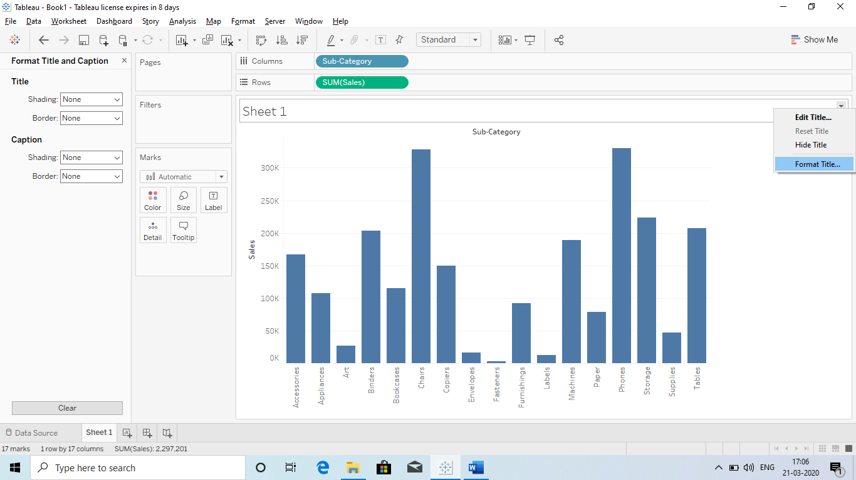

**What is Caption:** It is basically description of the graph.

How will we get Caption : Go to Worksheet (Top left) and select **Show Caption.**

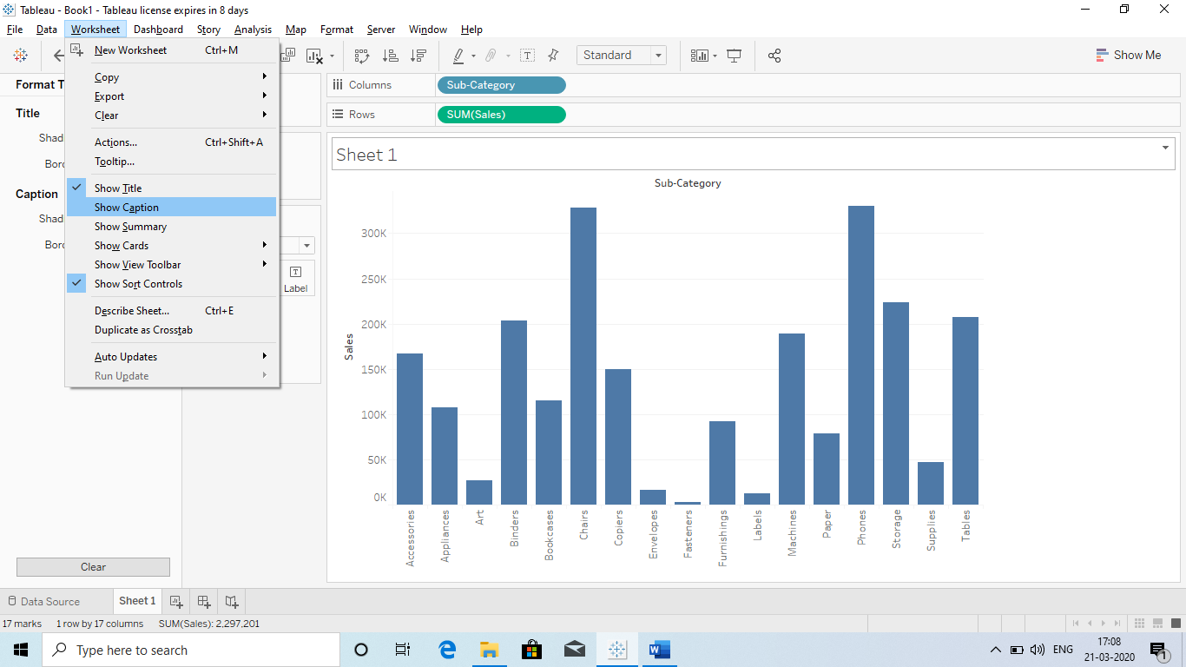

Now it will show at the bottom and we change it with Double click.:

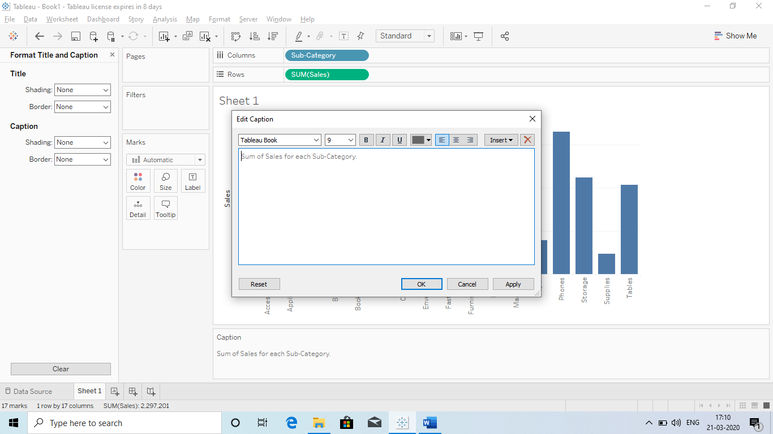

Double click: this window will appear.

**Q Exporting or where we can export Tableau data?**

* Excel
* PowerPoint
* MS excess database
* TWBX : Tableau Packaged workbook

Q) ***Important Interview Question: How we can share only that data to client on which the View or chart is based?

Ans we can just right click on the chart and copy then click on **CrossTab. It will export only the related data.** 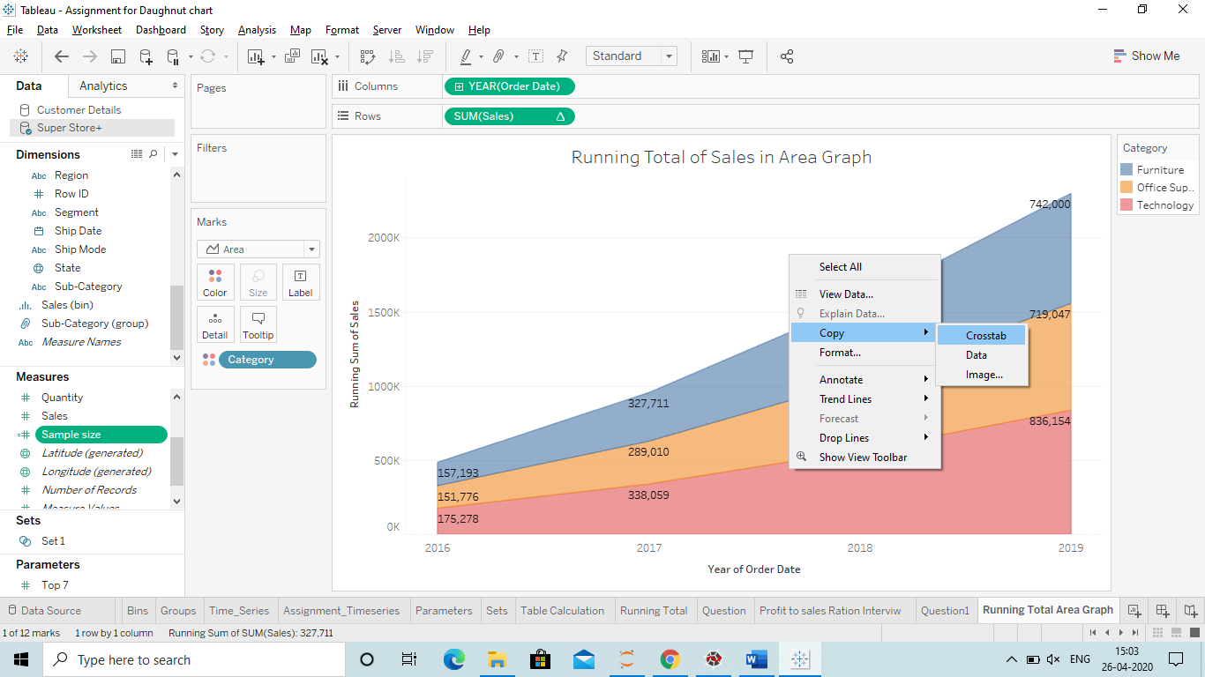

1. **PDF :** We can export it in PDF format : 1)Go to file – Export in PDF

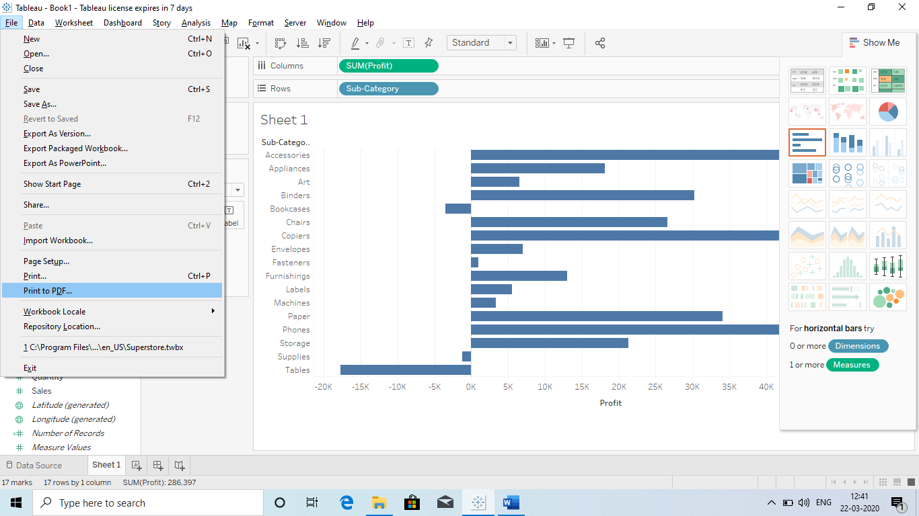

1. **Image** : We can save the dashboard in Image format: Go to worksheet and select Export – Image

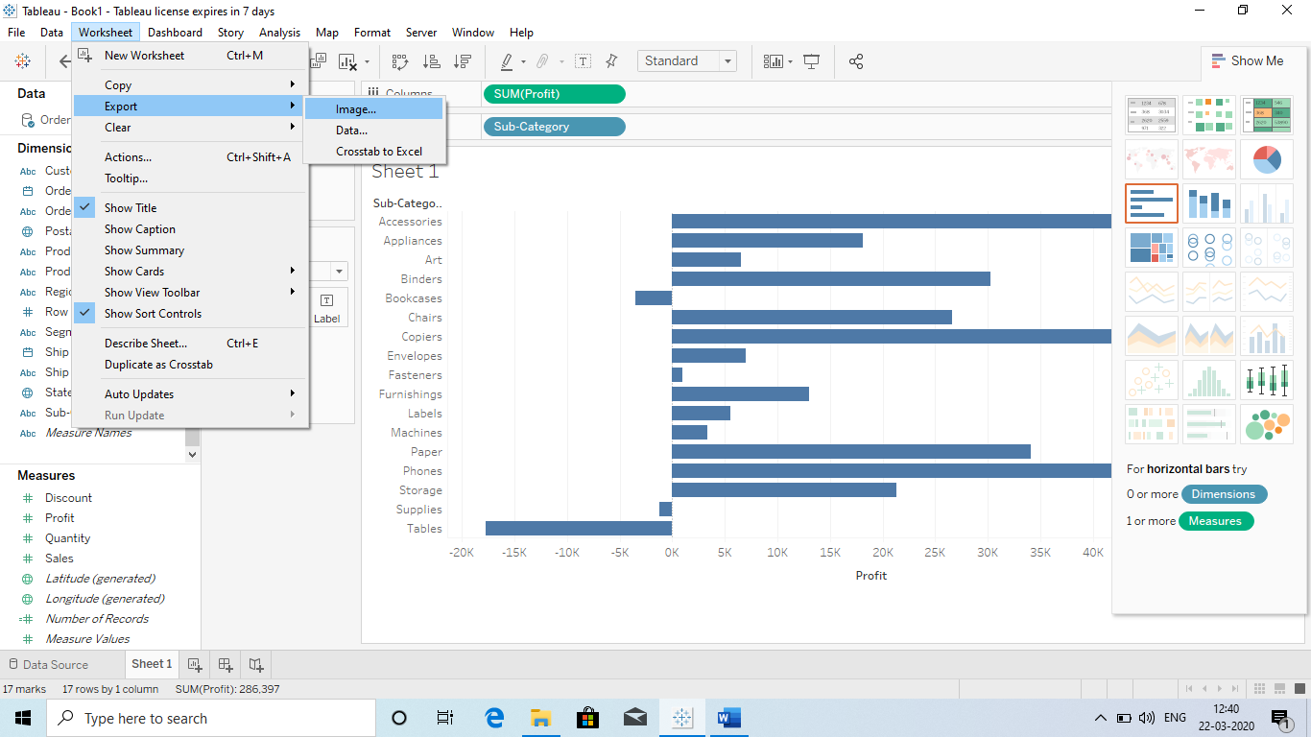

1. **Data: So can export the file in data format : Go to Worksheet – Export – Data.**

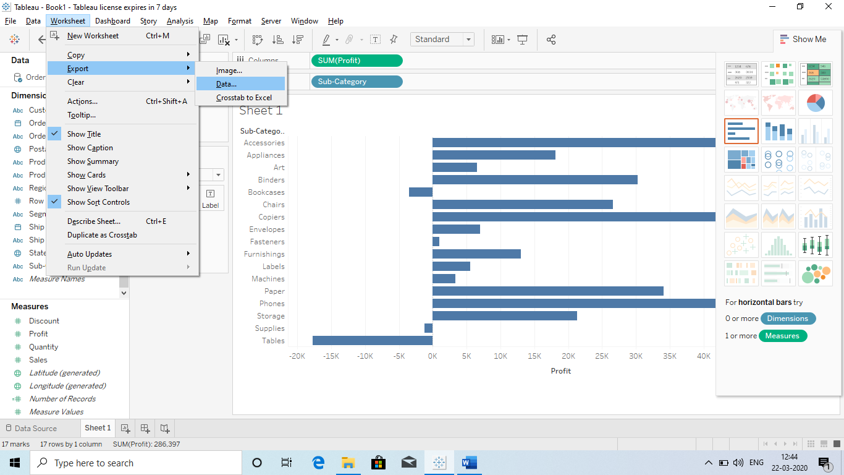

1. **Excel : Yes we can export data in Excel: Go to worksheet – Export – Cross Tab to Excel**

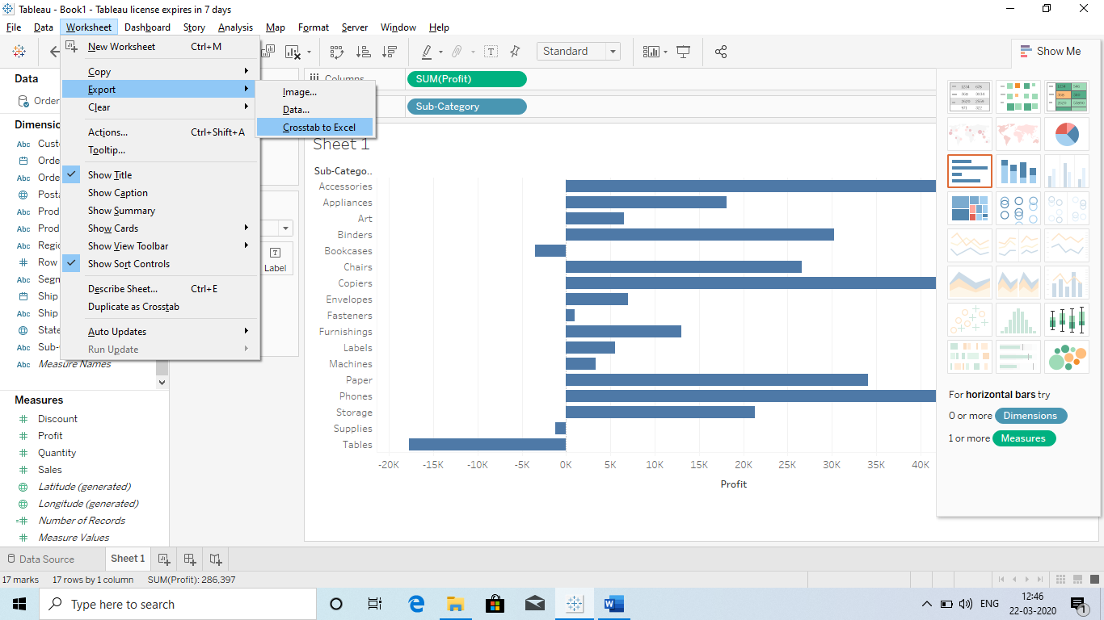

**Q Granularity:** It Means breaking down into small pieces.

For ex when we Drag sales in the Rows then it will give us the total sale : Granularity = 1

Now break it : Drag Category into the Column : it will break into 3 Parts : Granularity = 3

So in Simple way breaking or drilling down in data is called Granularity.

**Q How to work with Managing Metadata?**

* Hide or unhide the fields
* Rename
* Create different Hierarchies
* Create a folder: It makes the work easy since we have all related fields at one place
  + Ex: Location: city, country, state etc (so we will get these field at one place)
  + Now how we create it
    - First go to bottom of Dimensions and below Measure name in the blank area right click and **first select Group by Folder and then Create Folder**.
* Change the data type
* How to work with calculating fields:
  + What is calculated fields?
  + Ans Calculated fields are the fields which we have created according to our need so that we can use for interactive and effective dashboard.
    - How we can create a Calculated field?
    - Ans First go to bottom of Dimensions and below Measure name in the blank area right click and click on create calculated fields.
    - Use a formula you need.

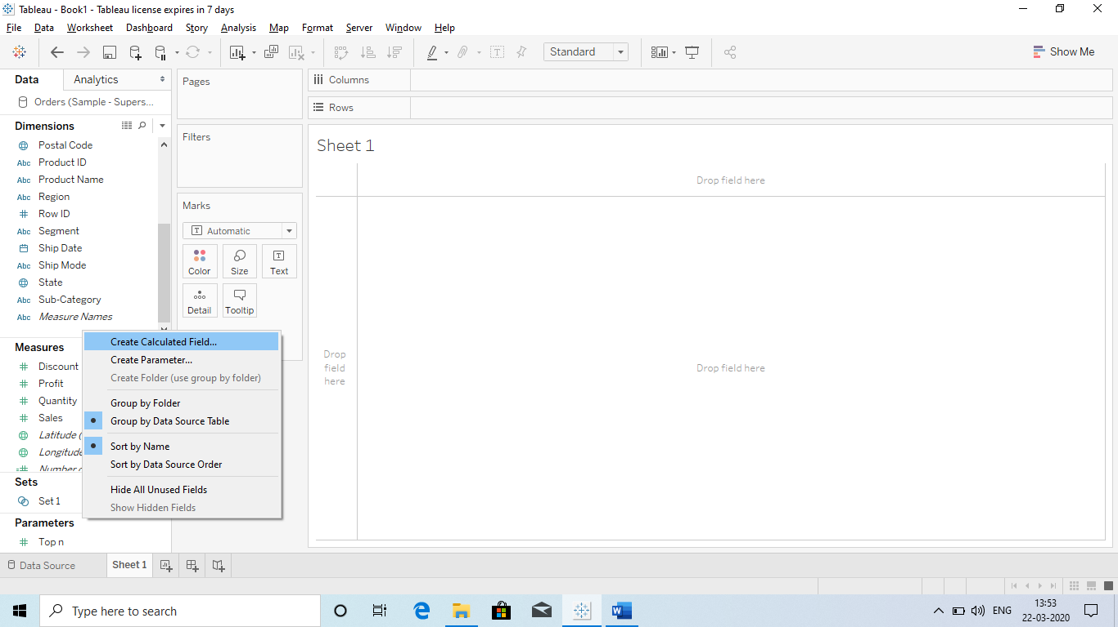

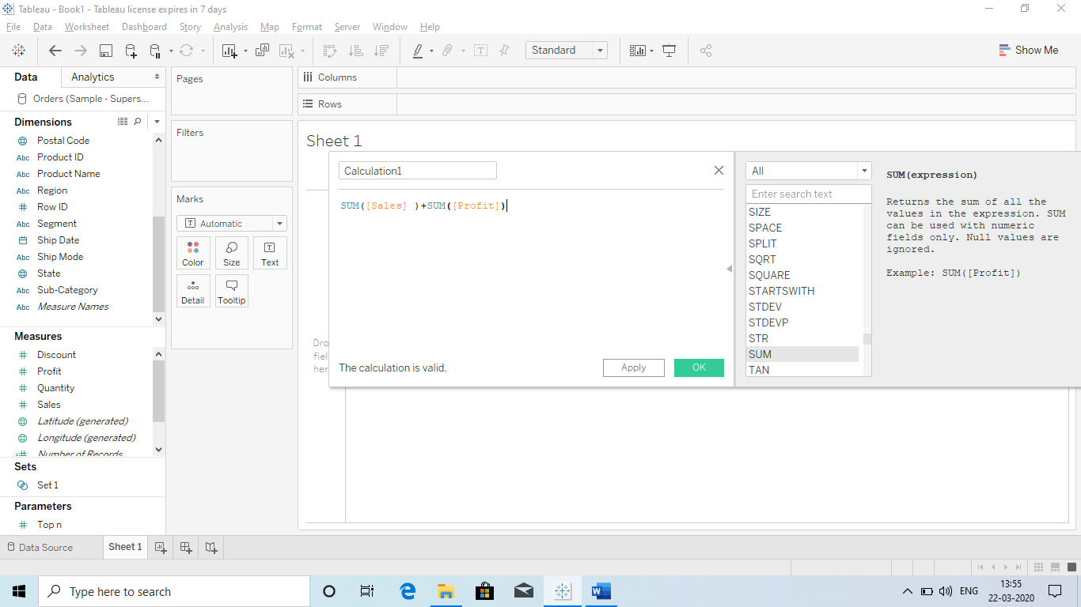

**Q Cross Join Database?** 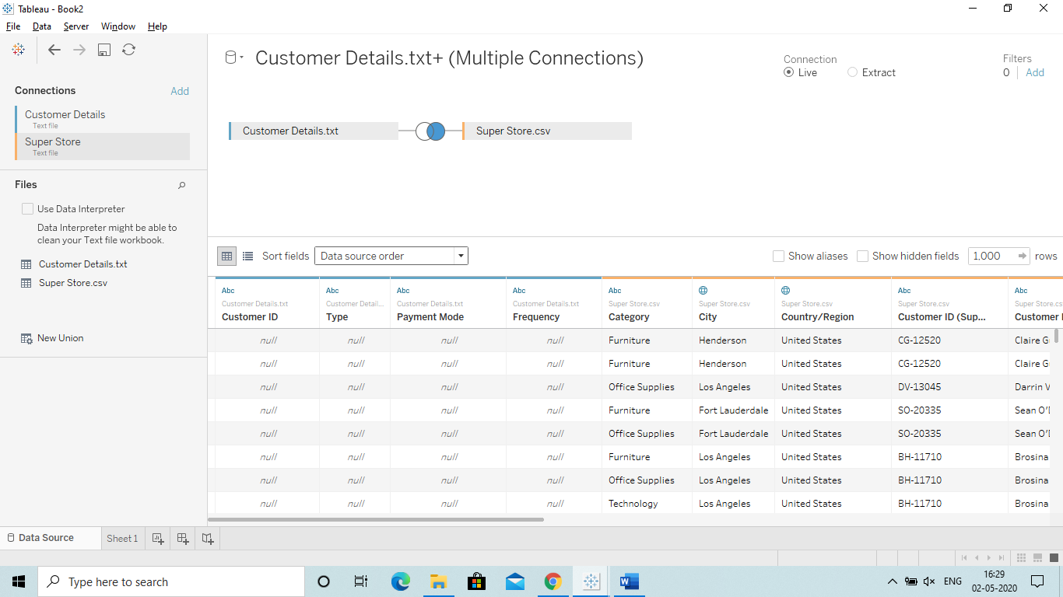

Ans Cross database means when your data is in different places like excel, csv, Tsv, oracle etc.

You want to connect these data together and perform some activity then cross join help to so.

Tableau is very smart toll which automatically pick up the common column in all the files and join it with that so that we can perform some activity with it.

**Q Data Blending? (If we are adding the 2nd data in the worksheet and make connection when we have already created some visulaization and we cannot use joins)**

**Ans It is similar to Joins however it is advance. It provide more accuracy in the data.**

**Advantage: Since our client need our source data with Tablue file. So we can use blending so that they can see only related data.**

**Disadvantage: It make the Tableau processing slow.**

**So if does not have a relation or headers are different but data is same then Data blending help us to join data and perform some task with it.**

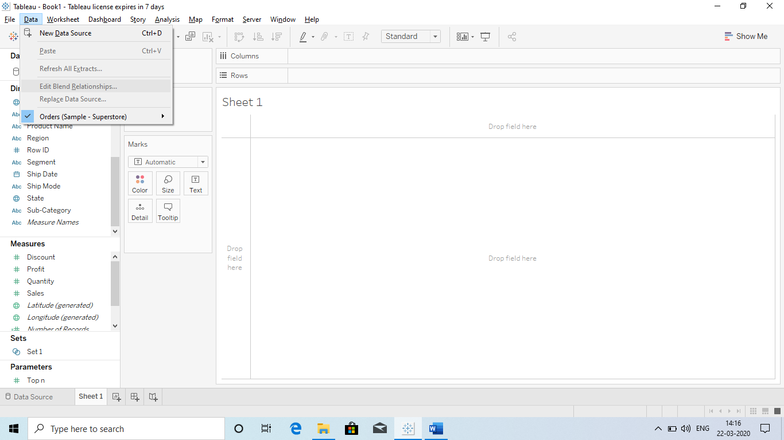

* It Automatically takes the common columns or we can define the relationship by connecting two columns.
  + Automatically

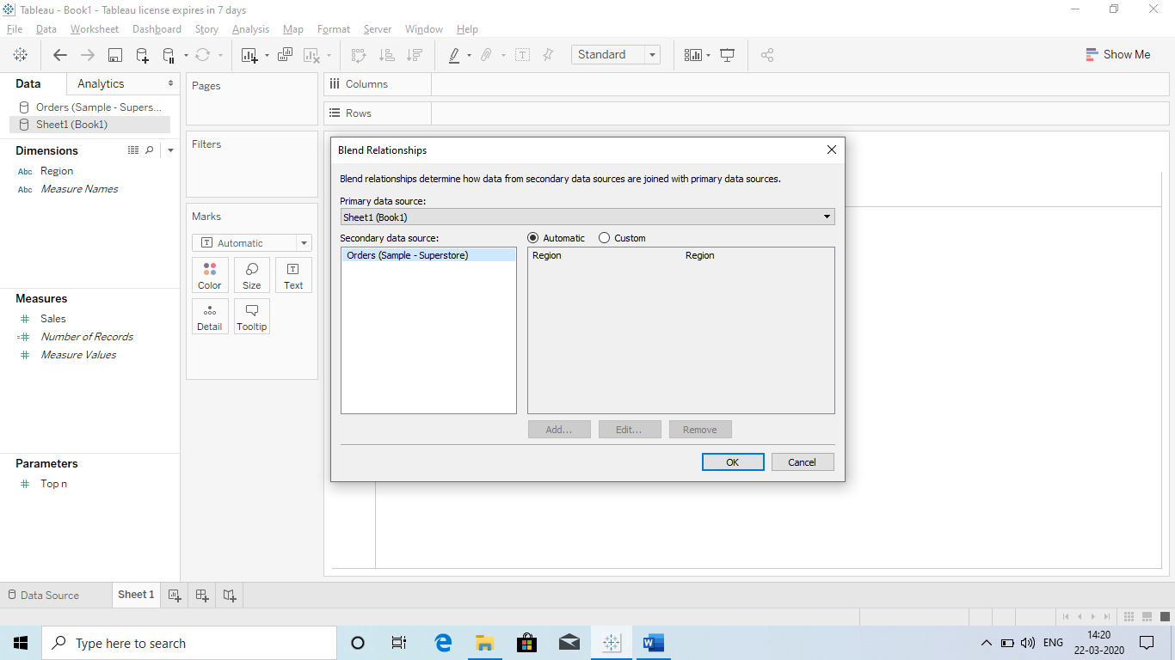

* + Manually

Select Manually common Column

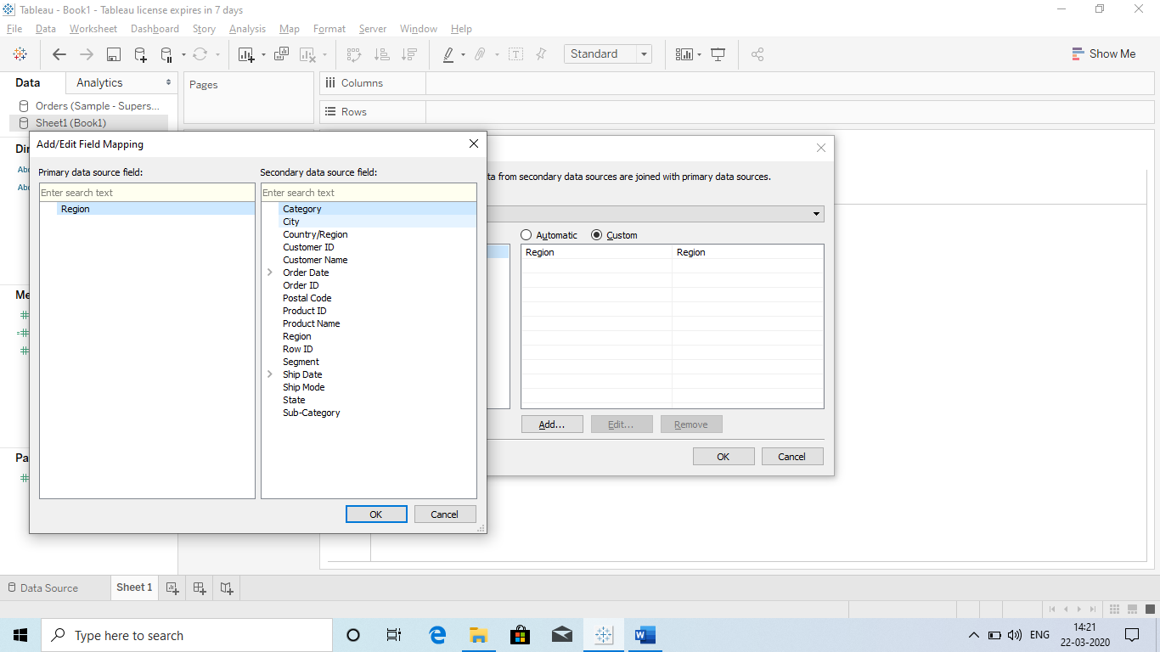

1

2

**Q) Data blending calculations:**

So after combining the common columns we can use it with **calculated fields**?

For ex if we have sales of Products in cities.

Product 1 have sale in 5 cities

Product 2 have sale in 2 cities (These 2 cities are common in both)

Now if we need total sale of all the cities, so we have use calculated field as **Total sales.**

**Problem:** Since in Product 2 sale is in 2 cities and other cities have null value so while showing the Total sales in Bar chart it will show total for only 2 cities.

It is because when we add some Integer to a Null value the result is NULL: **Sum(NULL)+Sum(7): NULL**

**So we have to use a formula while writing a formula in Calculated filed: “ZN”**

**ZN will convert the NULL to Integer.**

**Q DIFFERENT TYPE OF FILTER?**

**Ans There are 5 Type of filter:**

1. **Extract**
2. **Data Source Filter**
3. **Context Filter**
4. **Dimension Filter:** Normal Filter as below
5. **Measures Filter: :** Normal Filter as below
   1. General Tab
   2. Wildcard Tab
   3. Condition Tab
   4. Top Tab

Explain:

1. **Data Source Filter:** This filter is directly applied on the data source since we are making changes in the data source not in the fields. So it will affect all the worksheets (Visualization) in the tableau since we have filtered the data.

**It means we are not using the Filter Card and we Filtering the data from the Data Source:**

**Go to Data Source and right click : Select Data Source Filter.**

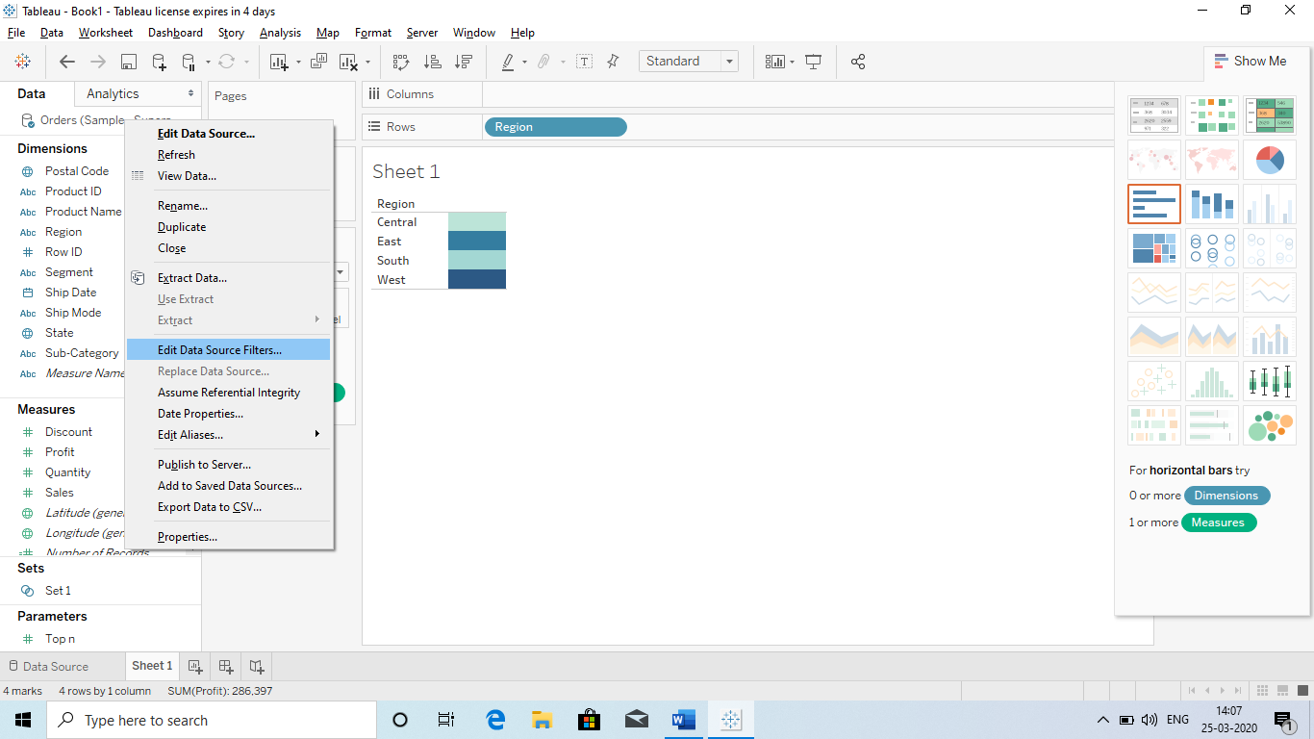

Q why we use data source if it affects all the data?

**2) Context Filter: It makes the dashboard more interactive and faster.**

**For ex : when have a lot of data, so it create a separate filter so that we can work easily and faster.**

**Ex: If we have 2 sections :A and B we need top 3 Students from both.**

**A: Kapil: 90%, Suresh: 88%, Manish: 99.5%, Niki: 68%**

**B: Nina: 89%, Meena: 96%, Sheena: 67%, Shilpi: 77%**

**Now Ans will be: 1.Manish, 2.Meena, 3.Kapil**

**However if we want top 3 from section A: Then Suresh will also be included.**

**So here we have provided a Segment and according to that segment the other filter wrk.**

**This is called Context filter.**

***Definition:***

We can make the filters more efficient by using context filter.

The normal filter in Tableau are independent, it means each filter reads all the rows from the data source and create its own result.

However, there might be scenario where you might want the second filter to process only the records return by the first filter. In that case second filter is called dependent filter since they process only that data which passes through the context filter.

A context filter set up a filtering hierarchy where the context filter is applied to the whole dataset and subsequent filter are applied only on the return records.

Link: <https://www.youtube.com/watch?v=zrpgY1H86PA>

3) **Extract: This is the filter which is applied when we import the data from a data source:**

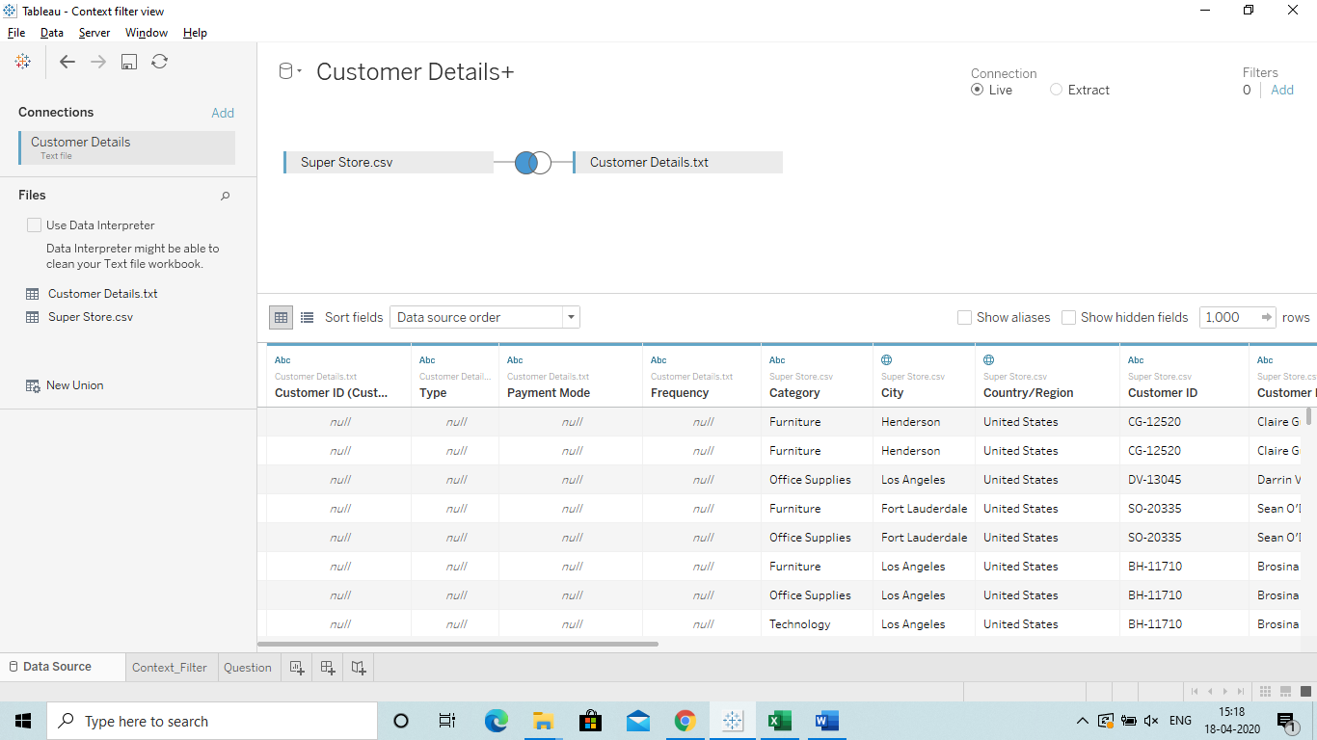

4) **Dimension filter**: When we Drag a Dimension into the Filter shelf.

5) **Measure Filter**: When we Drag a Measure into the Filter Shelf.

Q Filter Shelf?

We have 4 type of filters

* General Tab
* Wildcard Tab
* Condition Tab
* Top Tab

1. General Tab: Just Drag the Cat. To the filter and remove the items you don’t want.

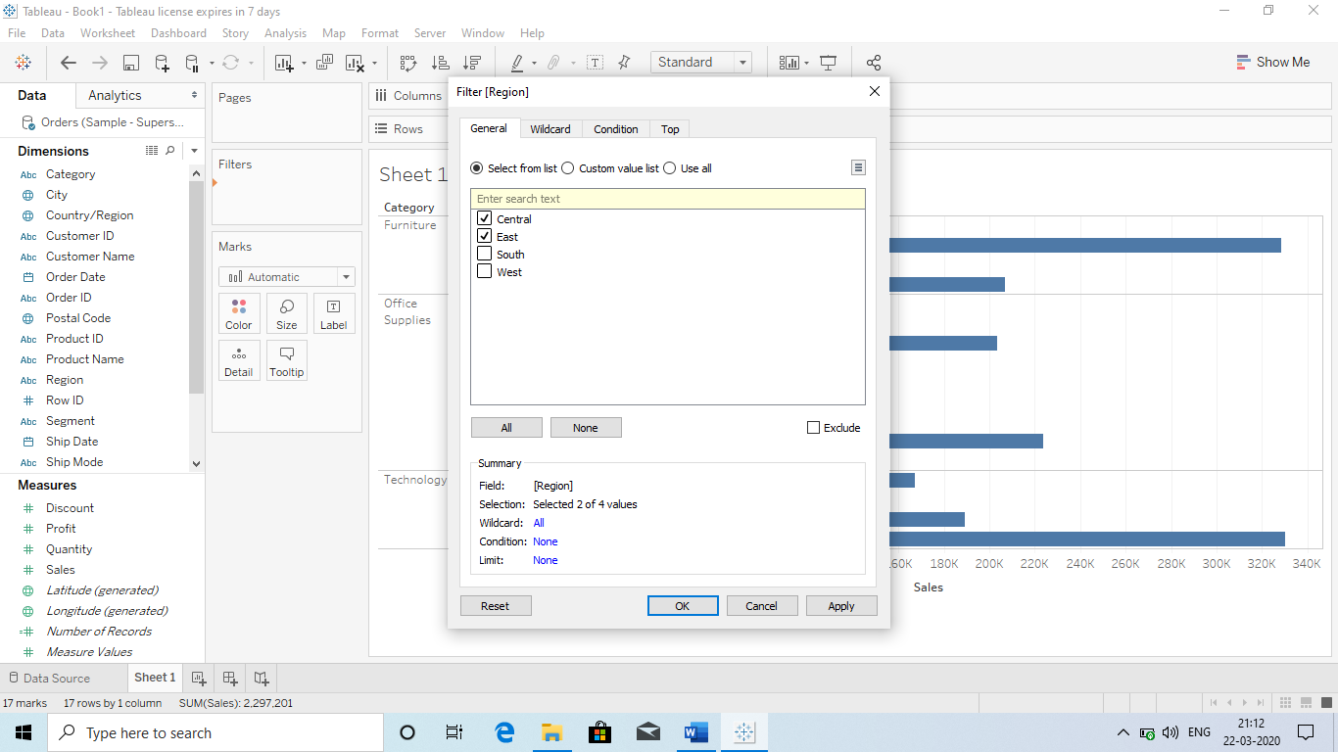

1. Wildcards: It is **Conditional Filter** in which are **Case Sensitive**.
   1. So If you want to check the cities which start or end with A(Means capital A: case sensitive.
   2. In real life we can use this while sending mail to specific mail ids which end with @google.com.

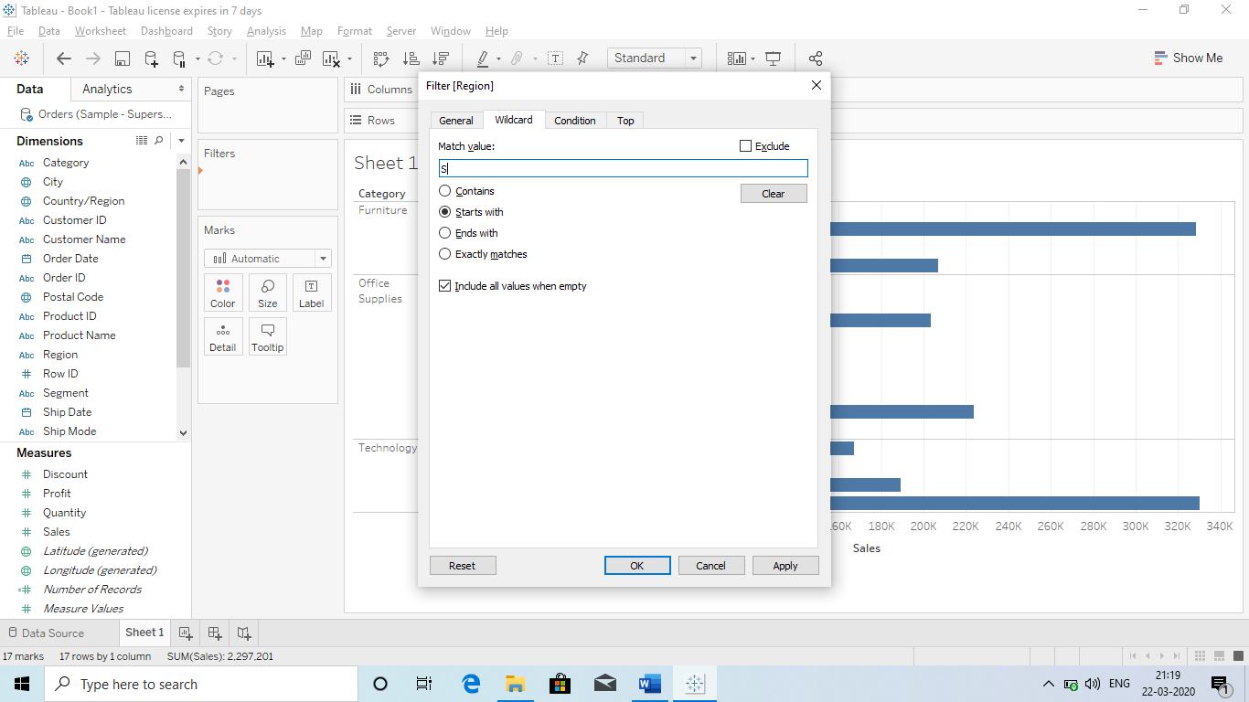

1. **Conditional Tab: It is like IF CONDITION in which we use a condition that**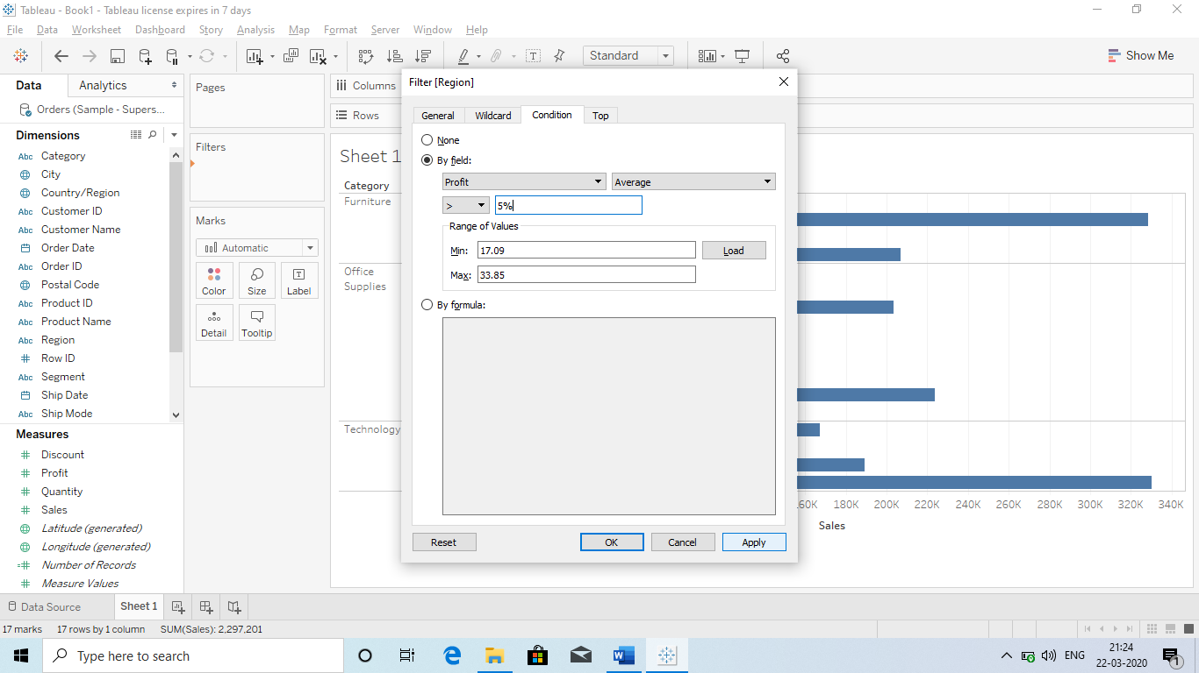

Load it, if no is in the result like in the screenshot then good to go.

But if it is showing NULL then something is wrong.

Select the Logical operator

Select a formula which you want to apply

Select the field by which you want filter.

1. **TOP Tab: It will give the top 5 or bottom 5 elements.**

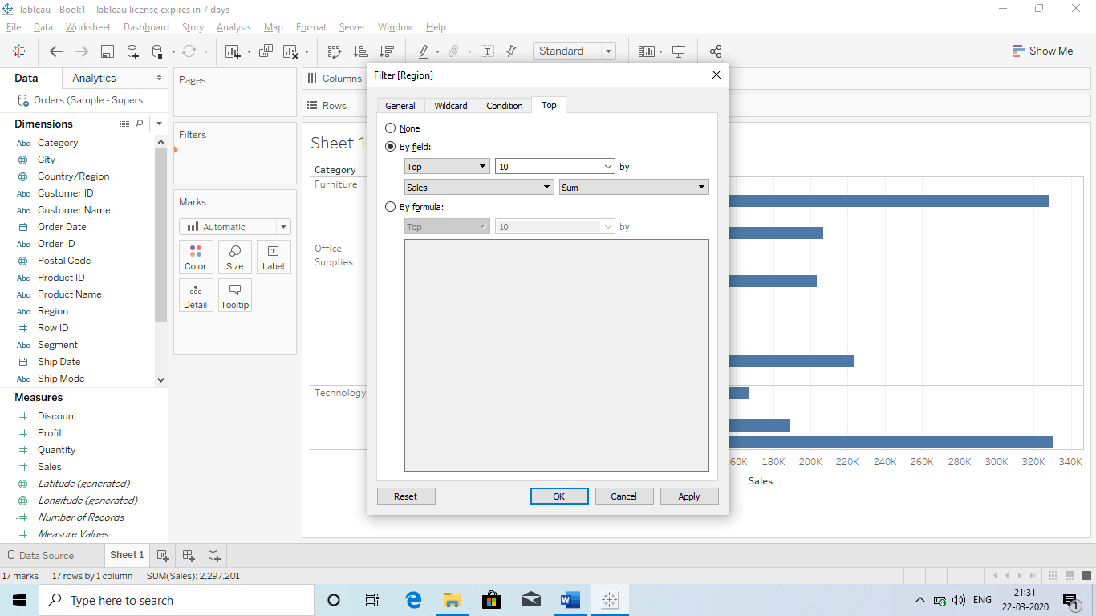

**Q) Date Filter?**

Ans We have lots of options related to data filter (We just have to Drag the Date to filter Card):

Column: Order date

Rows : Sub Cat and Sales

* **Relative Date:**

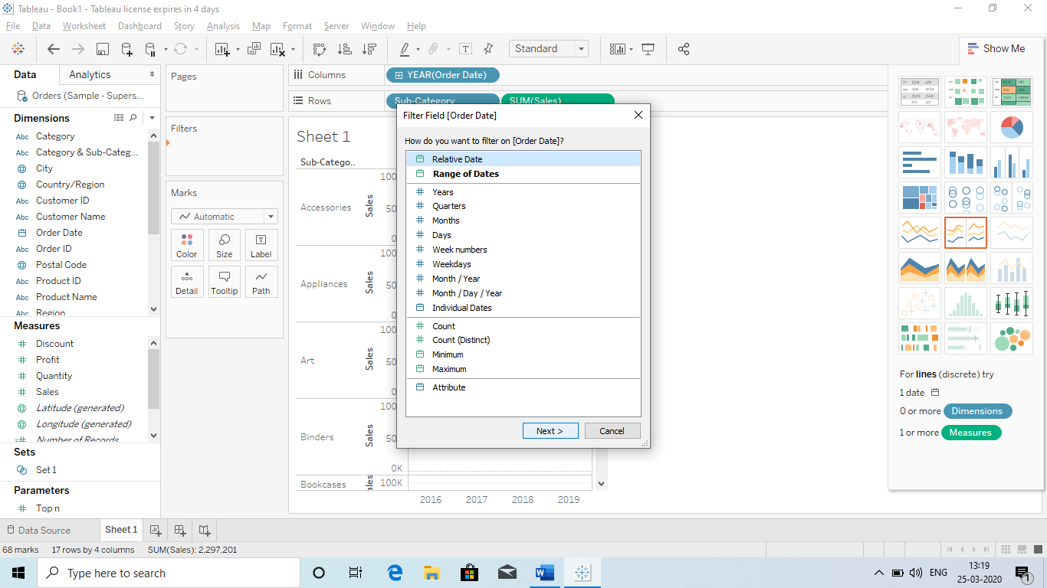

* Year
  + Last year
    - Last 3 Months
  + Next year
    - Next 3 Months
  + Previous year
    - Year to Date

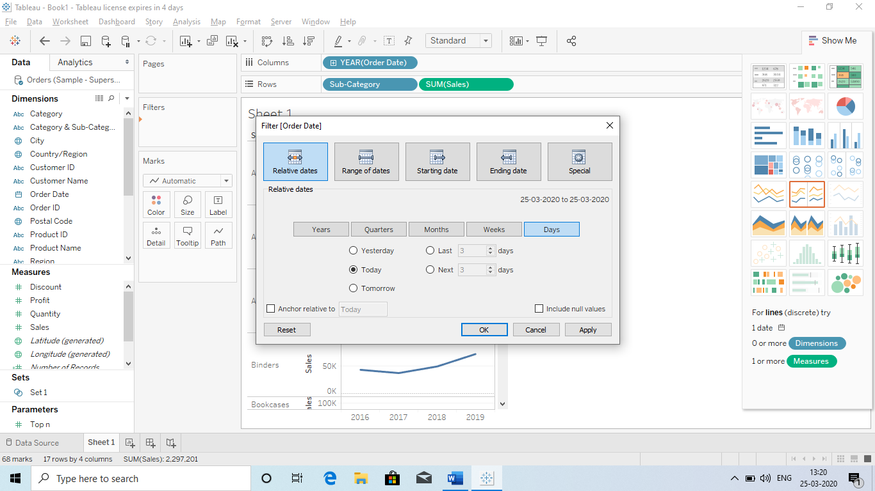

* Quarter (Similar options like in Year)
* Months (Similar options like in Year)
* Weeks (Similar options like in Year)
* Days (Similar options like in Year)

Our filter keep on changing and lot of option to show different type of Data with the help of date filter.

1. **Range of Date:** Means we can select the **starting date** and **END Date.**

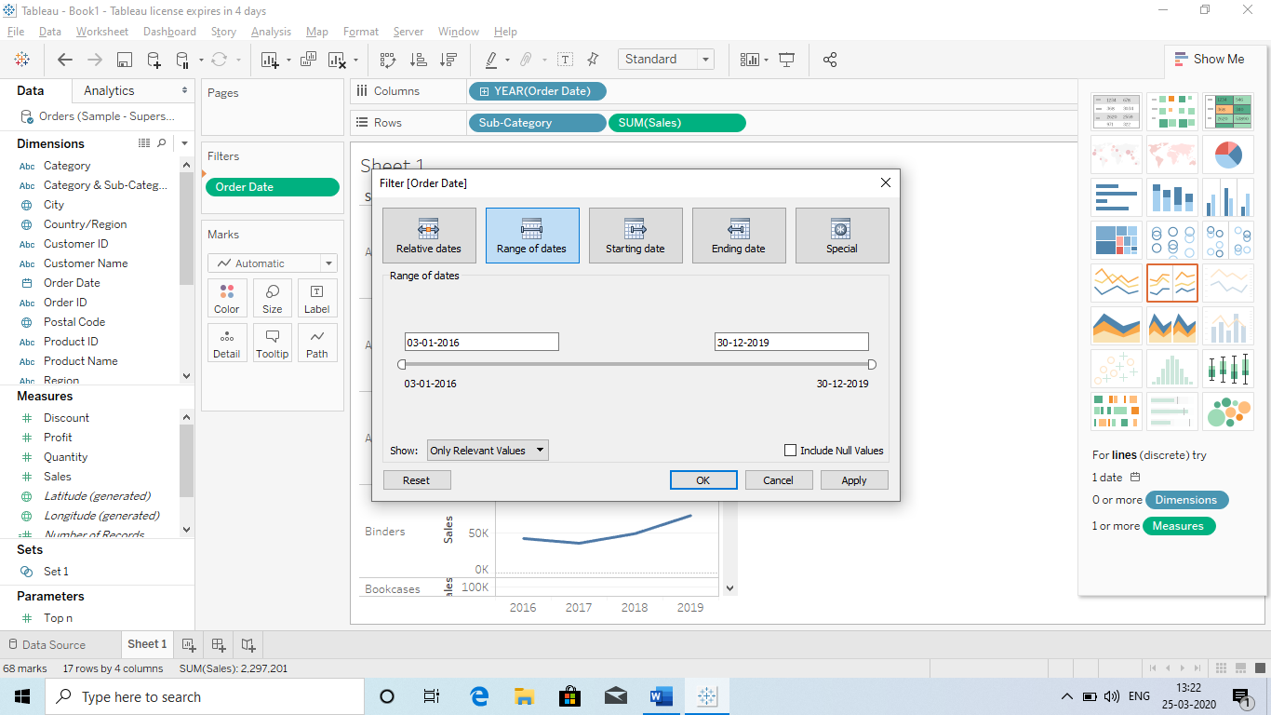

1. **Starting Date**

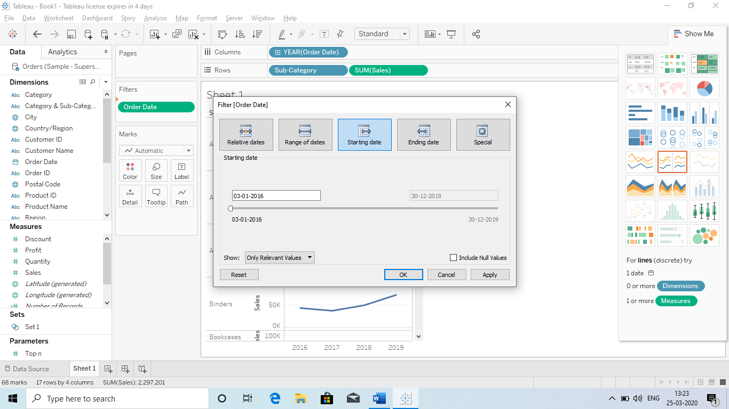

1. **End Date**

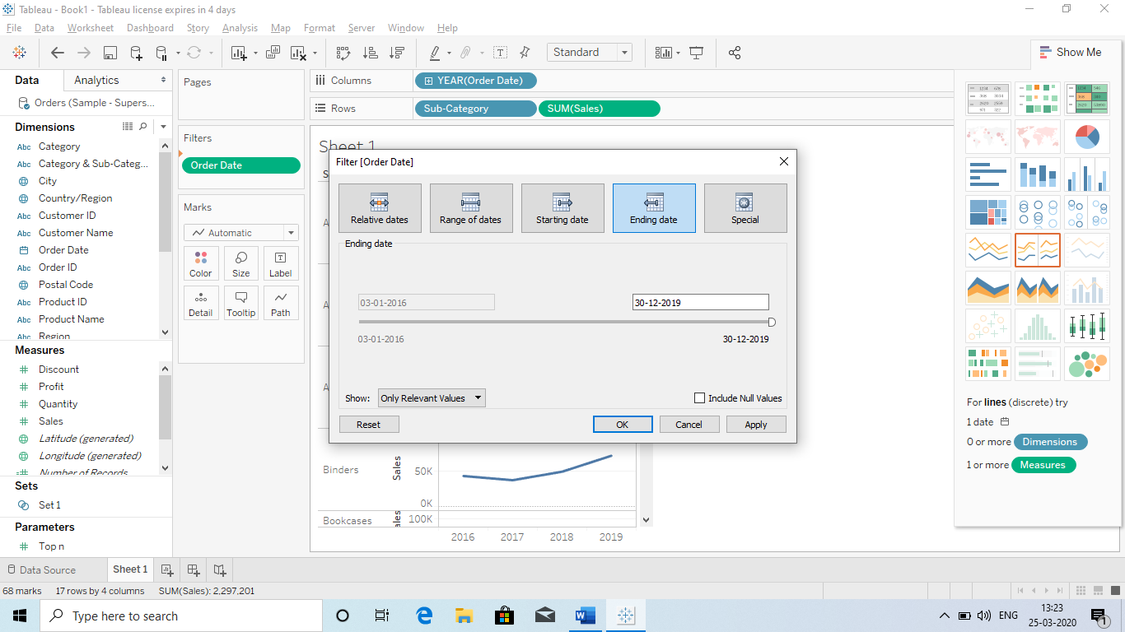

1. **Special:**
   * Null Dates
   * Non-Null Dates
   * All Dates.

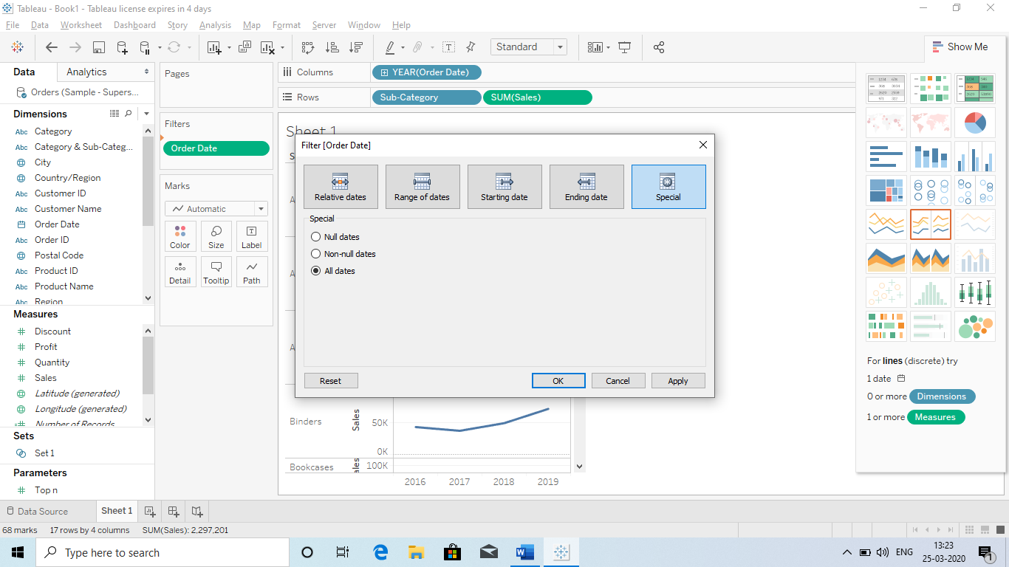

**Q) Interactive Filters:** It means we can or a user can interact with Dashboard accordingly.

1. Without Dragging the field in the Filter Card.

For ex if we certain categories and we need to just look at 1 thing in the categories. So just we need to select that check box all other will hide automatically without doing it with **Filter Cards**.

**Steps to create an Interactive Filter for the Dashboard:**

1. **Go to the Categories**
2. **Select Show Filter** (It will automatically show the list of Categories on the Right side of the window)

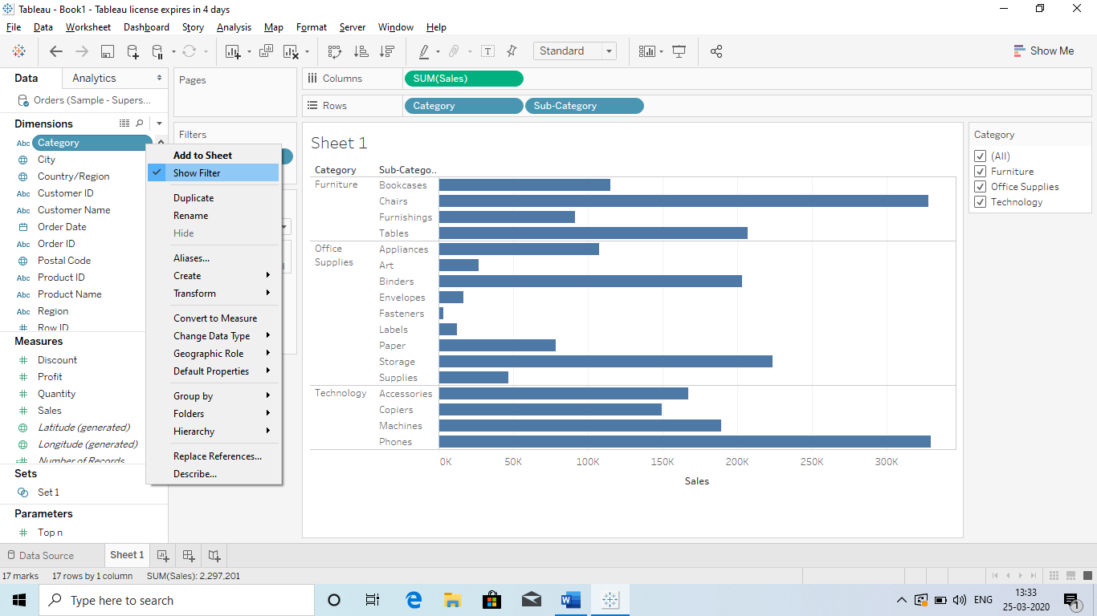

**Q) Can we change the layout of this filter:**

**Ans** Yes we can change the layout of the Interactive Dashboard.

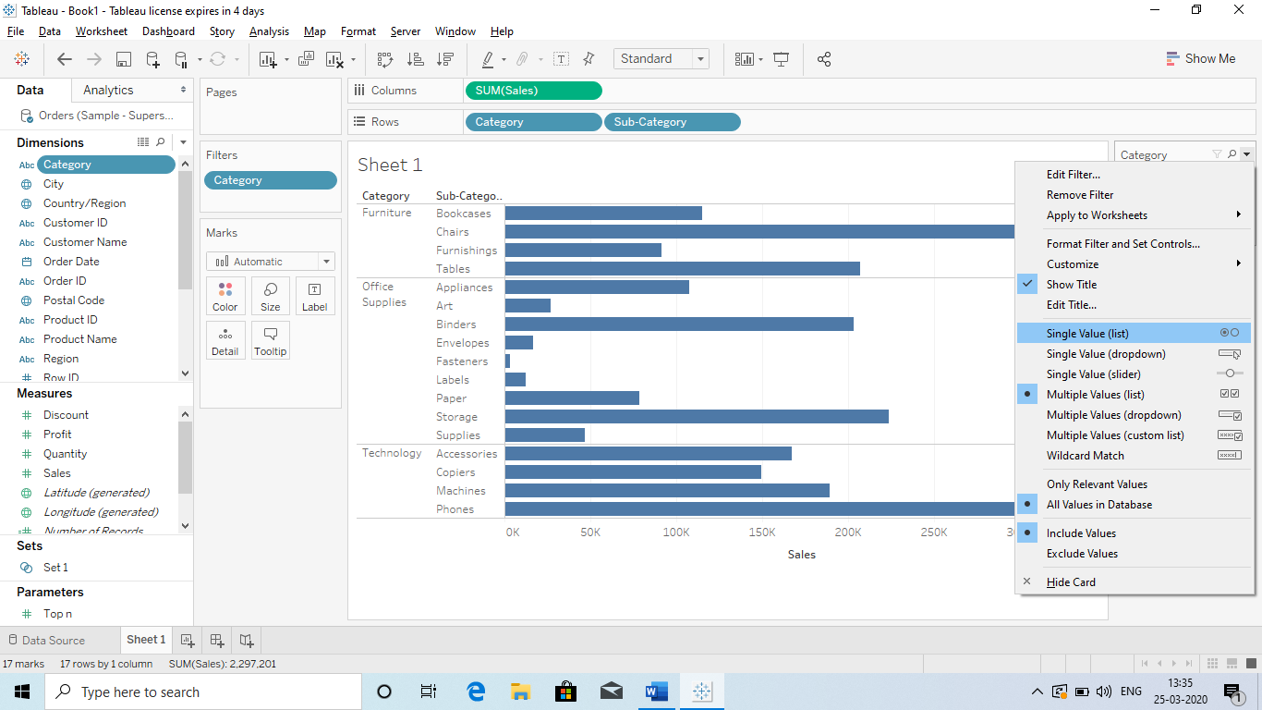

**Q) Wild Card A: It is just like Wild card filter in which we get the result as per Input Start with A or End with B etc.**

* **Just select Wild card**
* **Enter the first word : B**
* **Than press Enter and it will show the SUB Categories starting with B**

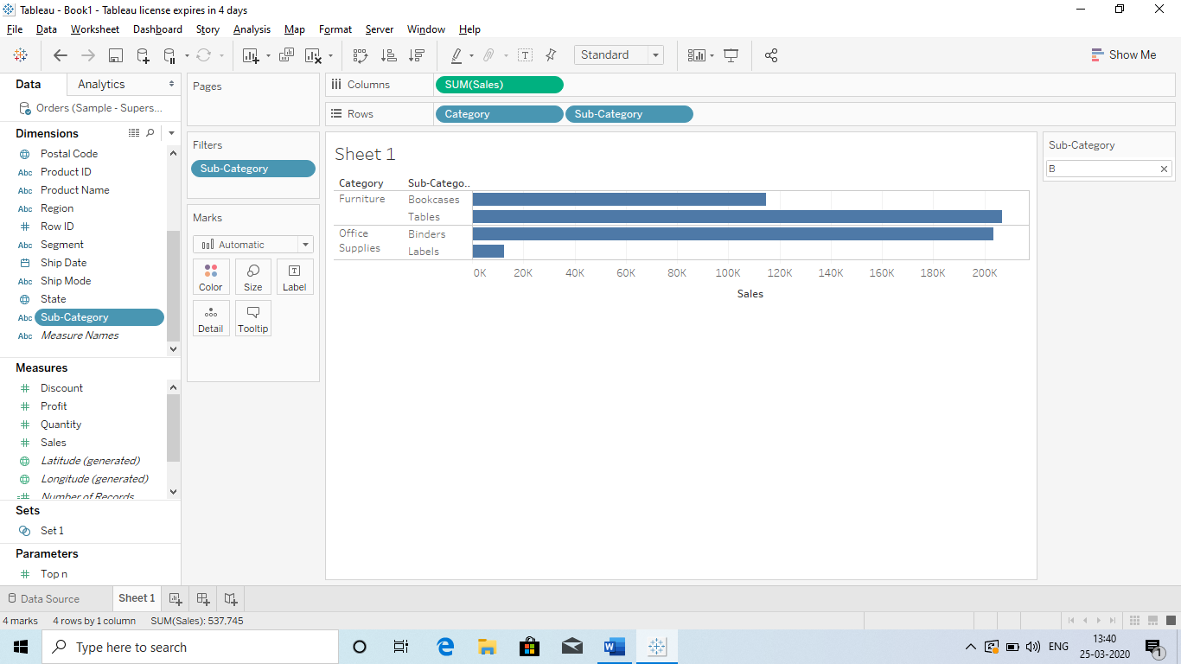

**Q Advance Interactive Filters: Dependent Interactive filters (one selection will filter the other)**

* **It means if we have Categories and Sub- Categories, we are using both as an Interactive filter.**
* **While selecting the 1 Category, it will show only those sub cat which the relevant.**

**How we can do it:**

**Ans** It can be done by **Only Relevant Value.**

**Steps**

1. **Go the Sub cat filter and select Only relevant value. (It will automatically select the relevant filed)**

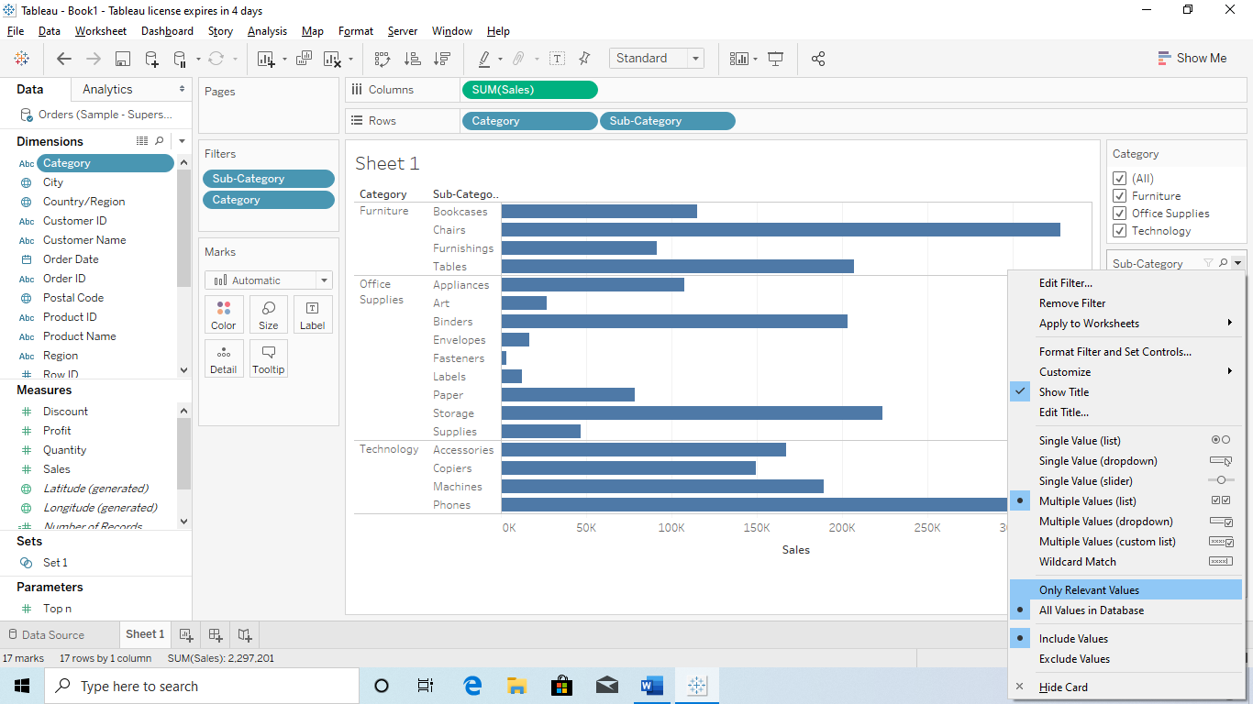

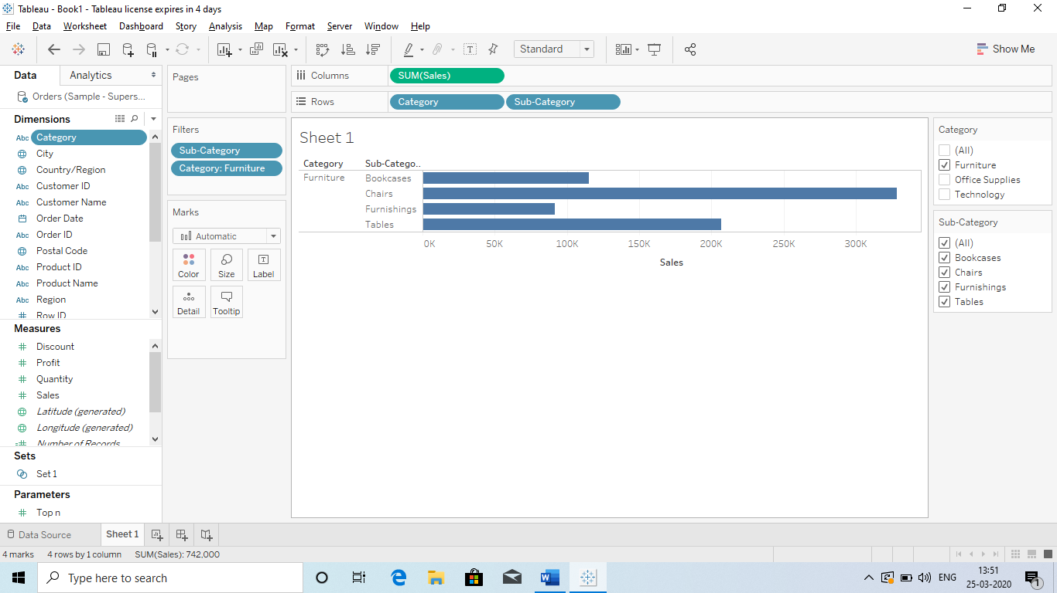

**Q) Same we can done with Dates:**

**Just take the below step**

* **Column : Order date**
* **Rows: Sales**
* **Colour : Categories ( So that we will get Cat wise yearly sale)**

**And then use interactive filter to order date.**

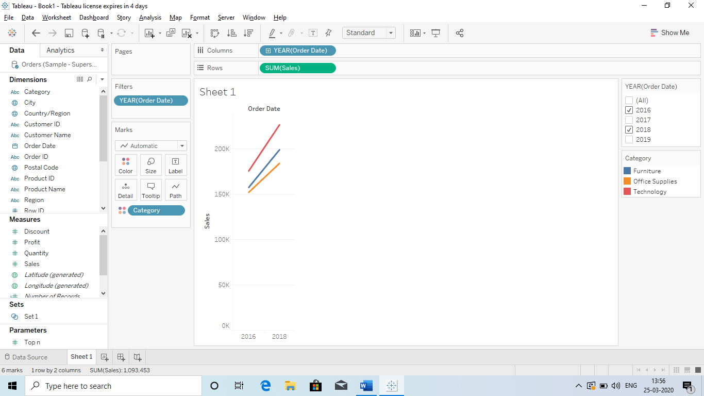

**Q Data Source Filter:**

It means we are not using the Filter Card and we Filtering the data from the Data Source:

**Go to Data Source and right click : Select Data Source Filter.**



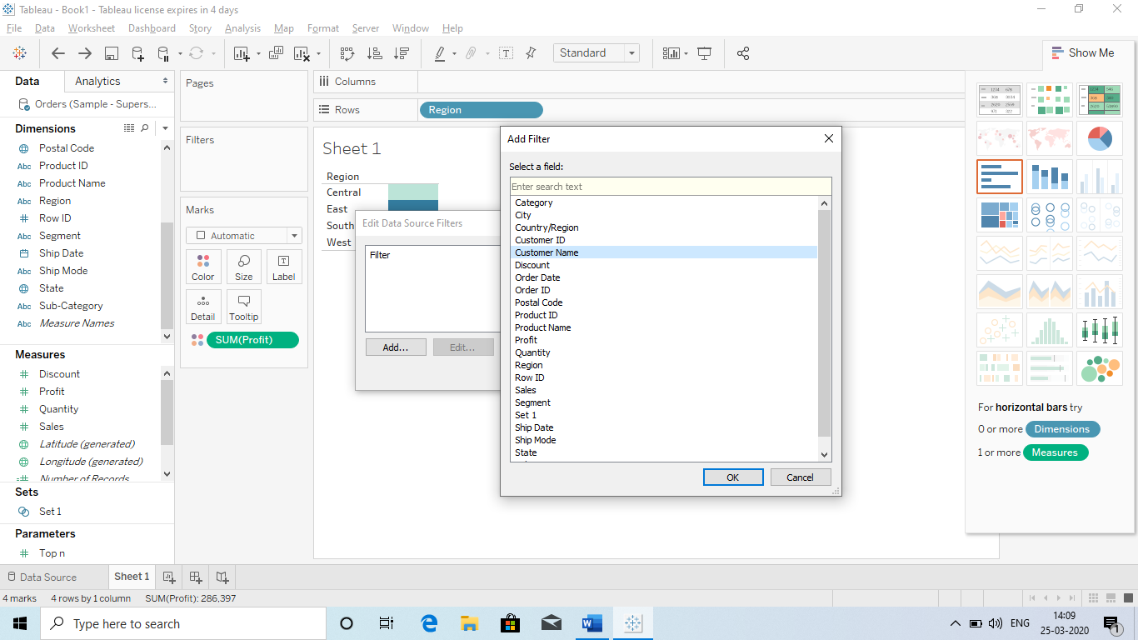

Select the thing by which you need to filter.

Q Summary of Filter?

1. Shelf Filter
2. Interactive Filter
3. **Header Filter :** Just select the headers from the Dashboard and select Keep only. It will show only the selected items.
   1. We can select Multiple headers.
4. **(colour Filter)Legends: (Dragging the field to the colour section)** It means Filter by Market dragged to the Color and new Filter will be added to the Right side and we can select the Legends.

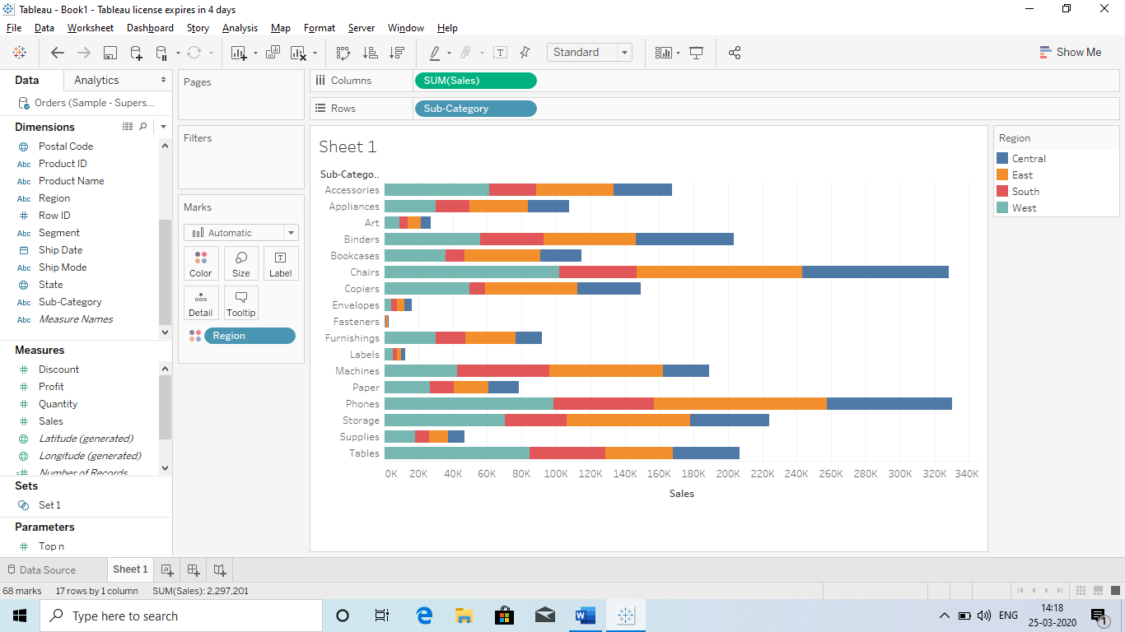

Than we can keep the selection and only selected item will be shown:

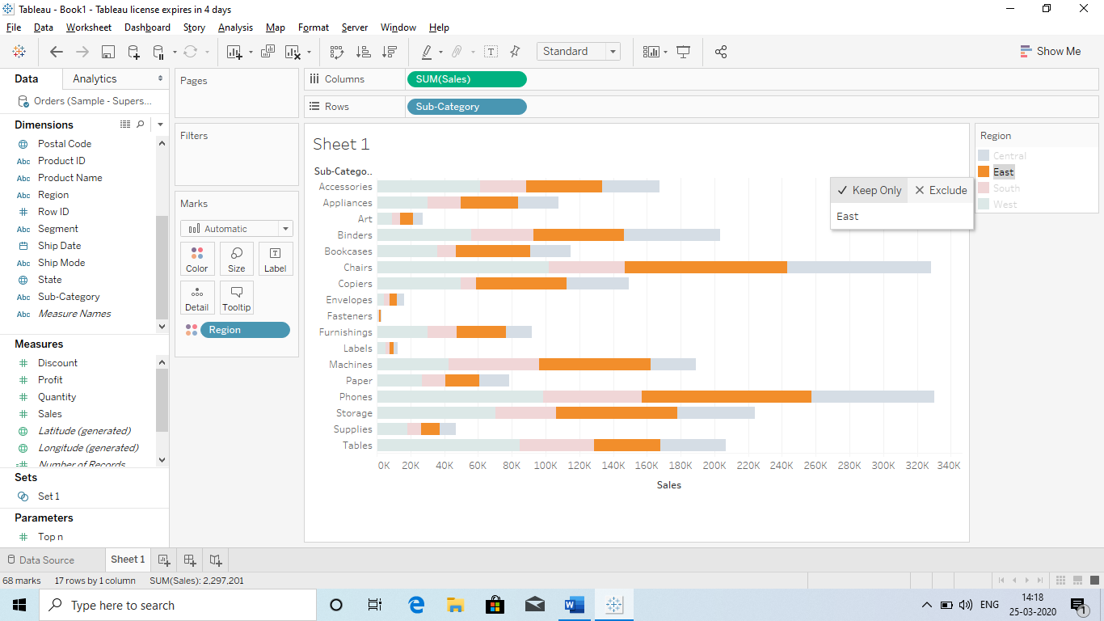

Q **Format Filters:**

**It means formatting the Interactive Filter Box:**

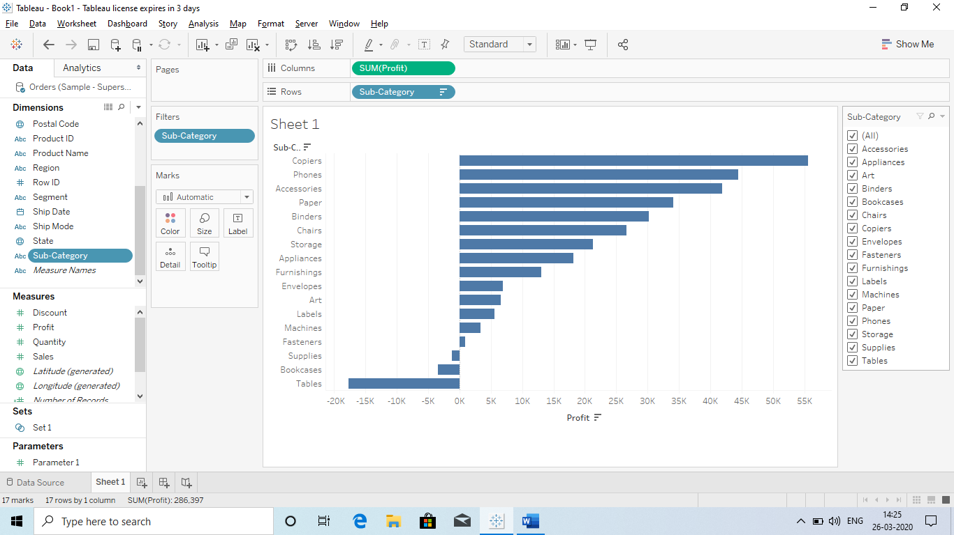

Do Remember that the changes will be only shown in the Dashboard.

It means we are making changes in this box which are only visible in the Dashboard.

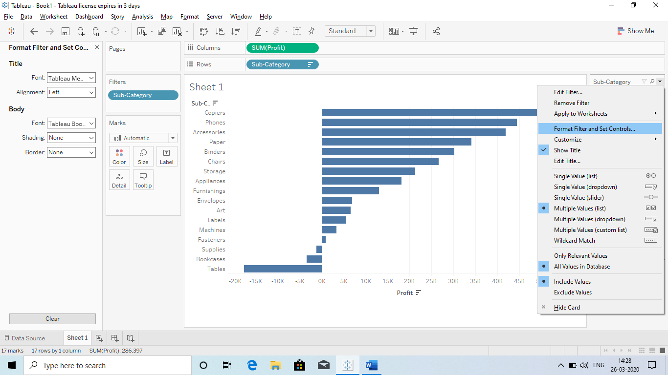

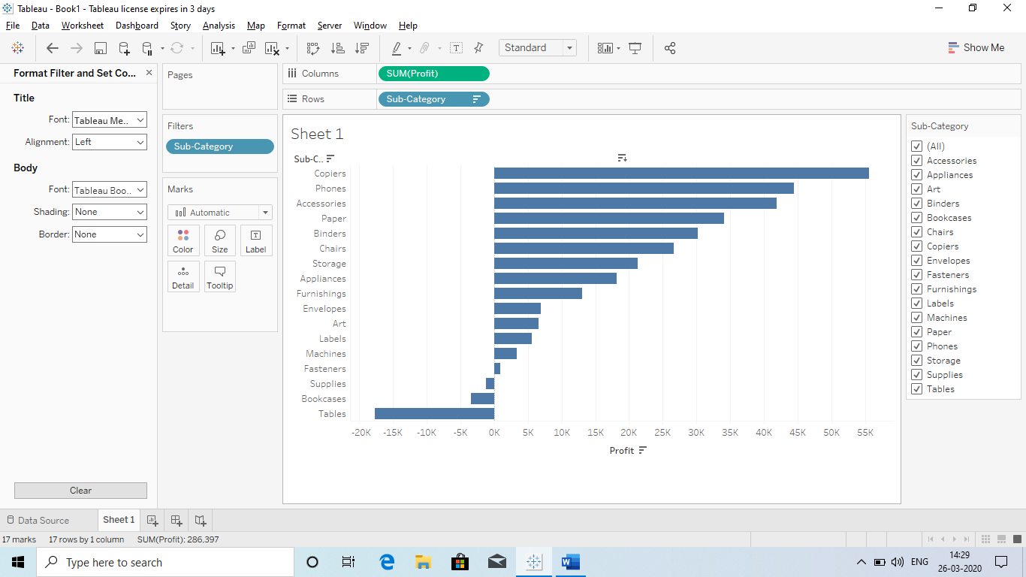

This is for changing the Body

This is for changing the Tittle

Q) Now we are working with **MARKS?**

**Ans Marks is a shelf in Tableau:**

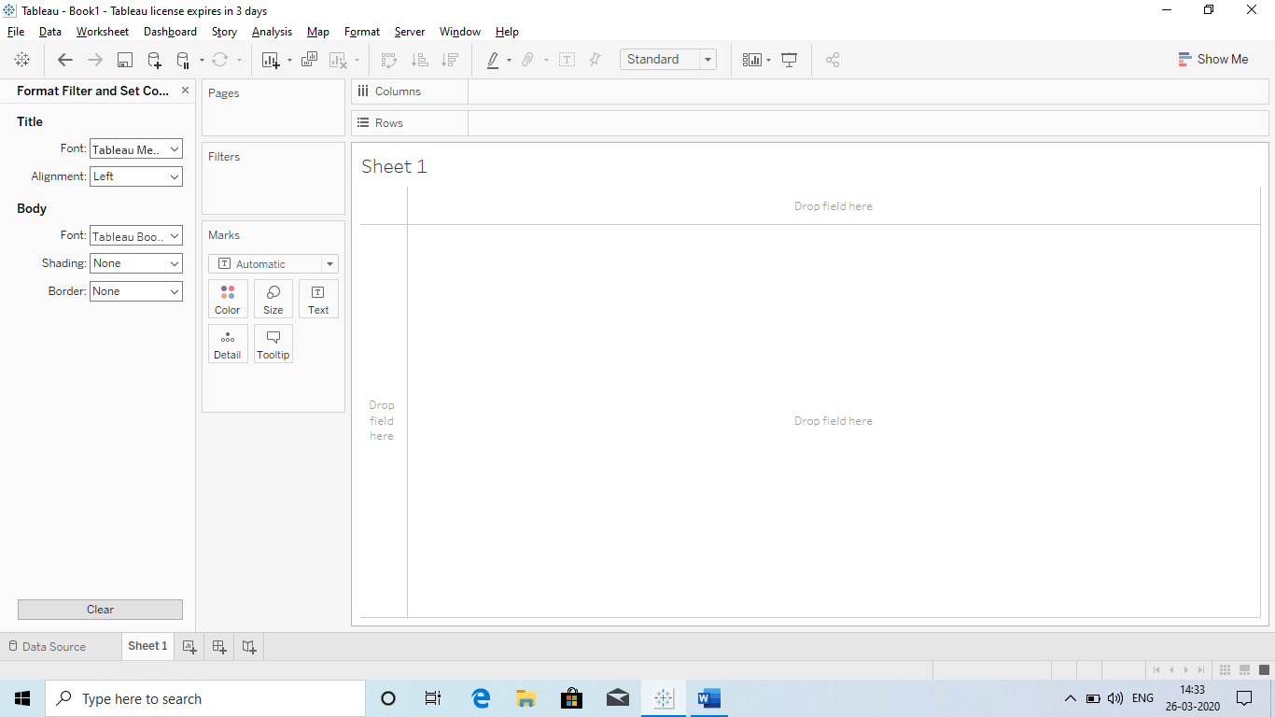

**Under Marks we have 6 things:**

1. **Size**
2. **Colour**
3. **Text**
4. **Detail**
5. **Tooltip**
6. **Shapes**

**Explanation:**

**1) Size: So we can use size to increase and decrease the size of the chart or graph.**

**For ex:**

* **Bar chart:** 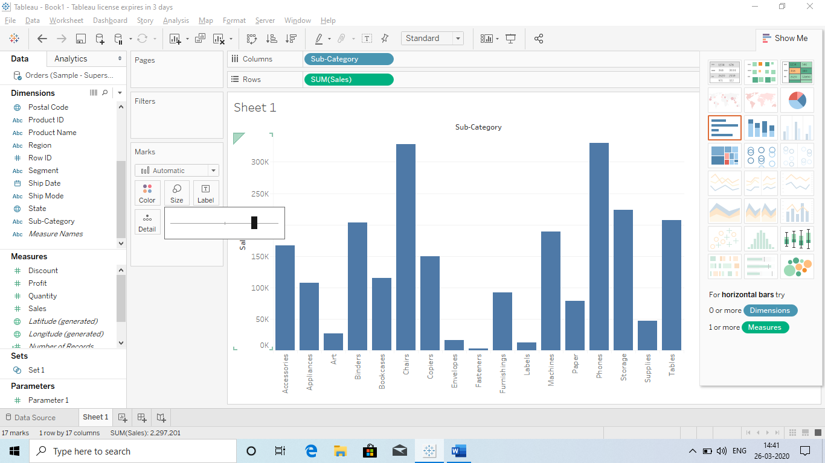
* **Line Chart:** 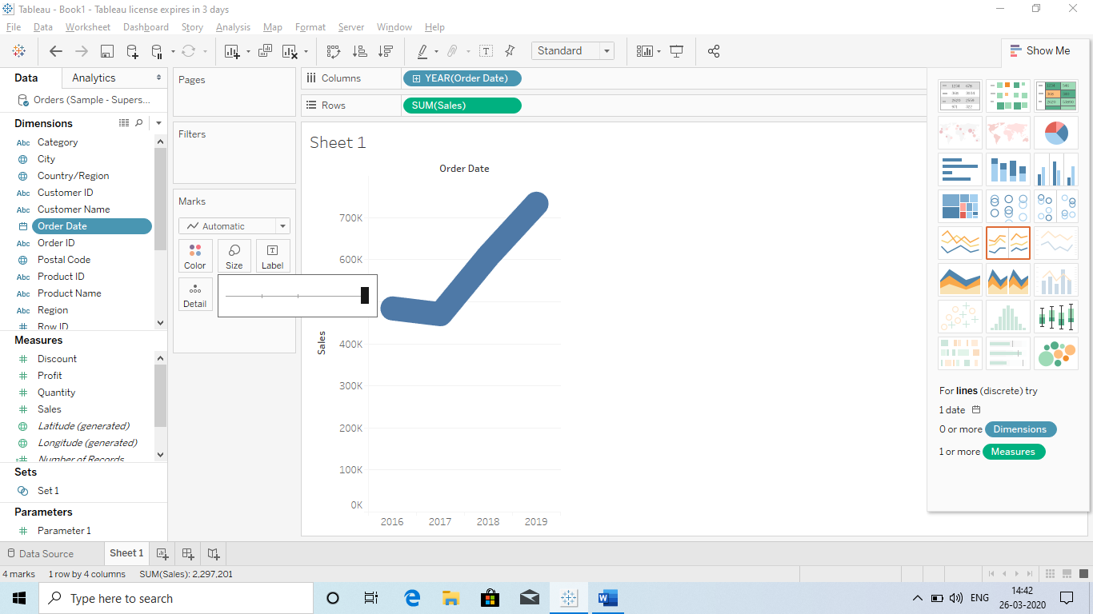
* **Maps:** 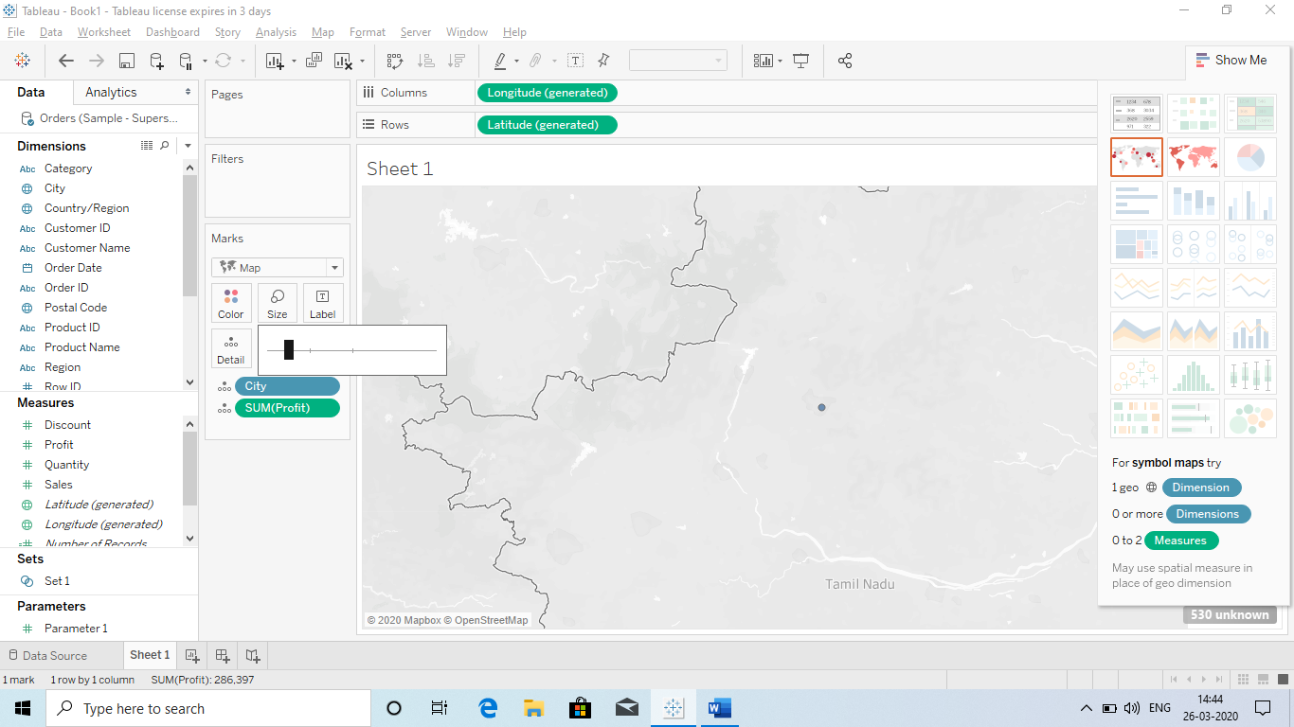
* **Raw chart:** 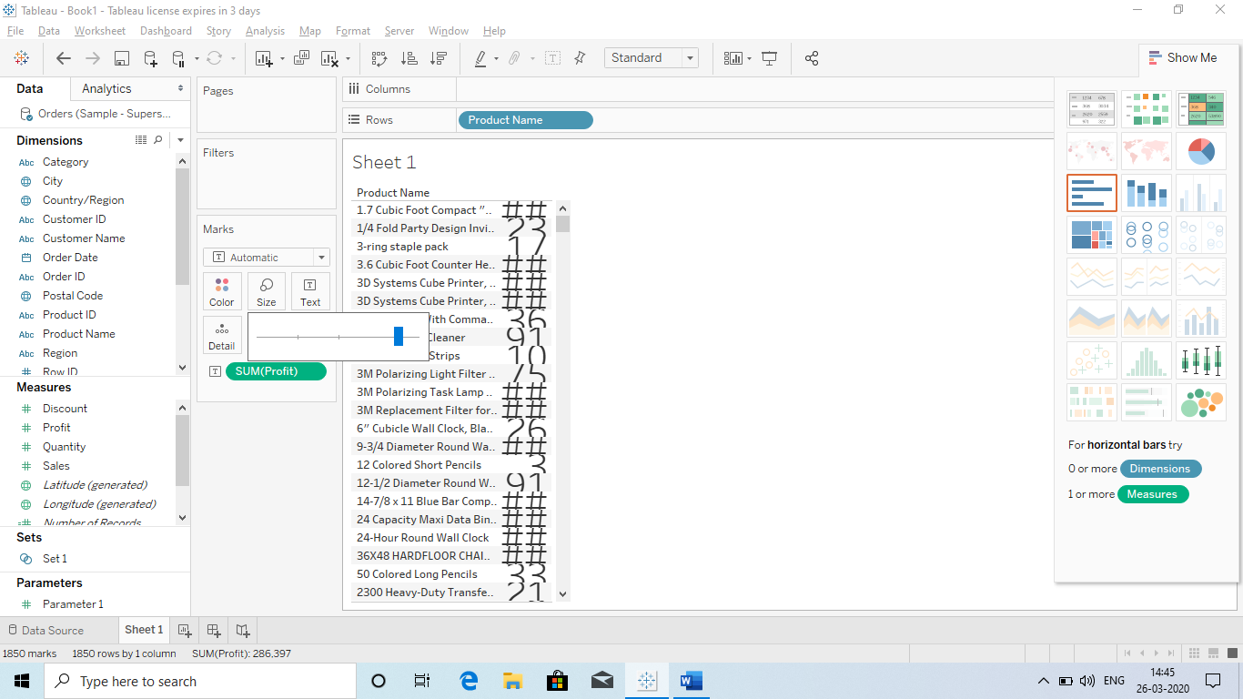

So basically, we can change the size

Or

We can use a category to change the size of the chart according to the category.

**For ex we can change the size of a chart by Dragging the profit in size.** 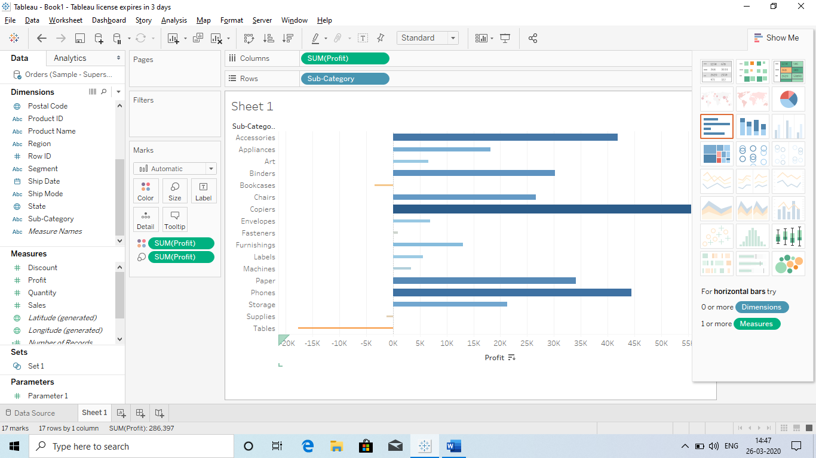

**In the above chart we showing profit by category wise. Size: Profit and colour: Profit.**

1. **Labels:** When ever we create a chart or bargrap, we don’t have the exact value. So do get the exact value, we use lables.
   1. **How to do:** Drag the field into label or Text to get the exact value.

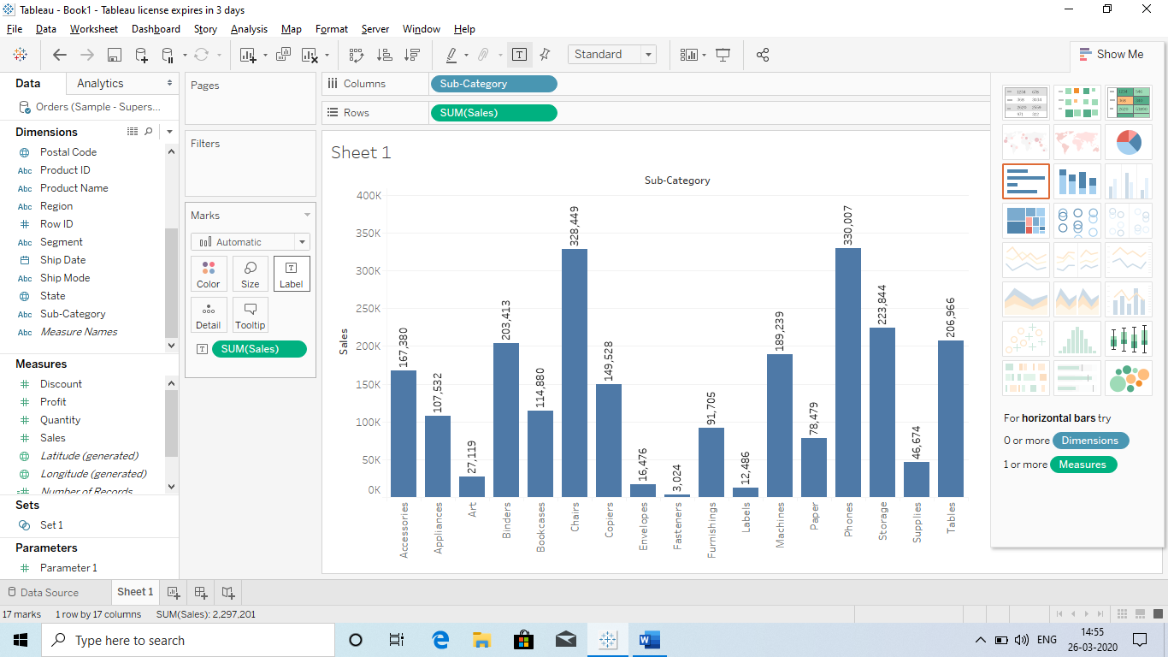

Here we have Dragged the sales to Text so that we will get the exact value.

We can also drag other fields like Profit etc.

**We can also customize the lable by clicking on the label:** 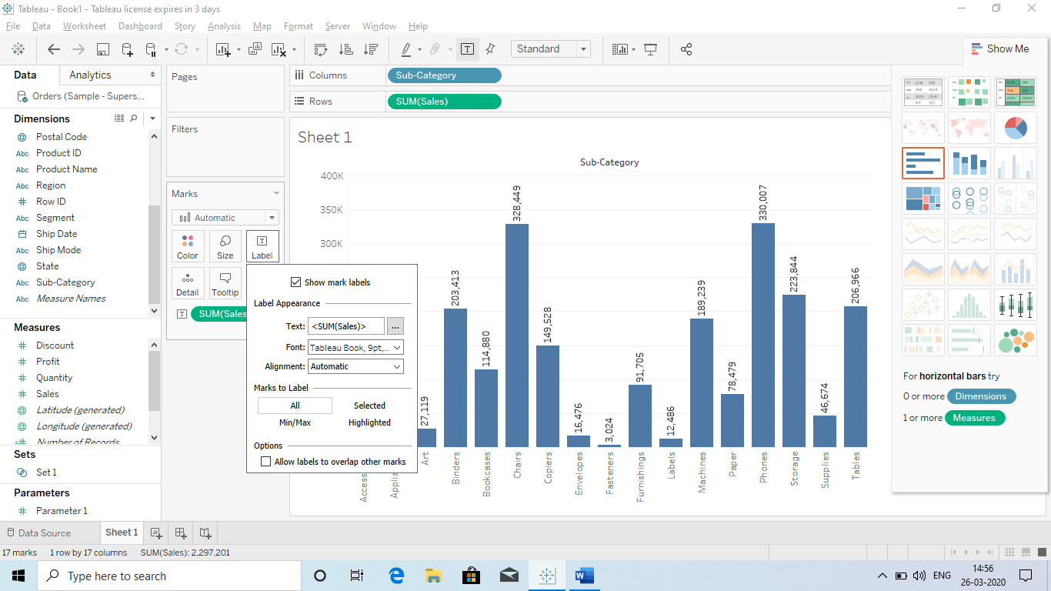

* So we can change the pattern, colour and also write the label header what is the number denoting.
* Like here no is denoting sales.
* **We can also Highlight the Max or Min Bar.** 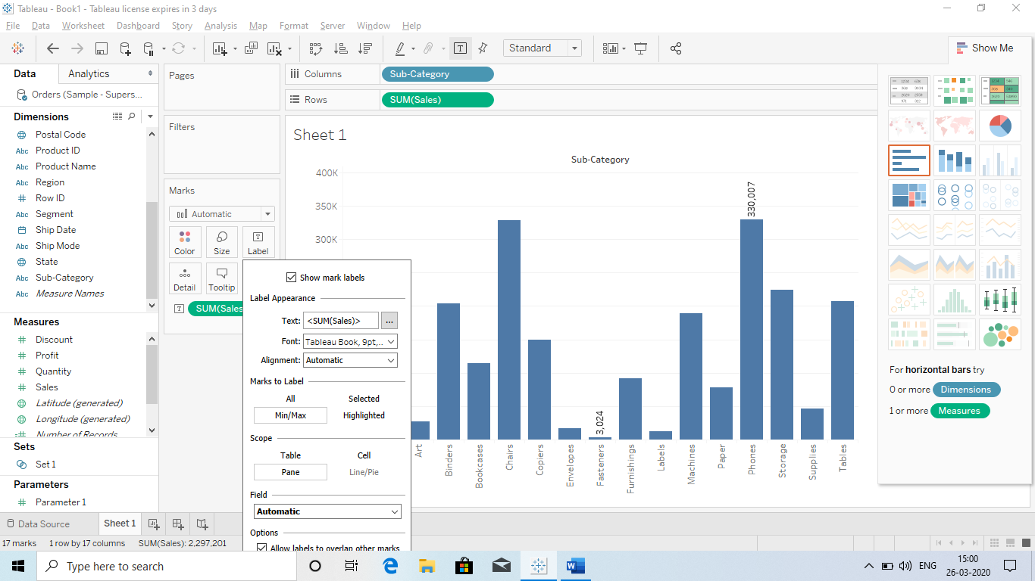

1. **Colour: It basically provide us colours according the fileds enterd.**
   1. **For ex if we draged the profit field than it will show Drag colour to Light colour to show profit.** 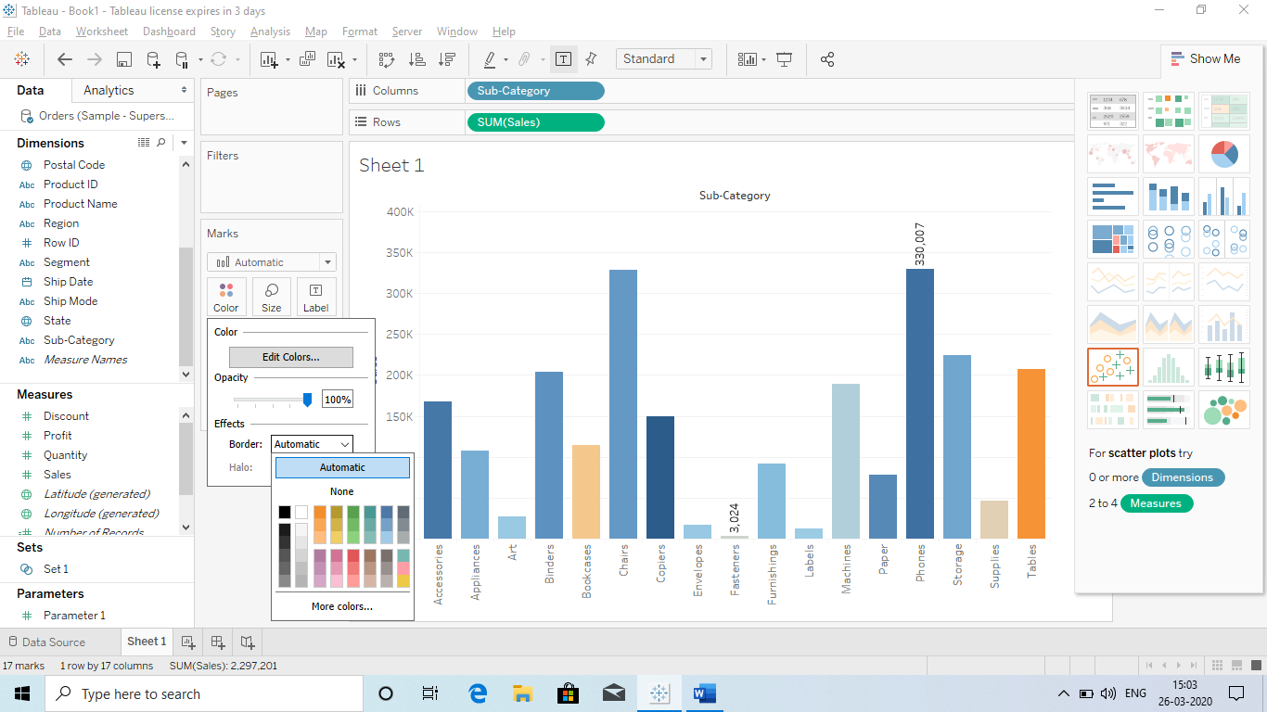
   2. We have use profit and we can also customize it according to our need.
2. **Tooltip: When we click on a bar then it will show the detail of that Bar, which is called tooltip.**
   1. 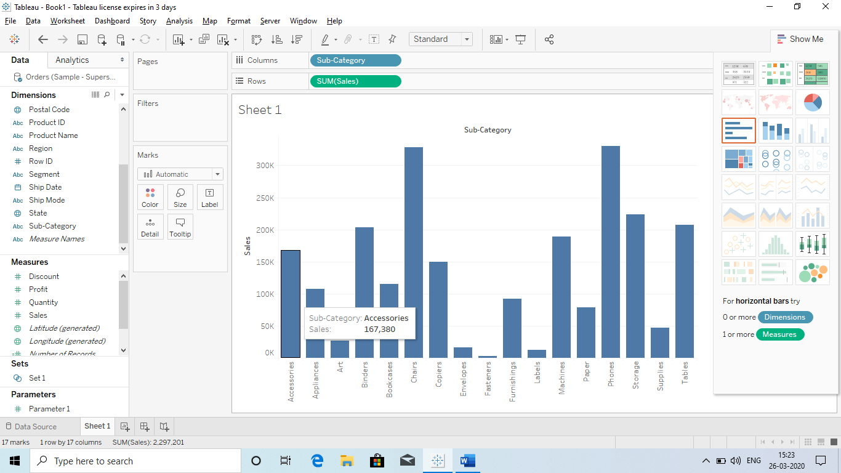
   2. **When we want to add Tooltip we can do it by Draging that field in tooltip.**
      1. **For ex : Profit and quantity:**

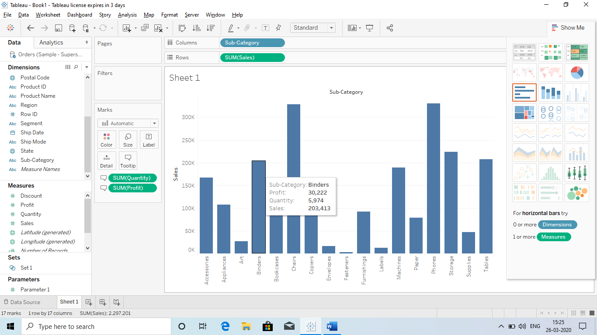

1. **Shape: It is not present by default, we have use a scatterd chart by draging 2 fields like “Sales and Profit”.**
   1. **Now we need to change the shape of that chart: This is an easy step, we just need to drag a category to the shapes and shapes will be assigned:** 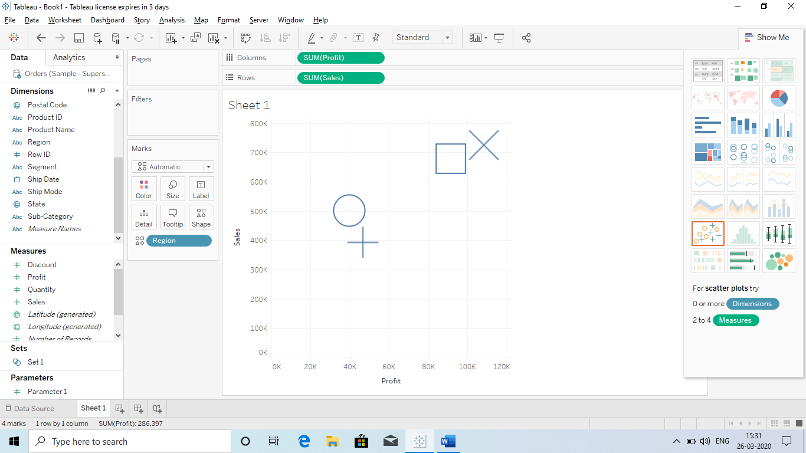
   2. **Can we change or assign a shape or change the shape:**
      1. Yes we can by clicking on the shape: 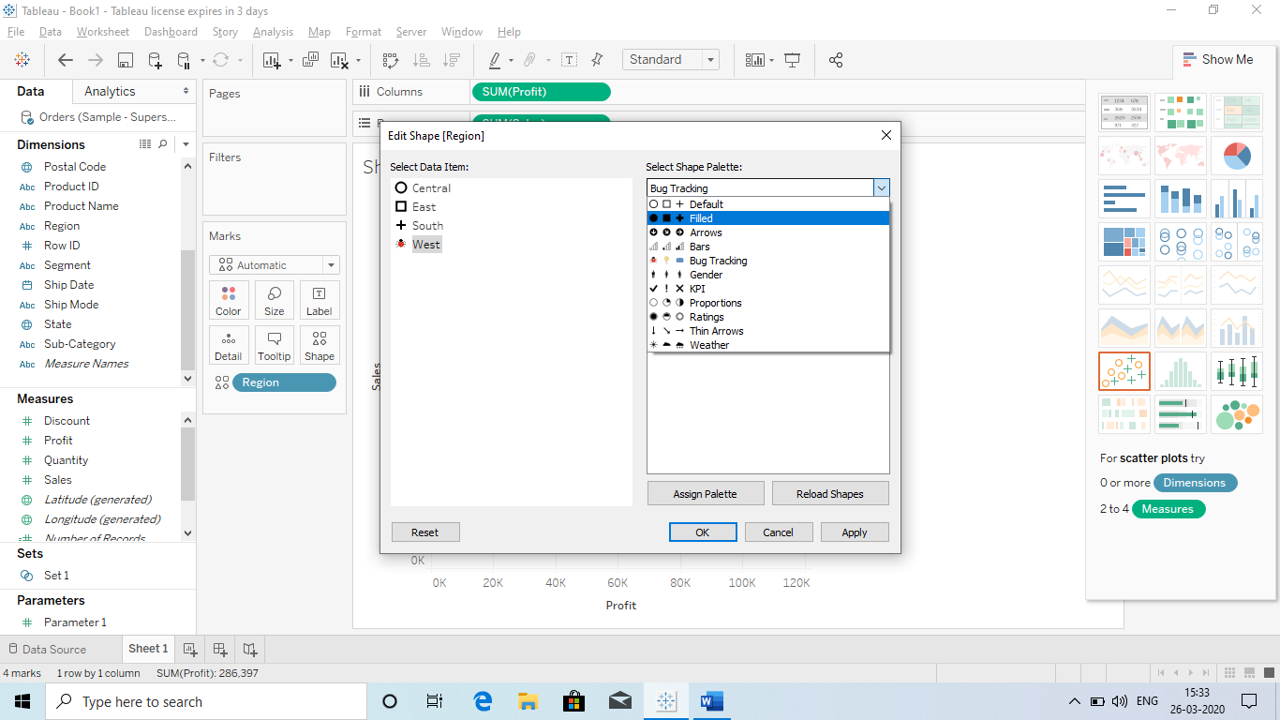
   3. Can we use our on shapes by downloading since there are only limited option available:
      1. Yes we can by below steps
         1. Download a zip file and extract all the folders
         2. Copy those folder and go to **Documents**
         3. **Click on Tableau Repository**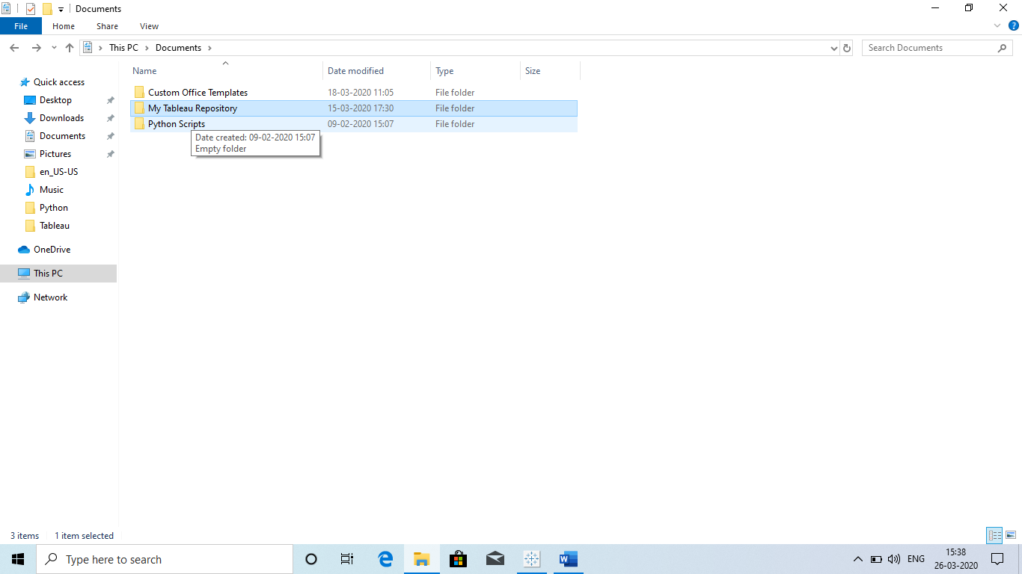
         4. **Click on Shapes:** 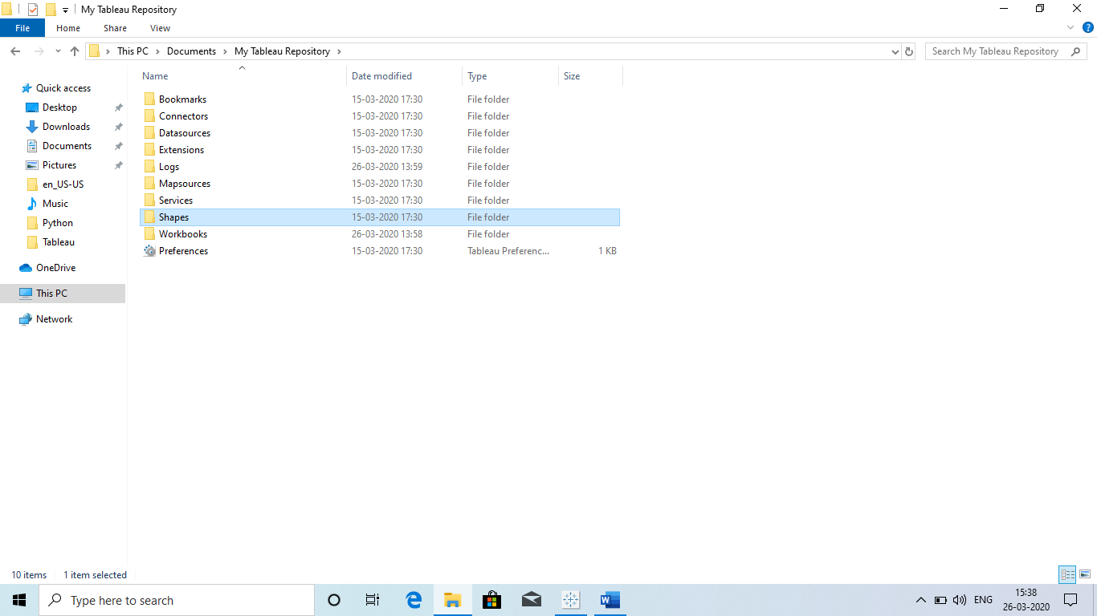
         5. **Paste their and restart the tablue.**
2. **Detail: It is similar to colours as we get Different colour, here we get different “Sections”.** 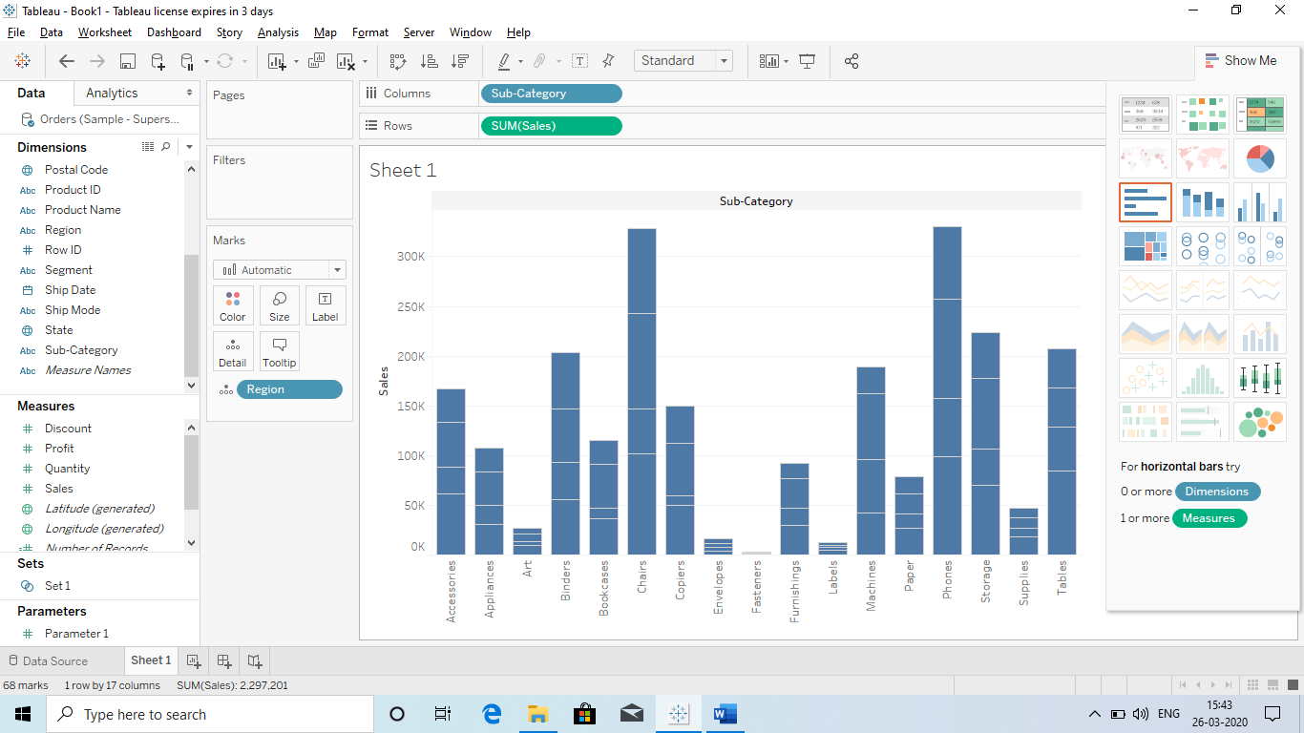

**Like in colour:**

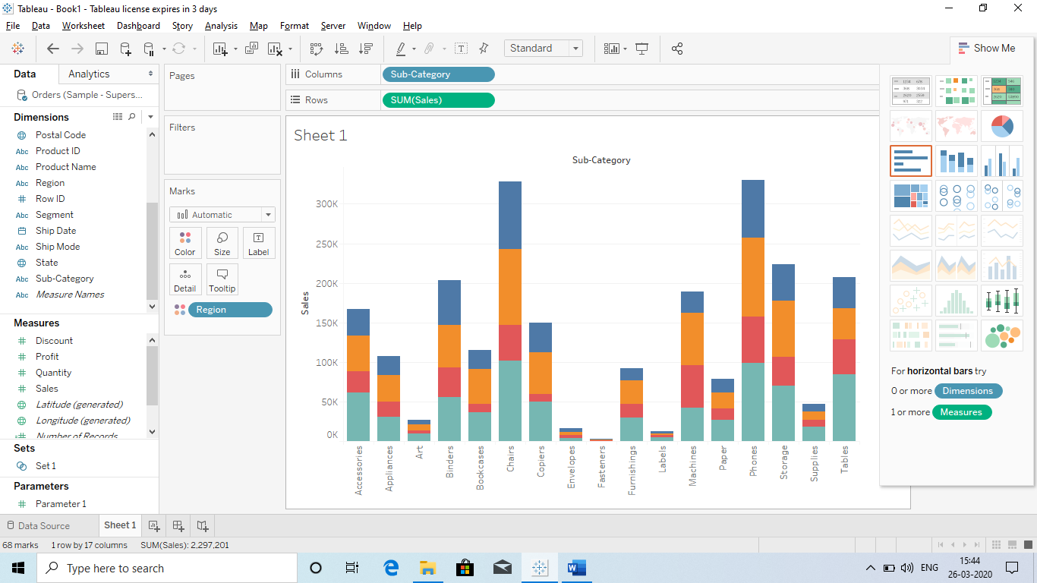

**Q) Formatting:**

* **Font**
* **Aligment**
* **Shading**
* **Borders**
* **Title**
* **Caption**

1. **Font: So we can change the font of the worksheet and report as per our requirment.**
   1. **We can do it b**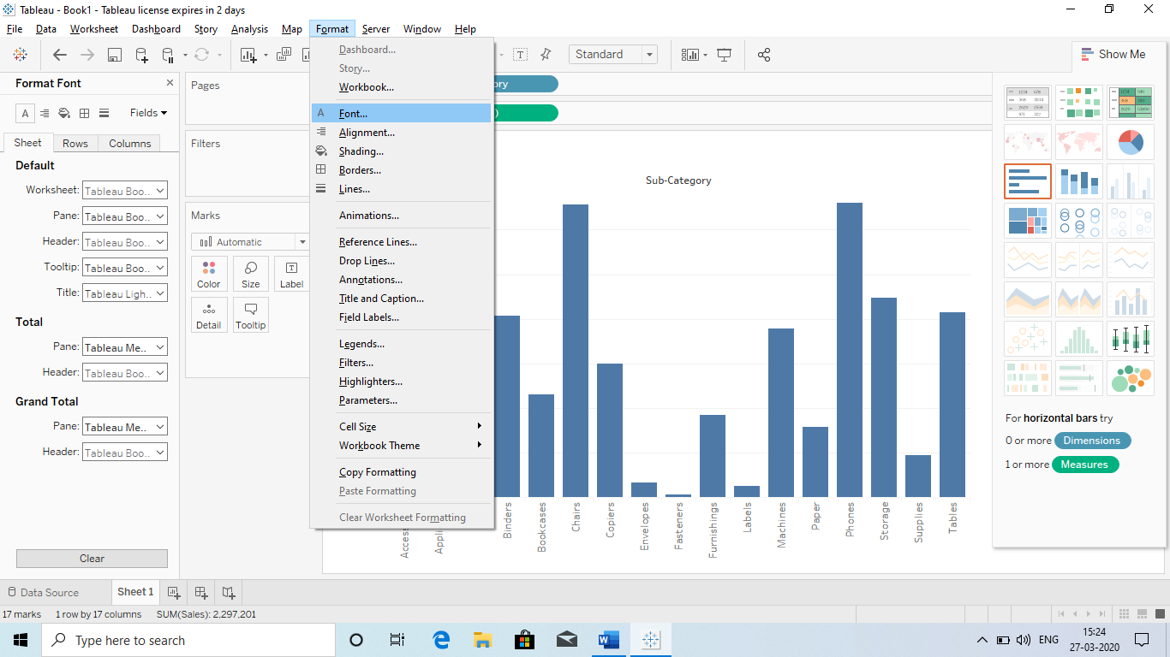

Font

* 1. **The Headers which are in bold : repesent the changes.**
  2. **We can remove this by the “CLEAR” option at the bottom.**
  3. **We will get Total or Grand total from : Analysis – Total – Total or Grand Total.**
  4. **Also we can change the font of a single slide:** 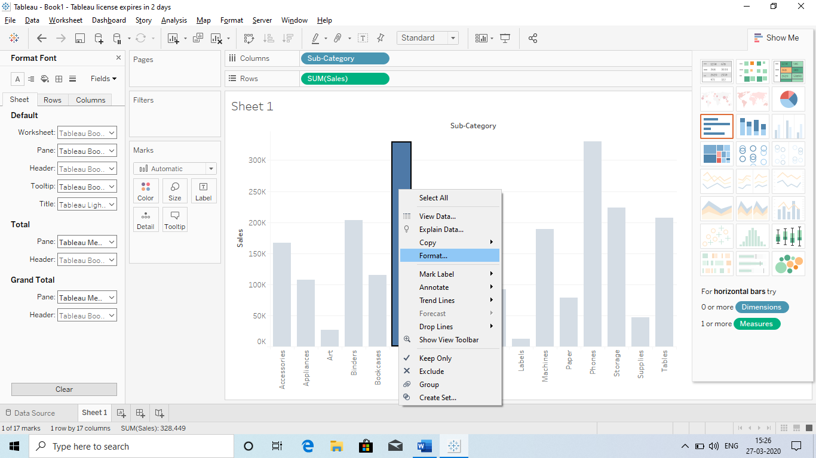

1. **Font**
2. **Aligment**
3. **Shading**
4. **Borders**
5. **Title**
6. **Caption**

**2.Alligment: We can change the alligment of Header, Pane (Numbers).** 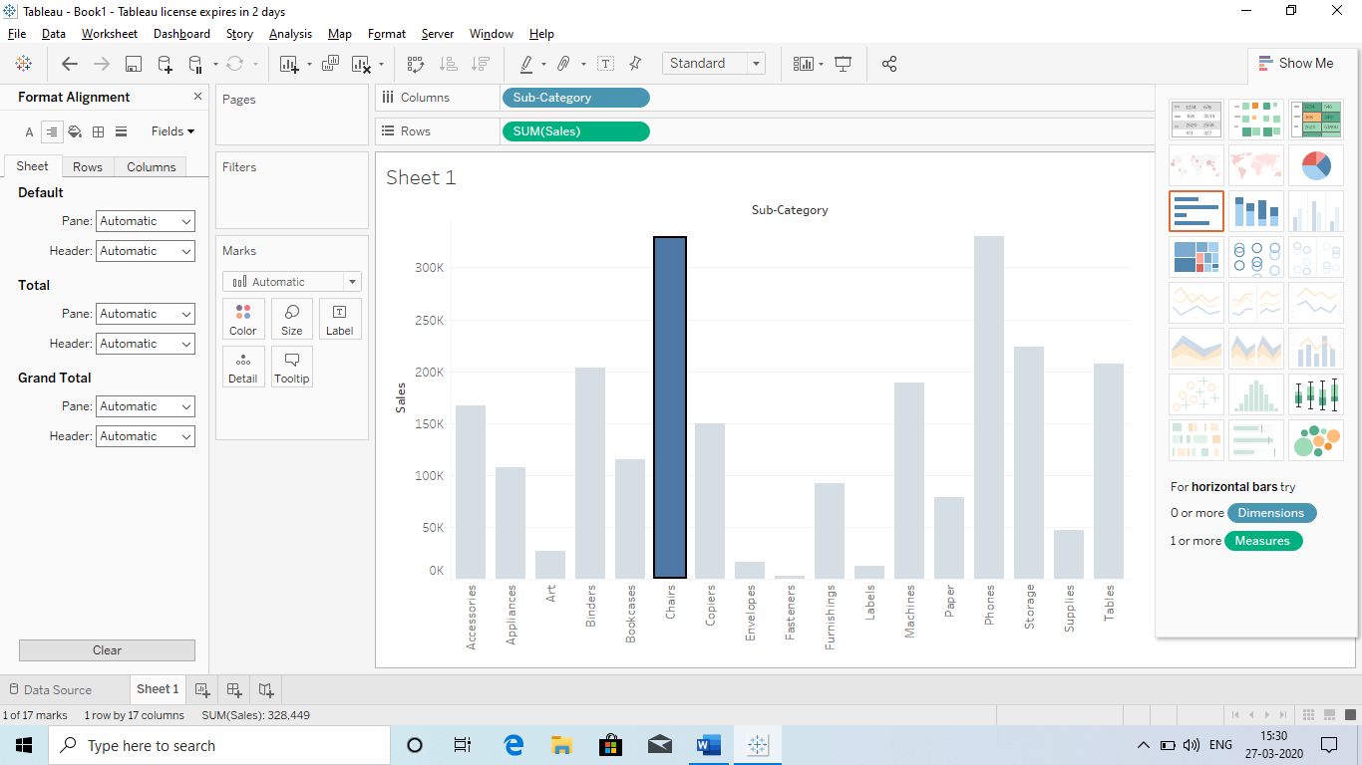

Alligment

* **Font**
* **Aligment**
* **Shading**
* **Borders**
* **Title**
* **Caption**

**3.Shading: Same here we have to go to Formati – Font:**

**a.We have 3 options: Sheet, Rows, Columns (If we choose sheet then this will apply the shades to the Rows and Column however if there are specific colour than we can also apply specifically by them.** 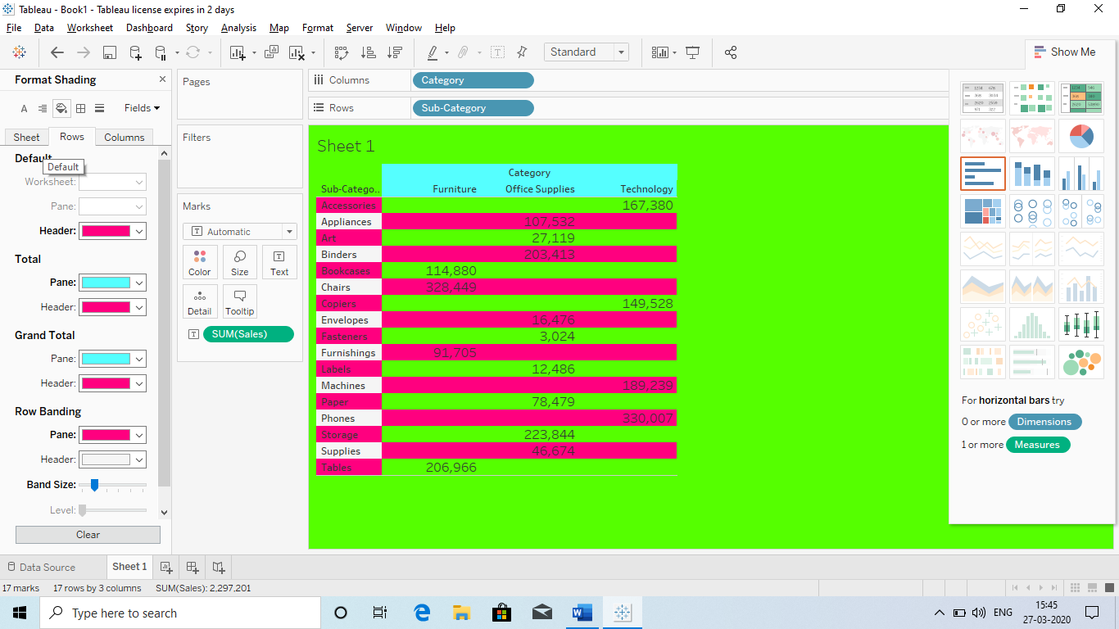

* **Font**
* **Aligment**
* **Shading**
* **Borders**
* **Title**
* **Caption**

**4.Boarders: Same we can also change the boarders of the chart or report.** 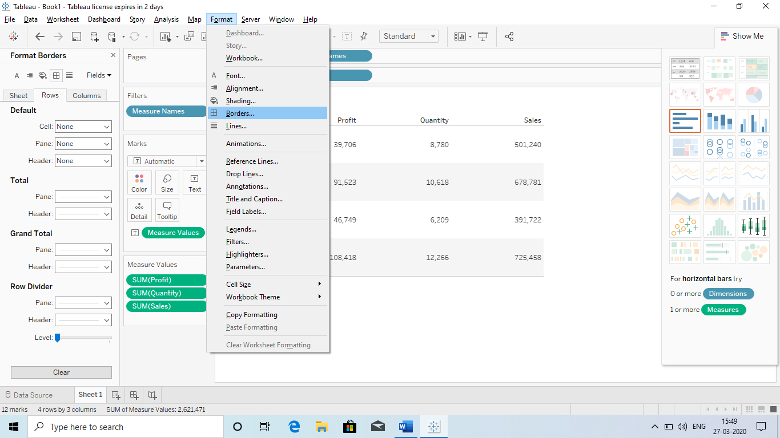

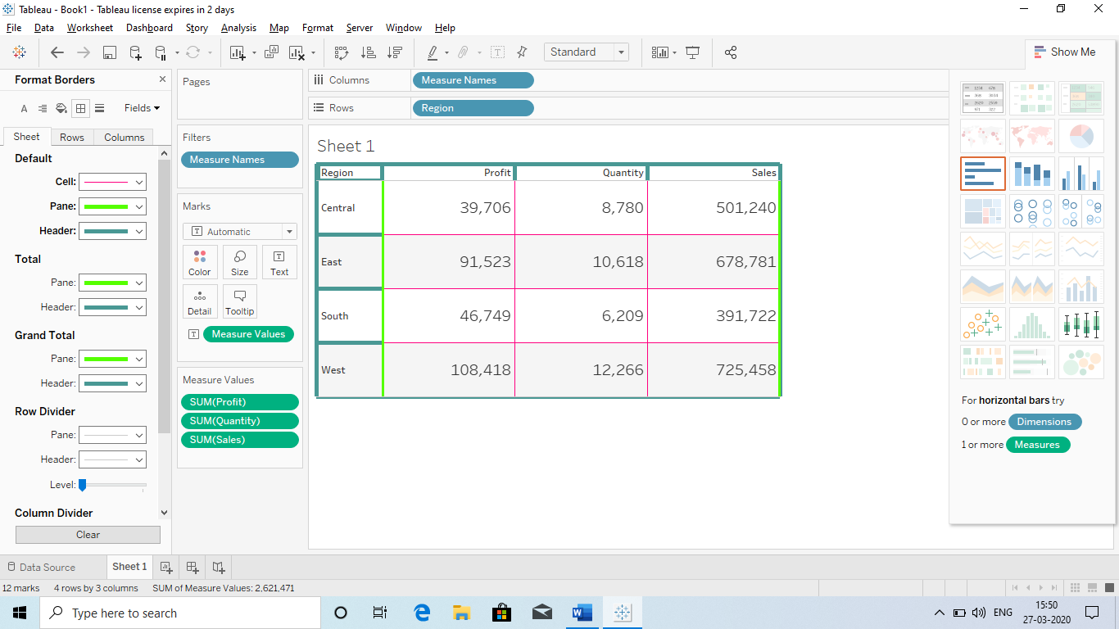

**Q) Creating Calculated Columns: As we have some inbuild functions in Excel, same we have in the Tableau in calculated columns.**

* **Some time we do not have some fields which we require.**
* **For ex: In the current excel sheet we have Profit and Sales however we do not have COST.**
* **For getting a COST field we need Calculated Columns**
* **How to get Calculated fields:**
  + **We just have to select sny field in the Measures – create – Calculated Columns** 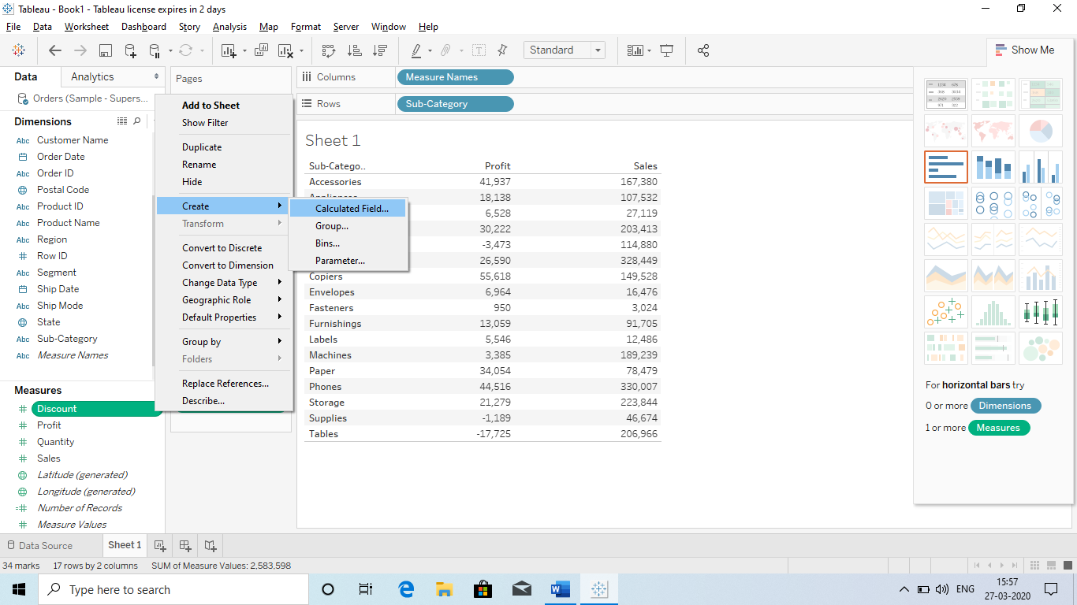
  + **Creating a COST :** 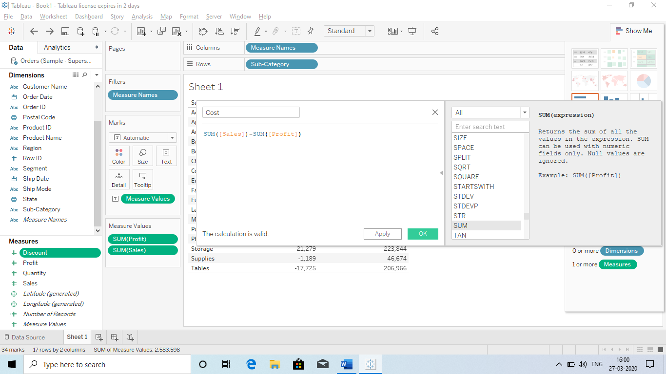
  + **Applying: A new Measure will be added : Cost and sign : “=#”**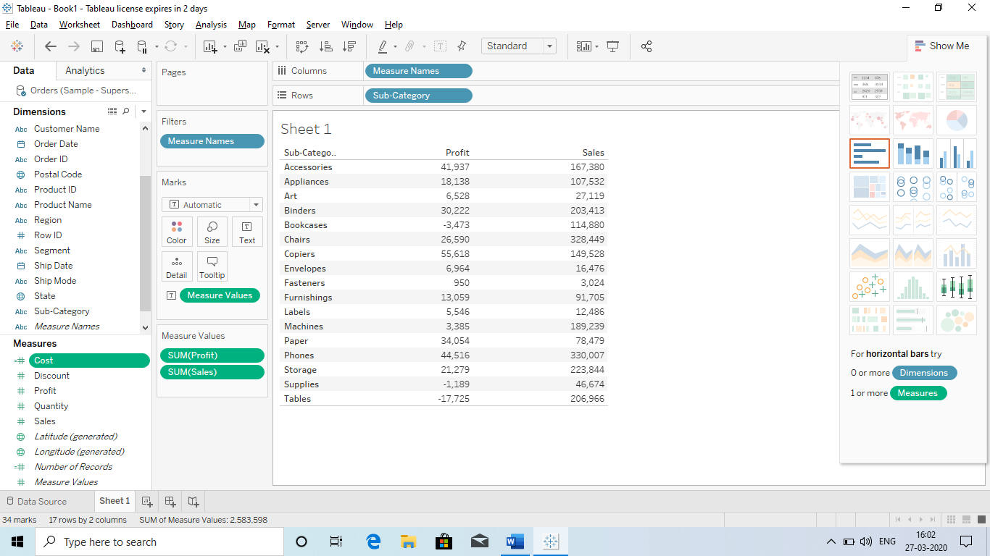
  + **Now Drag this to Pane:** 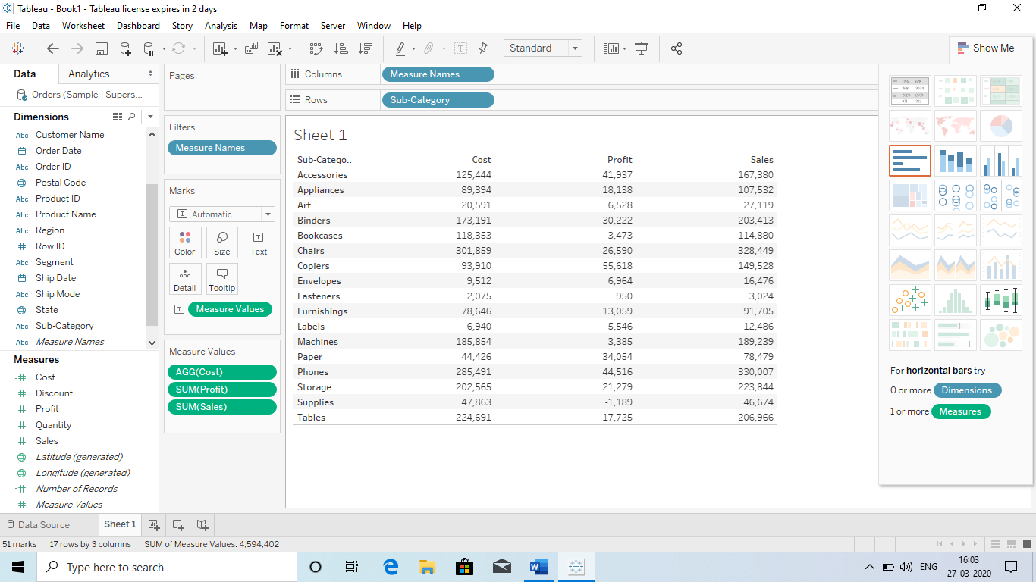

**This how we create a Calculated Field.**

**Q) What is Aggregate Measure: This help us in providing the Minimum and Maximum value with all the details in a report. Ex:**

**Here we have taken Product and their sales:**

**First we are getting the total sales of the product**

**Than we have bifurcated it with the help of Aggregate function.**

**Now it is showing how many times the product has been sold and what is Max and Min value.**

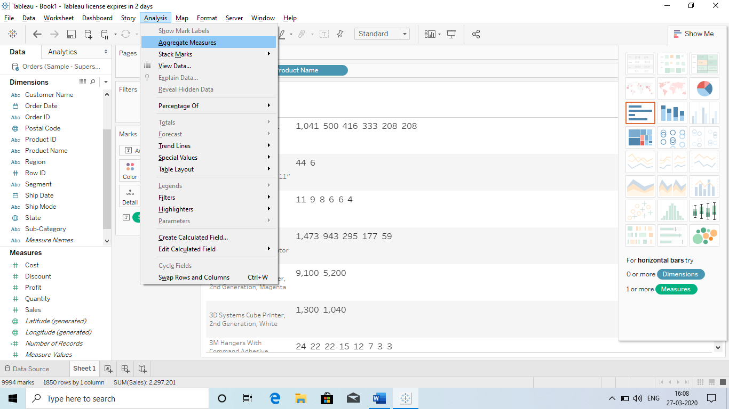

Min

MAX

**Q) However we can also do it with Calculated Field and get Max and Min?**

**Ans Use Calculated field and use formula:**

**Min(Sales) and Max(Sales)**

**Q) What is Ceiling?**

**Ans This Formula help us to Rounddown the value:or that we need numbers in Decimal Format: So go the Marks – sales – format and number – custom numbers – decimal select – select outside.** 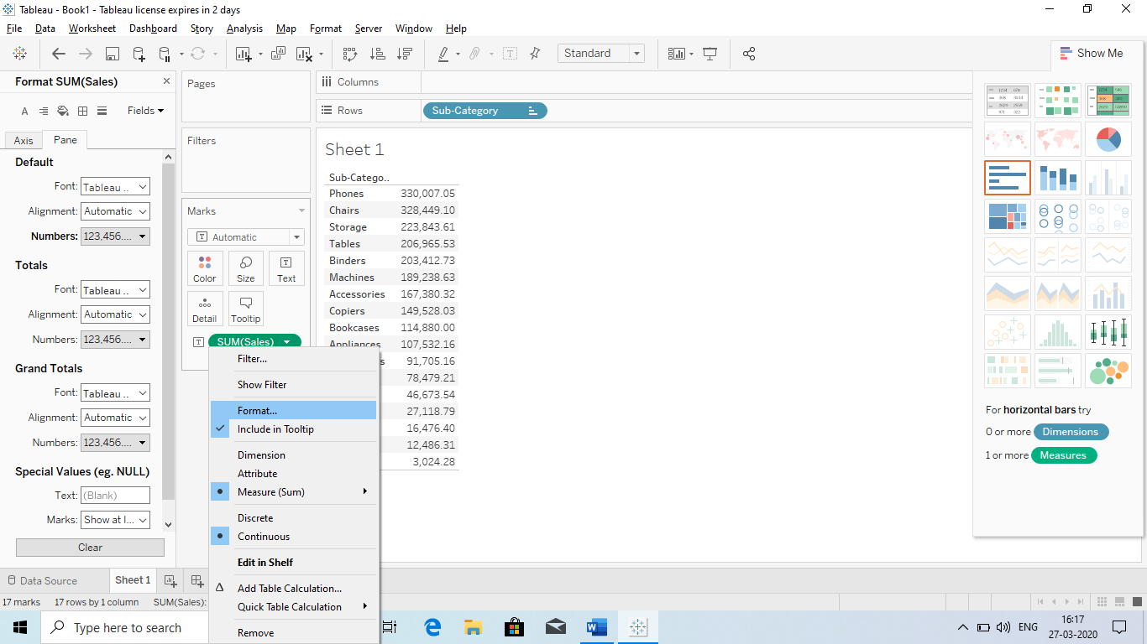

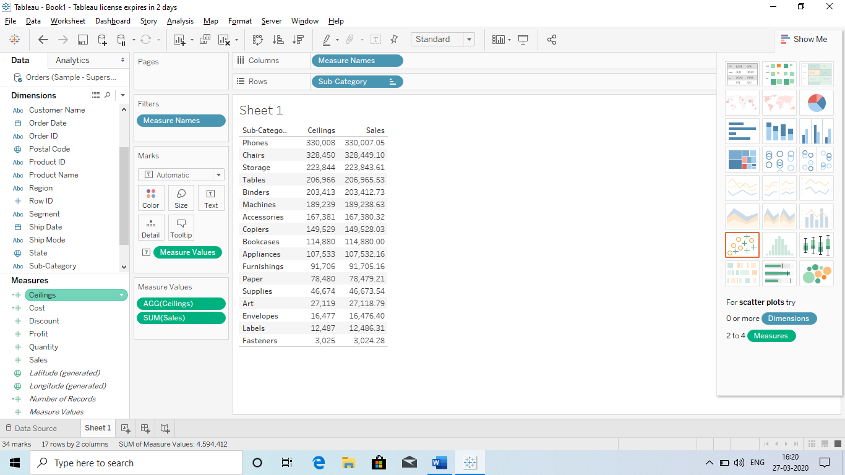

**Q) What is Floor?**

**Ans It is same as Ceiling however in ceiling a Roundup number is provided and in Floor we get Rounddown number.**

**Q) Number function?**

**Ans Min, Max, Ceiling, Floor etc**

**Q) String function?**

**Ans Upper, Lower, Proper, Left, Right, Mid**

**Split: It will help to Split the Data in the reporting.** 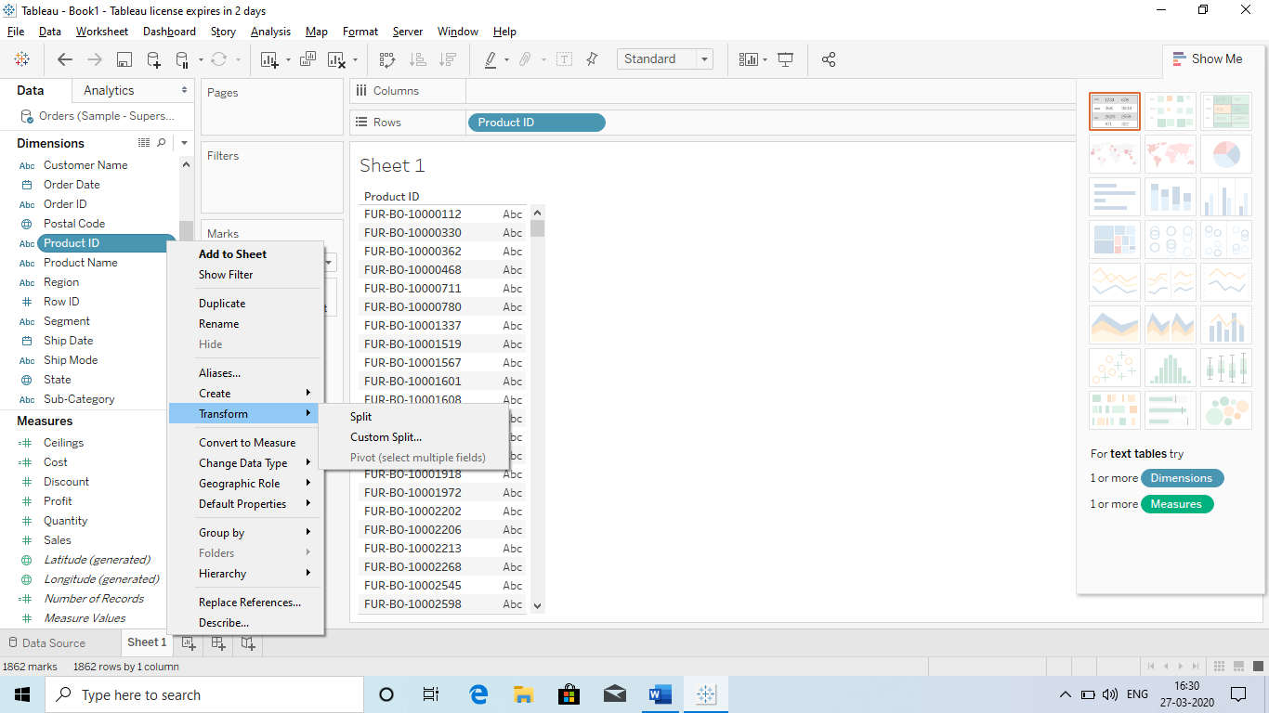

**Q) Calculations: We have 2 type of calculations:**

1. **Database calculations**
2. **Table calculations: It is shown in the form of**

**1.Database calculations: It means the calculations we are doing with our database.**

**Ex: Max, Min, ceiling, float etc.**

**2.Table Calculations: It means the when create a report, with the result of that report we are performing some calculations.**

**Ex: If we take region wise sales: Table chart (with that table chart we are calculating the % of every region. This is called Table calculations.**

**Q) What is QUICK TABLE CALCULATION? WHERE DO WE FIND IT AND WHEN WE NEED IT?ANS It basically help us to get the Percentage, Rank, percentile, difference etc.**

* Percentage calculations.

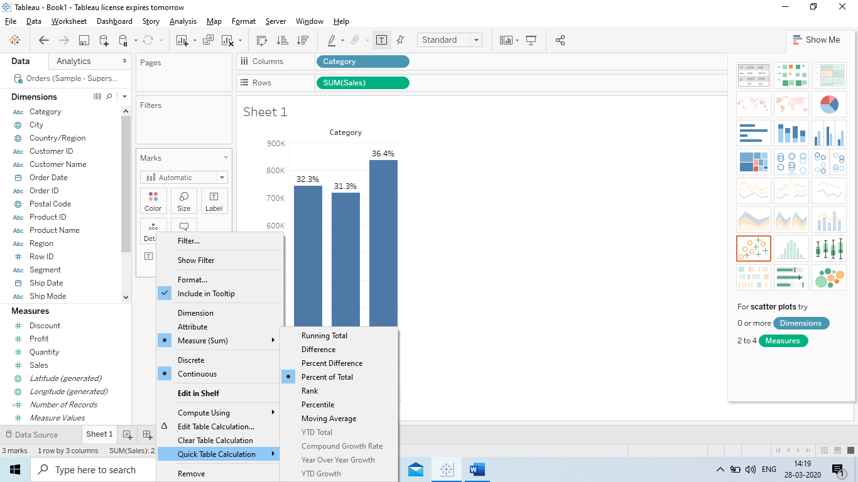

* Table Calculations:
* Here we have taken Column : Order date, Row : 2 times sales (To get 2 Graphs)
* Then Draged Sales to the Label. (However the question is how do we get label in both)
* Ans We have 2 Marks for Sales and we have drag the sales in both labels.

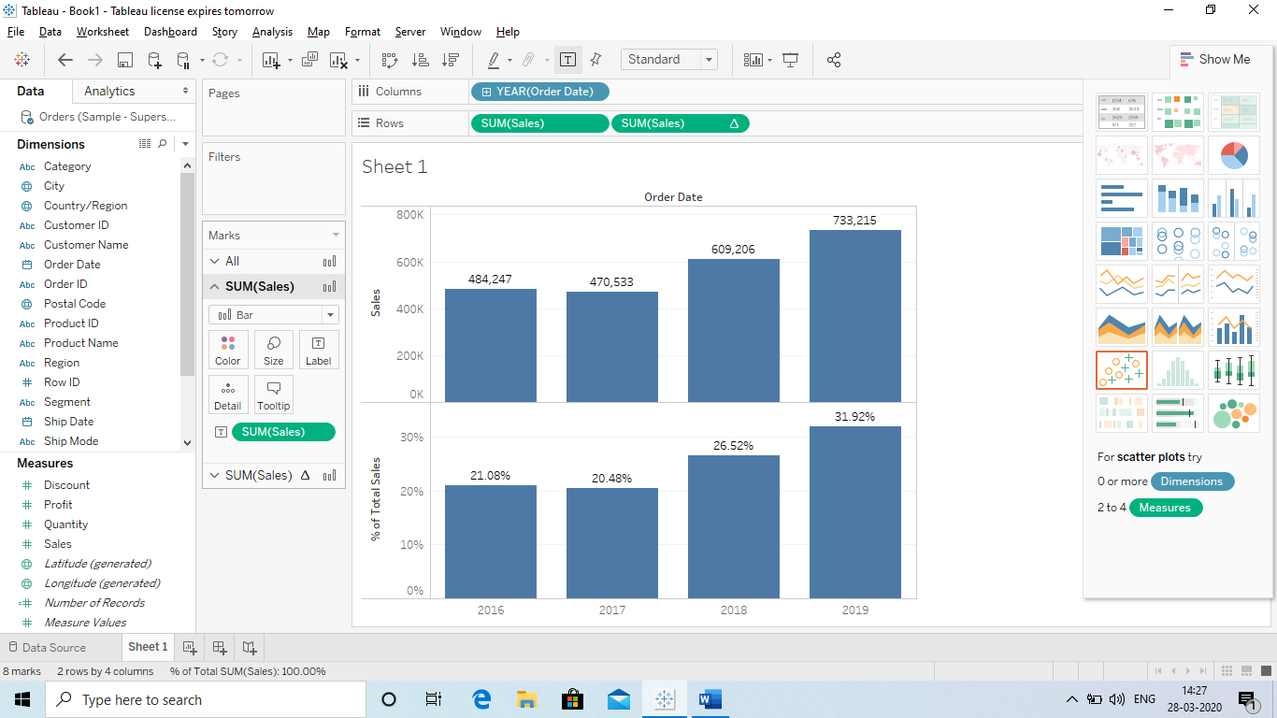

* Cross Tab: It is basically getting the Sub total and Total in a Table format for 2 categories against sales.
* How to do: Column: Cat and Sub Cat, Rows: Sales or Label
* Covert it into % by Quick Table Caluclation
* Analyses – Total – Grand Total
* Analyses – Total – Add all Sub Total 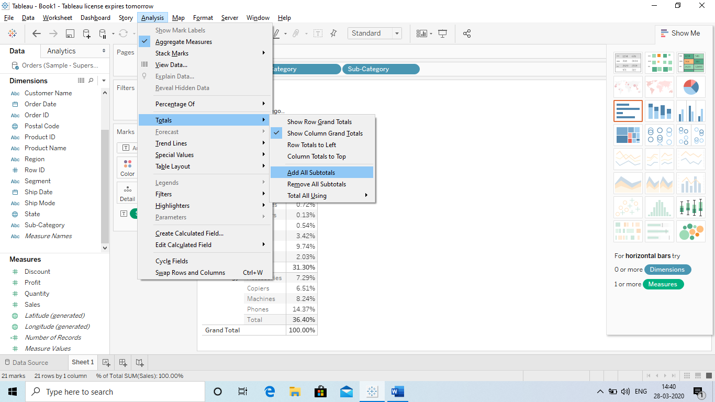

Add all sub total

Grand Total

Q) How to differnciate or Running Total:

* Running total means We are getting the total of ever row added.
* Below we are getting Month wise sales.
* Rows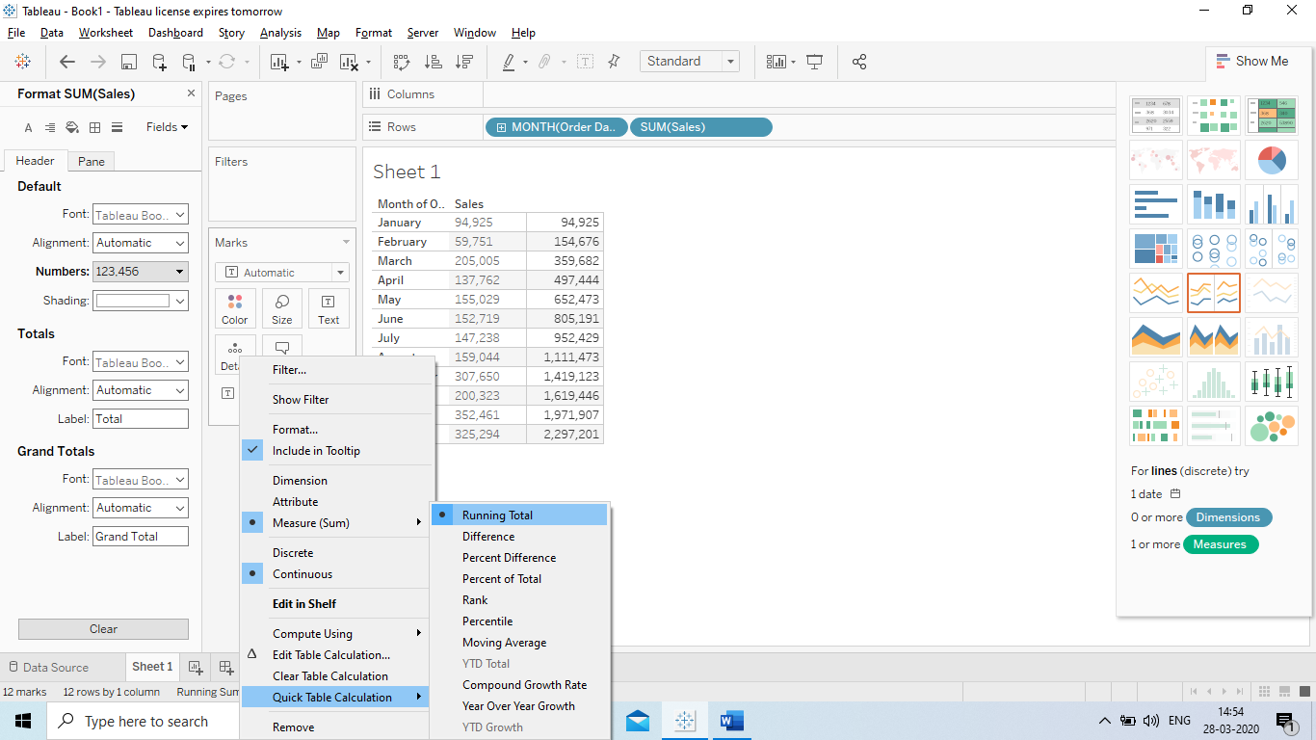 : Order date and expand the year and quarter to month and removed both.

Here we are getting total of Sales for every Row

* Taken sales in Label and than sales in Column. (Convert it in Discrete)
* Now go to – Quick calculation – Runnning total.

**Q) Compute Using? ***Very important in Table view using Analysis.**

Ans It means instead of getting the % as per the Grand Total, we want to get the total% of a Sub cat in a categories.

We can change our report as per our need : If we need Column wise, Row wise, Table wise, Total etc.

For Category : A,b

Sub Categories : 1,2,3

1 = 20% | 1 = 40%

Instead of using the % as per Grand Total, we are doing it Category wise.

2= 40% | 2 = 30%

3 = 40% | 3 = 30%

A= 100% | B = 100%

* It is by default selected as **Table Down**
* We have to select Sub Catogery wise.

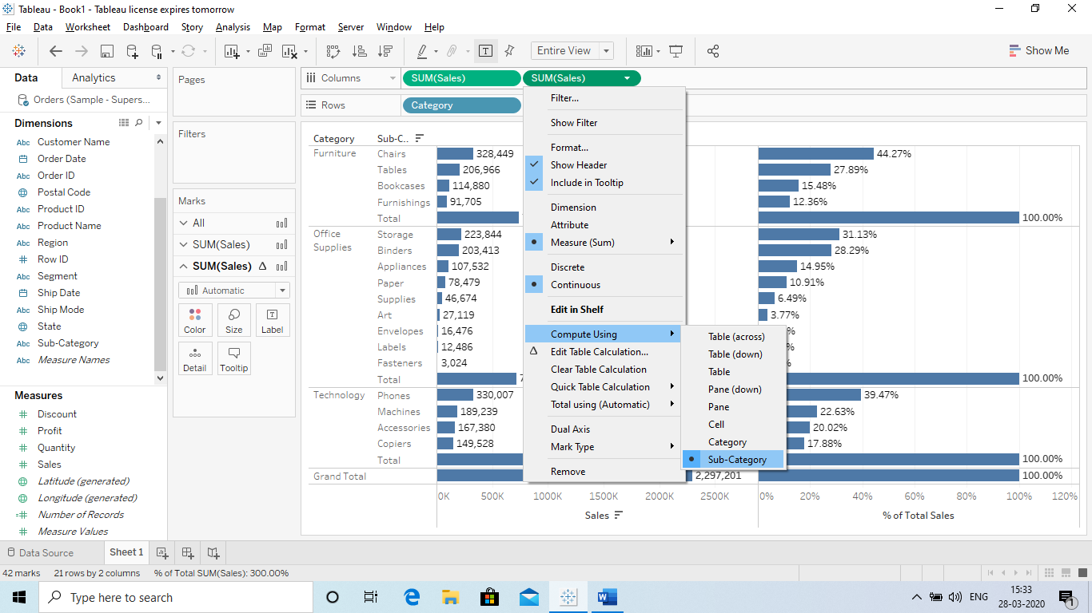

**Q) Conditional Formating?**

**Ans So in Tableau it is done with the help of 2 Formulas: INDEX AND LAST**

**\*\*\*\*\*PLEASE CONVERT THE REPORT IN DESCENDING ORDER**

**\*\*\*\*\*Also use Discrete for Index and Last**

**\*\*\*\*\*We will cretae everything with Calculated Field (Index is used as a Sr.no from 1 to 10 and last 10 to 1).**

**Top**

* **Basically Index will provide a series(Sr no.) from 1 to n times and we will Drag that in the report and make a calculated field stating that (Index >=10), it means we will get the first 10.** 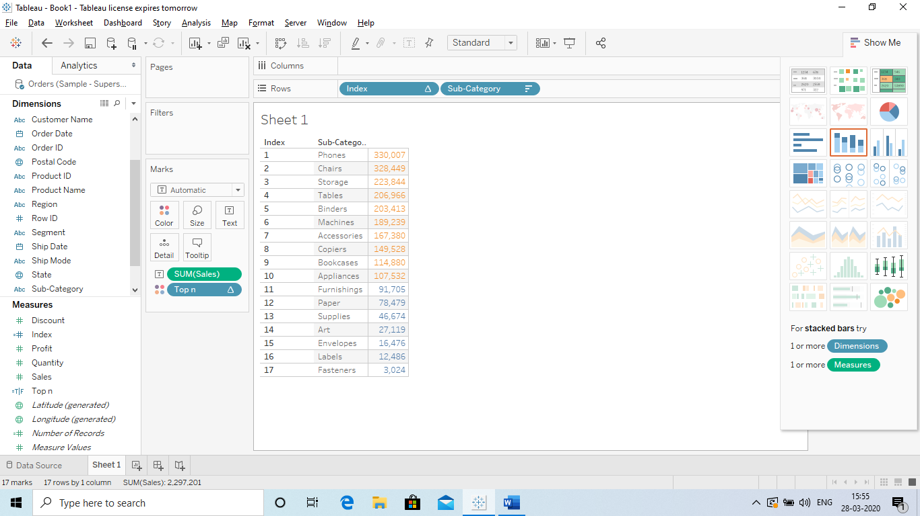

**Bottom**

* **Same as Index here we have to use LAST, Last will give us the Series of Number starting from last (1 to n). Then we have to use Last<=5.** 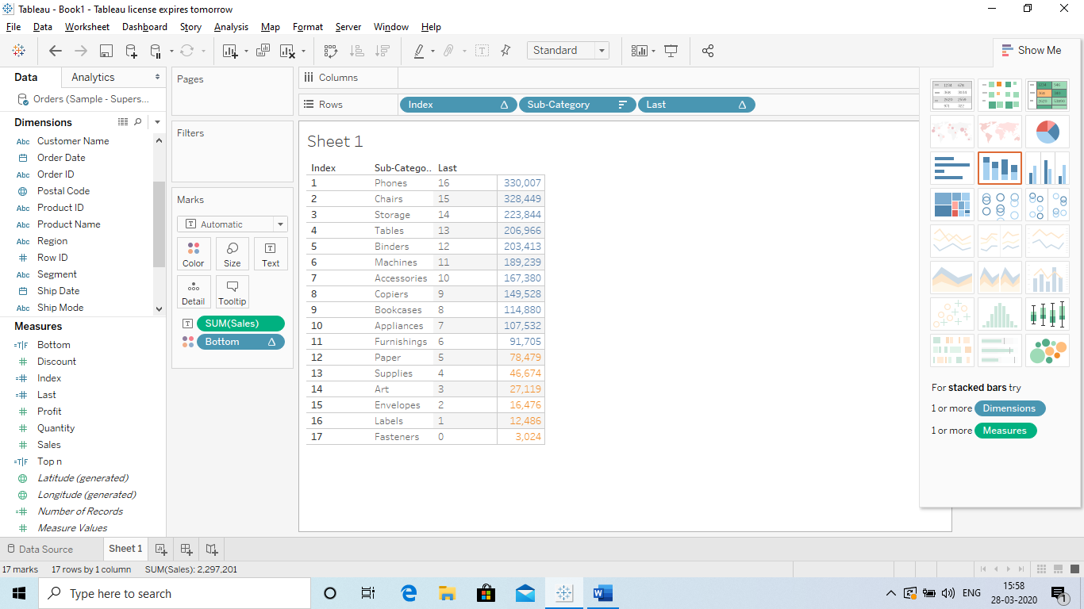

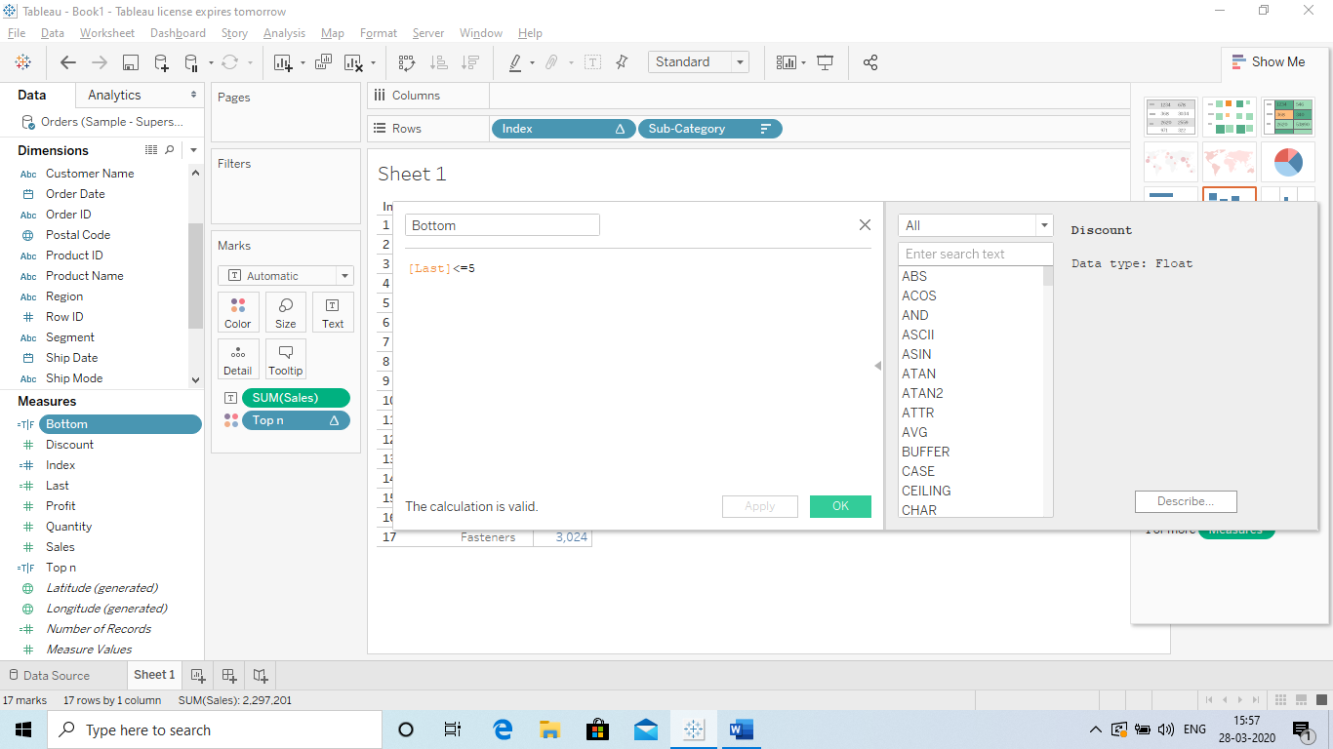

**Top and Bottom**

* **For that we have create a new calculated field called Top and Bottom.**
* **Index<5 and Last<5. ( we will get top and bottom)**
* 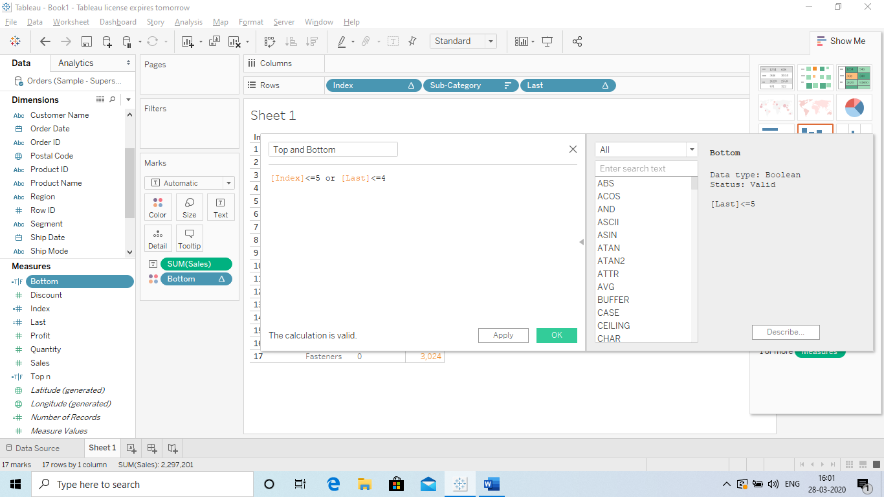

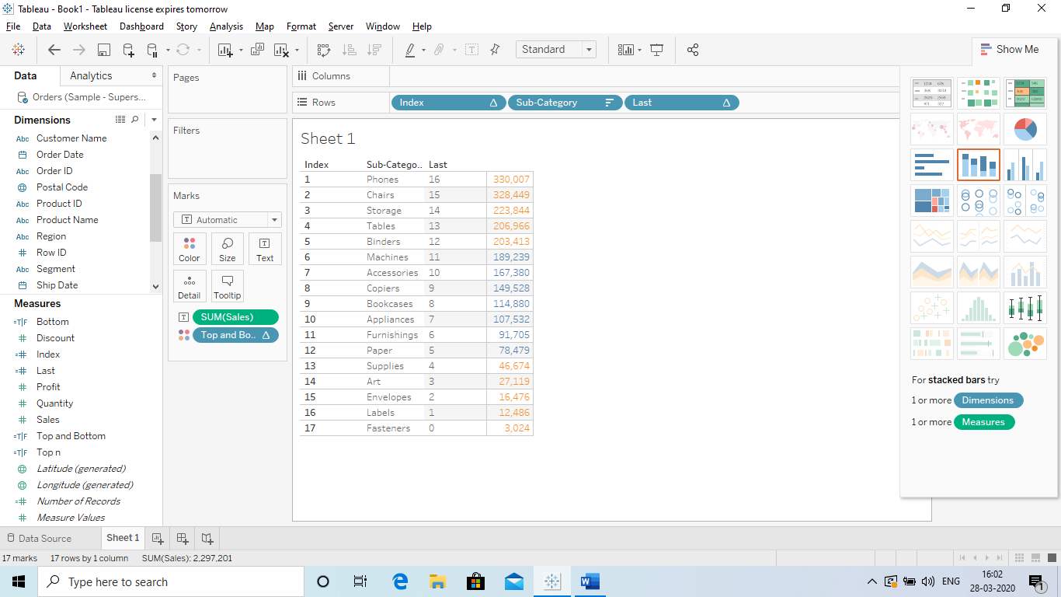

**We can also Hide INDEX and LAST so that the user cant see that by removing the SHOW HEADER.** 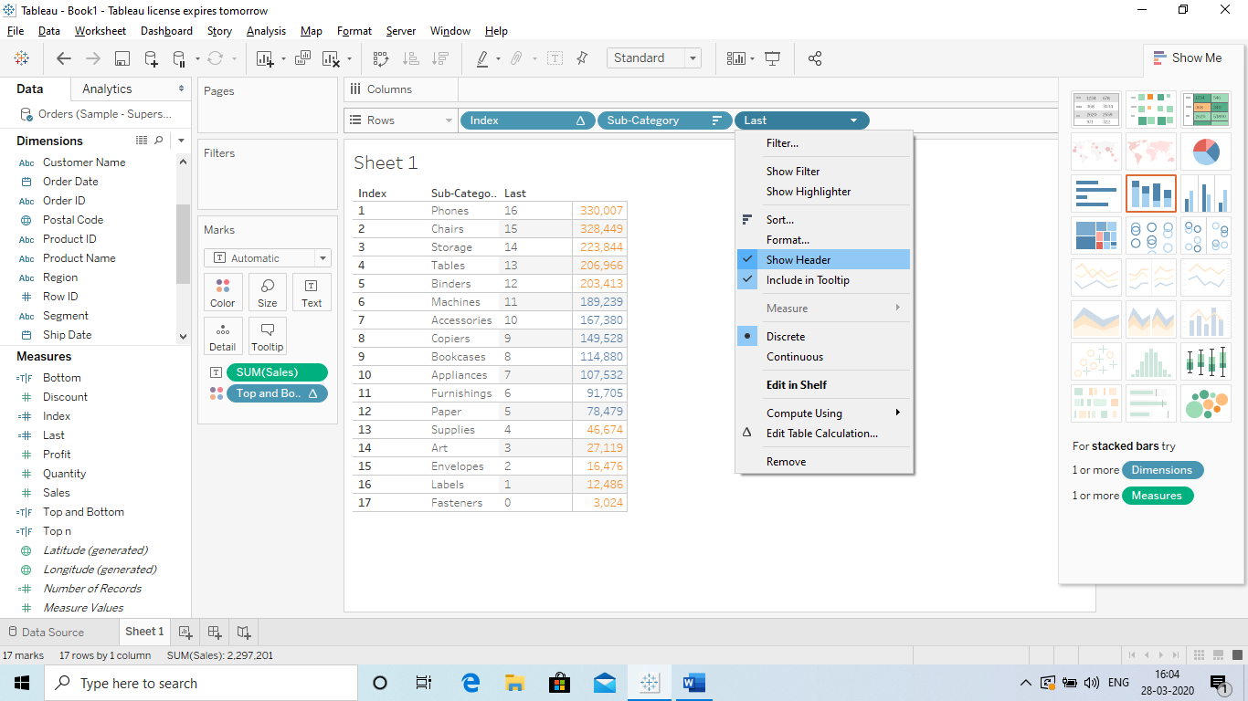

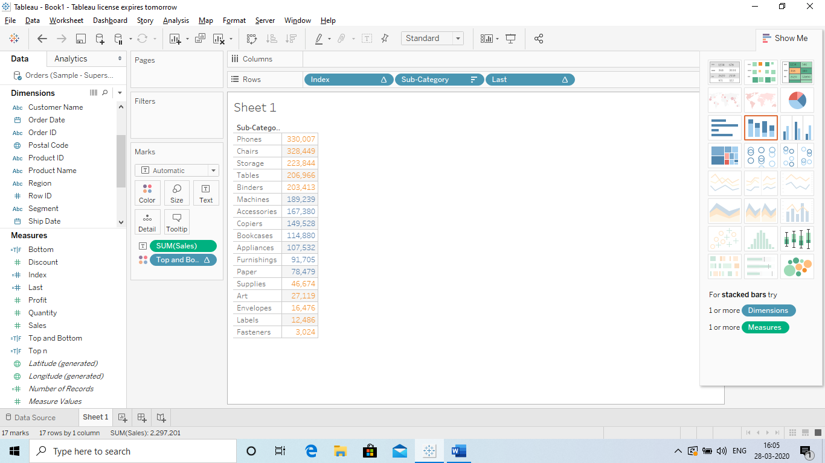

**Q Defination of Joins and why we use them?**

**Ans Joins basically help us the merge data from 2 or more datasources as per our requirment so that we can use them for better visualization.**

**We have 4 types of Joins:**

1. **Inner Join**
2. **Left Join**
3. **Right Join**
4. **Full outer Join**

**Explain:**

**1) Inner Join: It gives us the common record or values present in both the tables if there is atleast one match between the tables.**

**2)Left Join: Return the value or record present in left side of the table maching the value of records from the right side.**

**3)Right Join: Returns the value or records from the right side of the table and maching the value or record from the left side.**

**4)Full outer join: It is performed between 2 datasource which give us all the values from left and right table.**

**The values which do not match in both the table gives us NULL value.**

**Link for the video on Youtube:** <https://www.youtube.com/watch?v=tDa5vF1-Qys>

**Q CHATS:**

**The most important parts: Chart usability according to Data.**

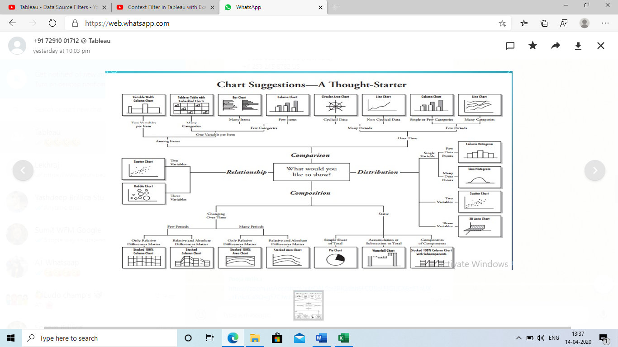

**There are 4 type in which we need to create charts:**

1. **Comparison**
2. **Distribution**
3. **Relationship**
4. **composition**

**Expalnation:**

1. **Comparison: To compare data the best chart is:**
   1. **Line chart (over a period of time)** 
      1. **or Area chart: Mostlu used in Parts as a whole over the time.**
   2. **Column chart: if 2 variables (over a period of time)**
   3. **Bar chart: if 2 variables**
2. **Distribution:** 
   1. **Column Histogram : few data points**
   2. **Line Histogram: Many data points**
3. **Relationship:**
   1. **Scattered chart: 2 Variables**
   2. **Bubble charts : >2 Variables**
4. **Composition:**
   1. **Pie chart: Depict proportion of a whole: 100%**

**Rule**

* + 1. **Start from 12 o’clock in clock wise direction**
    2. **Not more than 7 items**
    3. **Greater to less oranized**

**Doughnut chart:** Same like Pie chart however it shows total in the centre of the chart.

* 1. **Waterfall chart: This chart shows us the cumlative efforts of sequentially introduced positive and negative values.**

**Q) Rank related Function:**

**Ans This function will provide the Rank to the values:**

**For ex: 10, 20 ,50 ,30. So Rank will be: 1 = 50, 2 = 30 and so on.**

**So we create this in Calculated fields. There are many Rank function:**

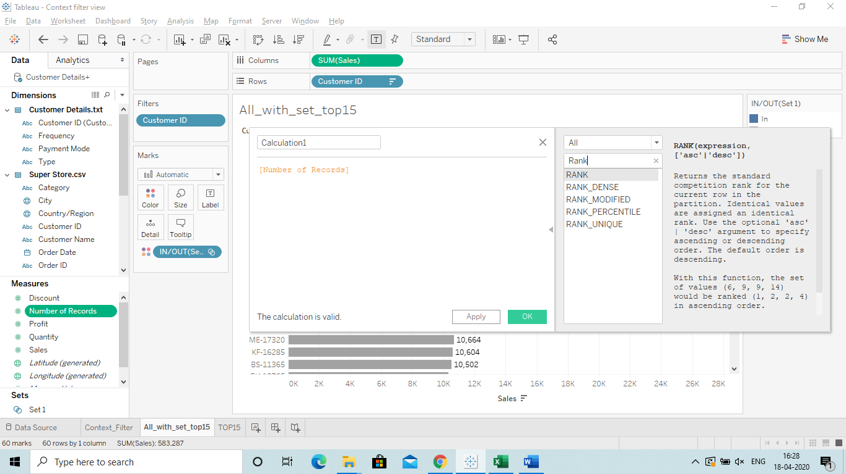

**1.Rank : Not commonly used: Gives the rank but not accurate.**

**2.Rank Dense: It is usefull since it give accurate Rank.**

**For ex: If we have 10, 20, 20, 30**

**Rank: 30:1, 20:2, 20:2, 10:4 (Here 10:4 instead of that it should be 3)**

**Rank_Dense: This will give us the correct view. 30:1, 20:2, 20:2, 10:3**

**3.Rank Modified: In case of Duplicate value It will skip the lowest value and return the highest.**

**4.Rank_Unique: This will give us the result as a unique value: First as per values and second as Characters.**

Here unique rank is provided. 2 is given to B since the value is same and B is greater the c.

**Example below:**

|  |  |  |  |  |  |
| --- | --- | --- | --- | --- | --- |
| Product | AMOUNT | RANK | RANK_DENSE | RANK_MODIFIED | RANK_UNIQUE |
| A | 10 | 4 | 3 | 4 | 4 |
| B | 20 | 2 | 2 | 3 | 2 |
| c | 20 | 2 | 2 | 3 | 3 |
| d | 30 | 1 | 1 | 1 | 1 |

**Link:** <https://www.youtube.com/watch?v=6Crr3mECluU>

**Q) Logical Functions: If, else condition.**

**(So we have 2 type of If condition in Tableau:**

1. **If: When we have more than 1 condition.**
2. **IIF: when we have only 1 condition.**

**So how we can use if else condition in Table:**

**We can dot it in calculated fields: Show the Sub-cat and profit.**

**Use a condition where the number is above that is high profit and below that is low profit.**

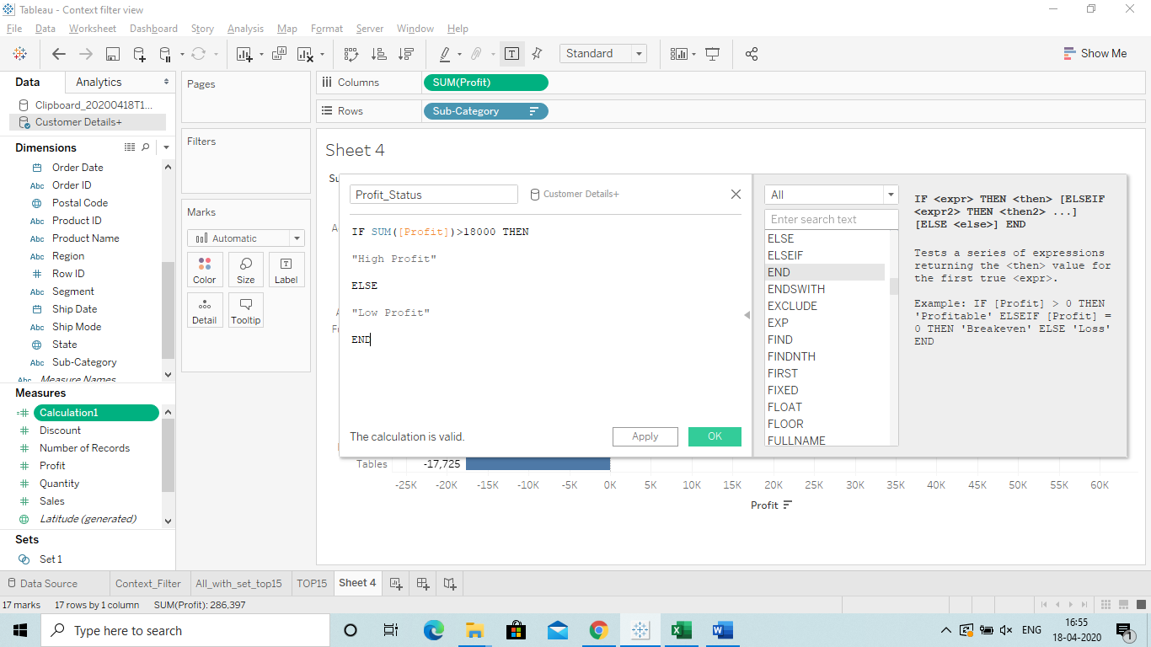

**A new Filed in created and then Drag it to colours Part and in crosstab(Either colour or Row Shelf)**

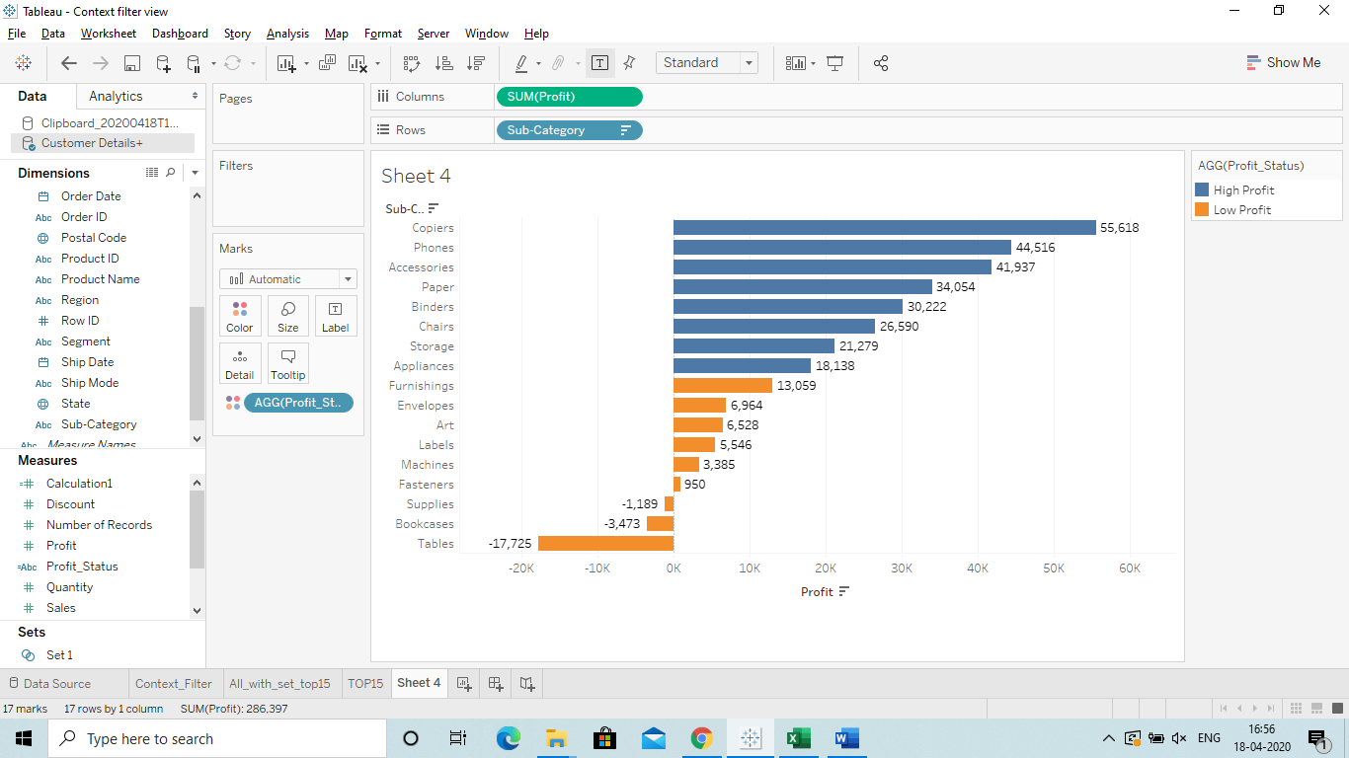

**Link:** <https://www.youtube.com/watch?v=LNGwR6SAEjo>

**Introduction of Charts:**

How we can select chart according to our data:

When we select a chart it shows at the bottom the criteria.

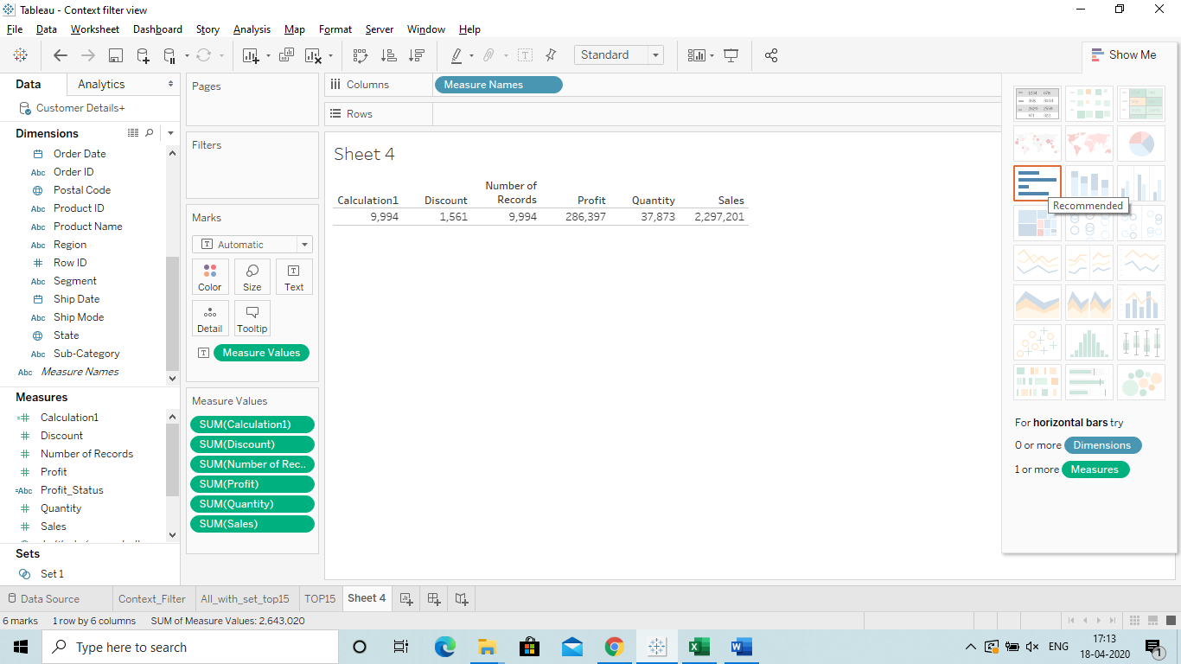

@How can Tablue show us the Chart automatically when we select Dimensions and Measures.

Ans **Just Select the Measure and CTRL Select the Dimension.**

We can **select a Measure and then press CTRL and select a Dimension or viseversa**, the option of charts will be highlighted in the showme Tab. We can select the chart we want.

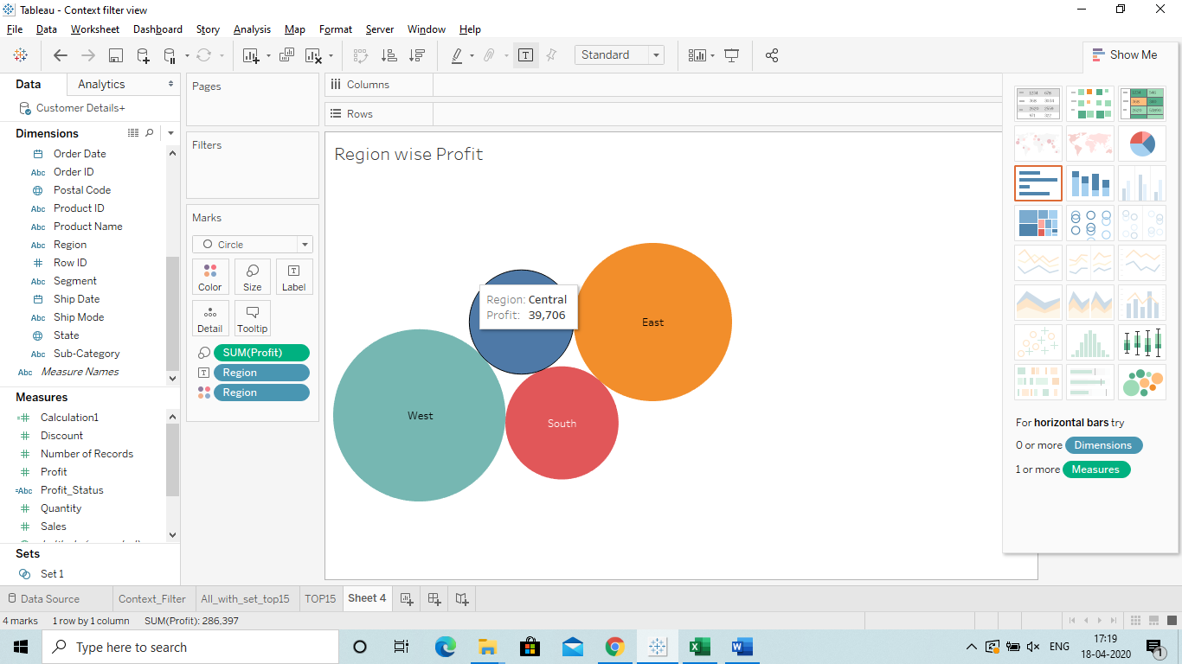

3.Select the chart

2. CTRL+Select

11



@Double click first Measure and then Double click on Dimension will result: Bar Chart

@Double click first Dimension and then Double click on Measure will result: Text view or Table view.

Link: <https://www.youtube.com/watch?v=XUALIrP7MYk>

**Scattered Chart**

To create a scattered chart we need:

Measures: 2 to 4

Dimension: 0 or more

**Since we are getting a single dot and we want to bifurcate that we can Drop a Dimension in the Chart.**

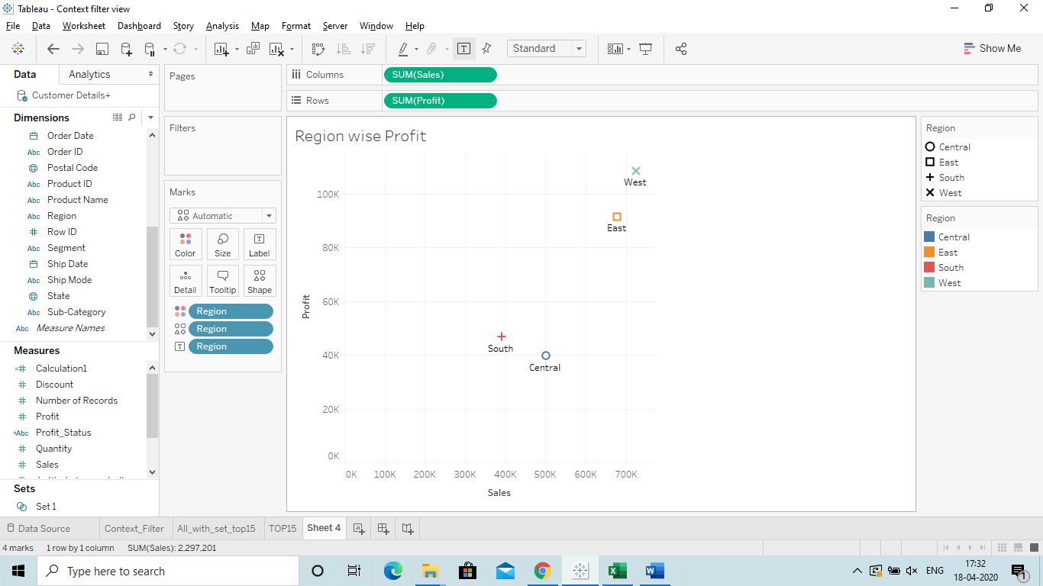

2 Measures were taken and Region is dropped in the chart.

@ **Now what is dropline in Scattered Chart:**

**It means it will show the line and detail when you click one the the shape in the scattered chart.**

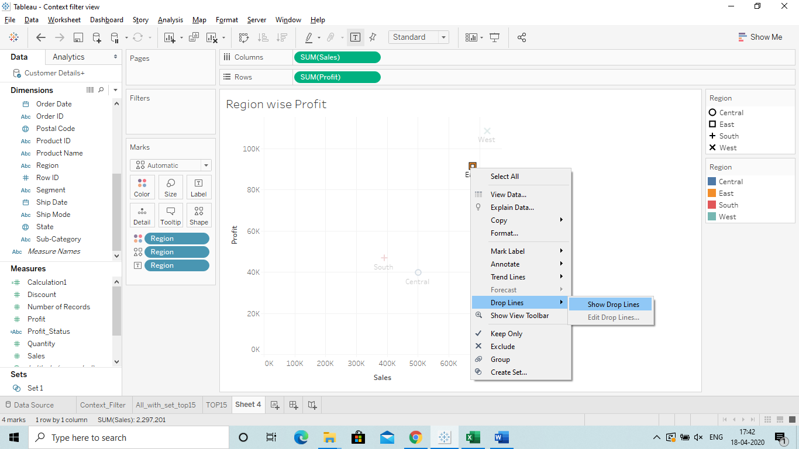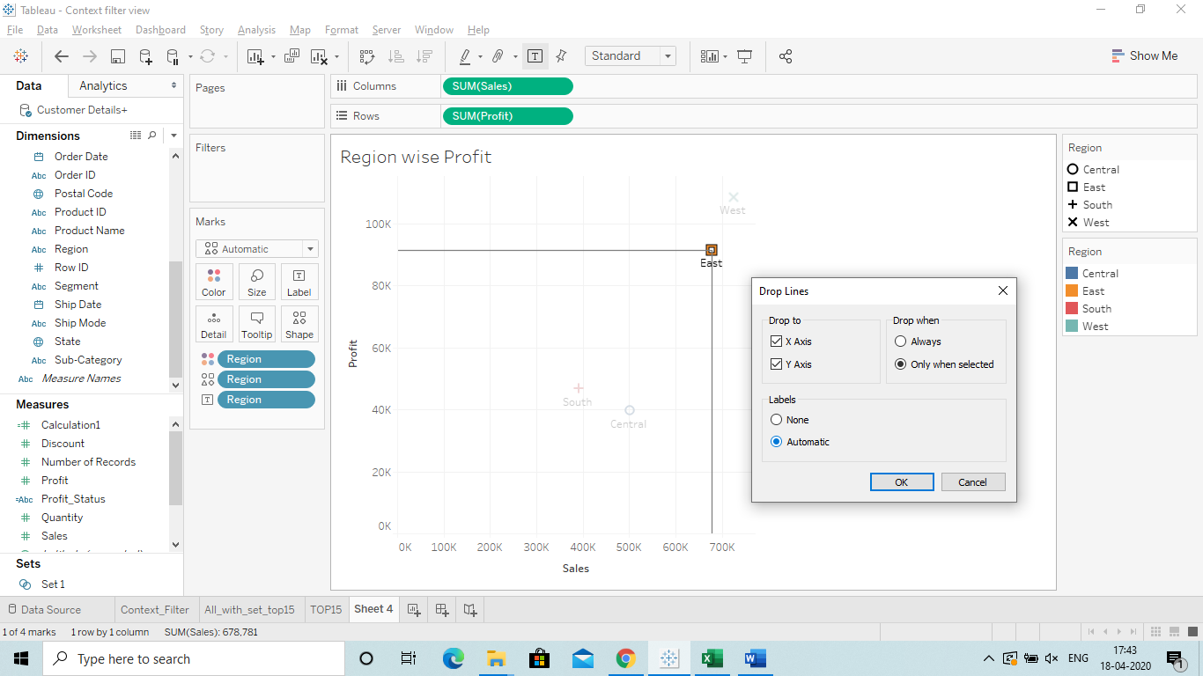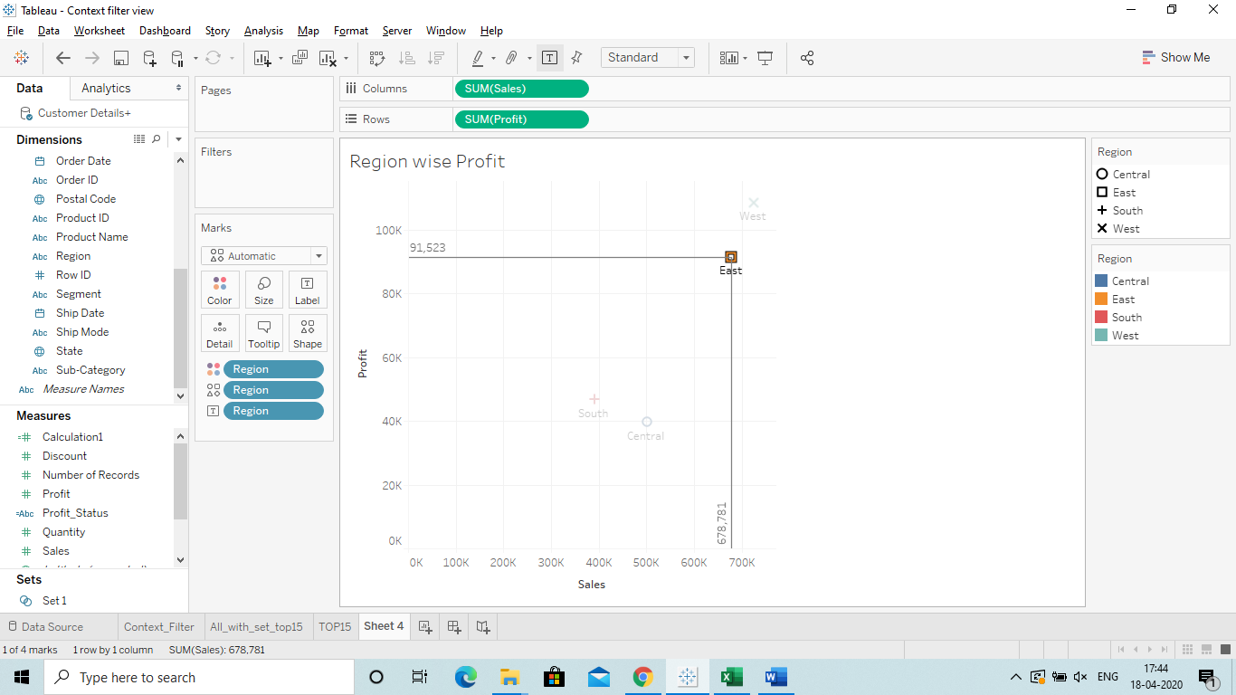

When we need to see the Labels in the drop line on both the axis then we have to select Edit Drop line and select Automatic. It will show us the Labels.

@**WORDMAP:**

This will basically show the name of the Country or cat as per the Measures selected (Profit or sales etc)

Steps:

1)Drag the city from the Dimension to the Text Marks

2)Drag the sales /profit in the **Size.**

3)In Marks select the TEXT option where Automatic is selected.

4)For colour just Drag the Sales or profit in the Colours Marks.

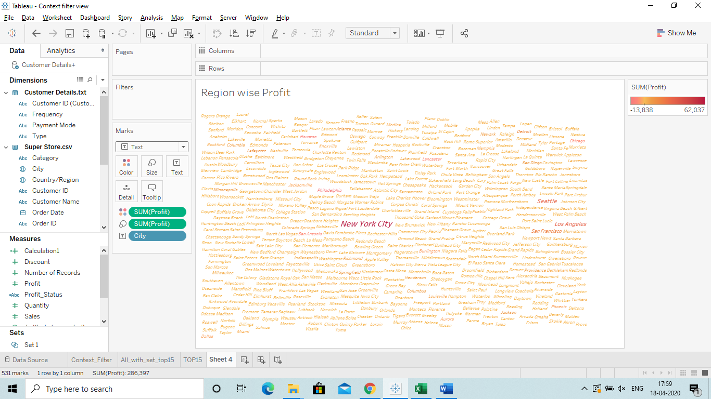

Link: <https://www.youtube.com/watch?v=ADyBByZjrcw>

**@Doughnut Chart:**

**Steps to create this chart:**

1. Select the Measure value (Sales/Profit/Discount etc) and Drag it to **Rows 2 Times**.
2. Change both into Attributes from Rows olny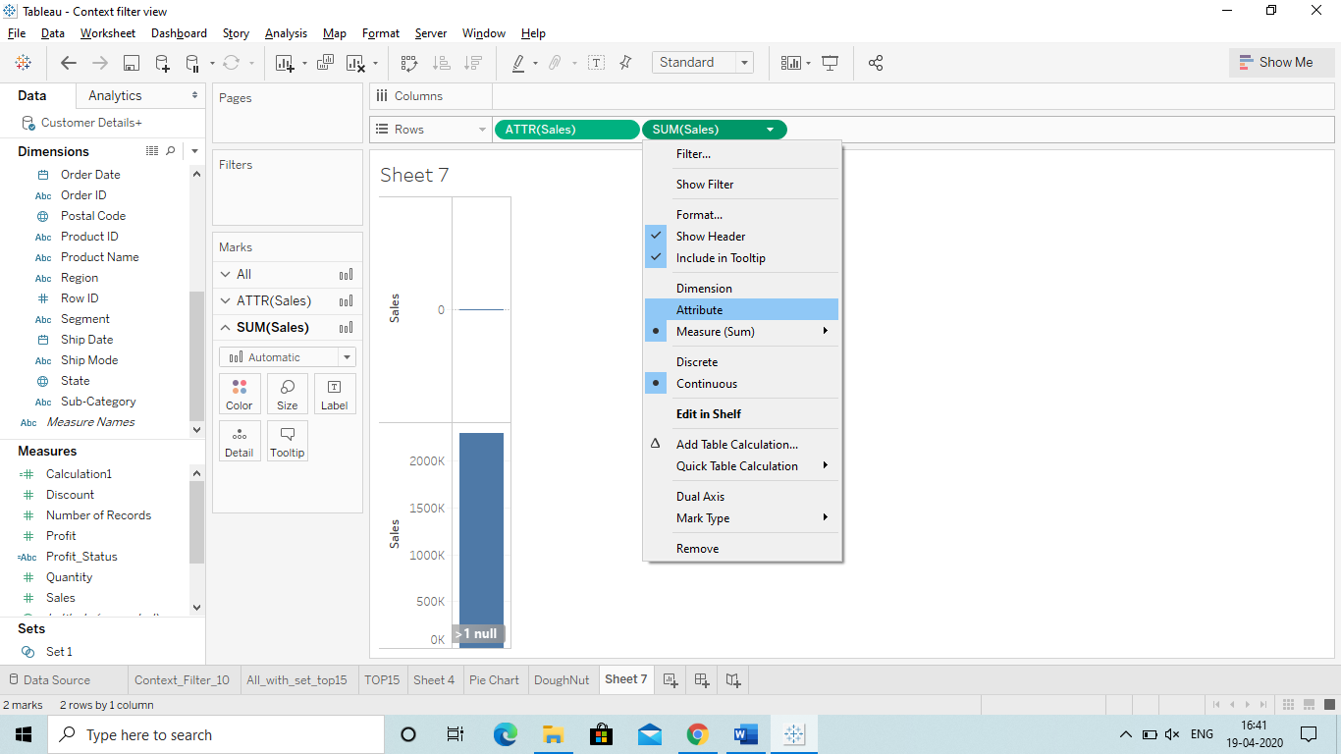
3. Then go to Marks and select Pie Chart for the first sales.

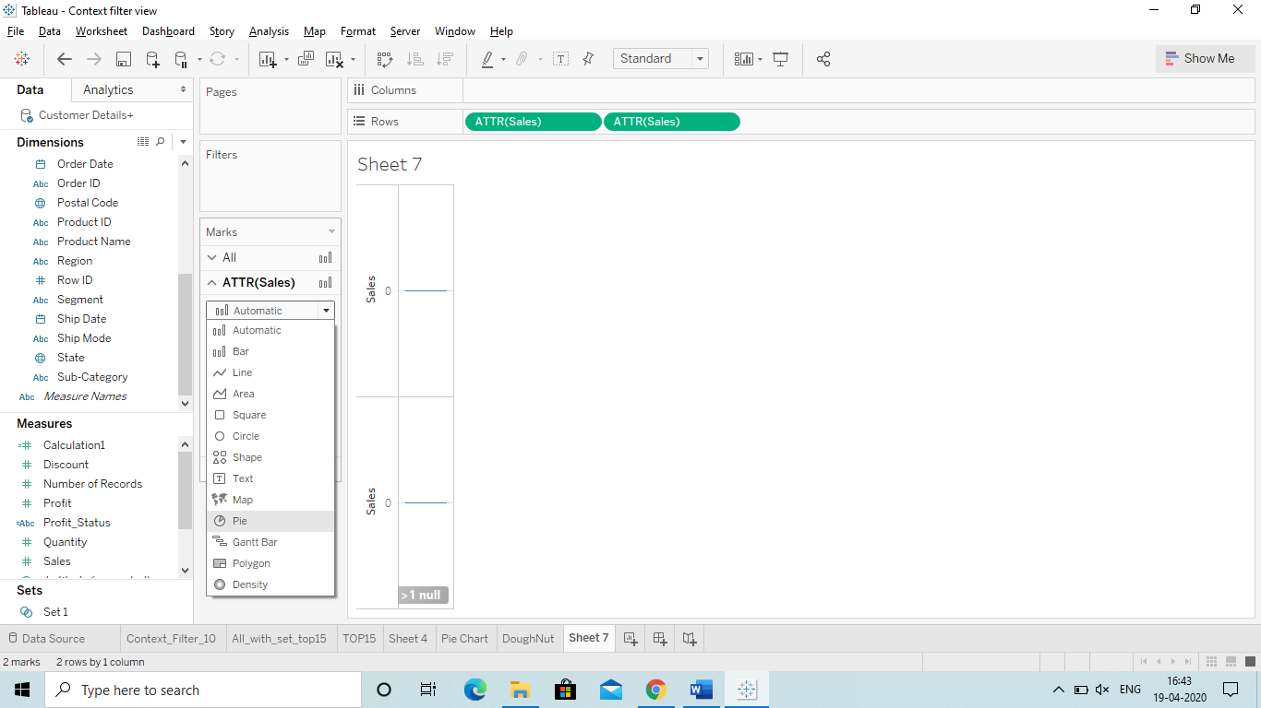

1. Drag the Dimension by which you want the colour bifurcation.
2. Drag the (sales/Profit etc) to the Text, Angel and Size.
3. Now in Marks select the second Sales (Measure) and change it to Circle.
4. Change the colour into white.
5. ***impotant step: Now got to Rows and select **Dual Axis** in the second sales.
   1. **If you miss this step then you will not able to able to make the chart.** 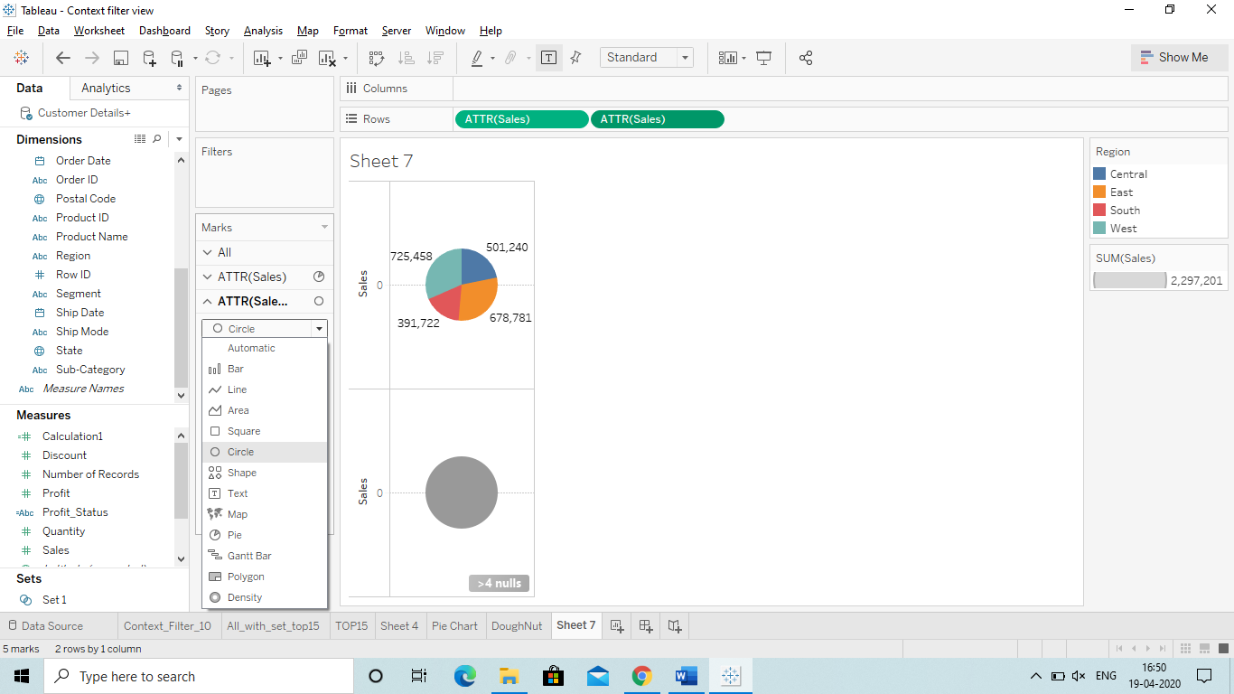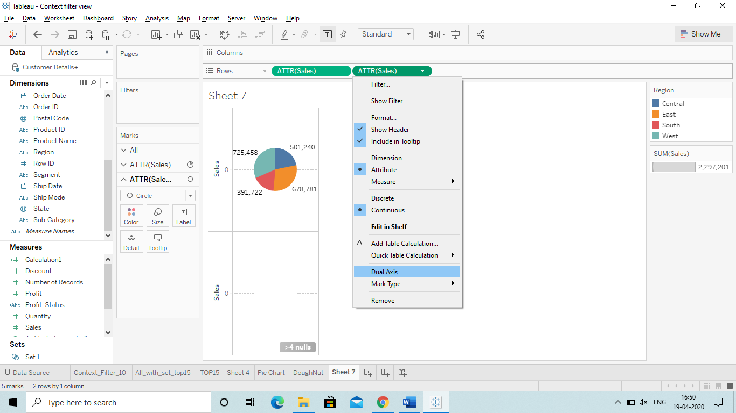
6. Now just change the size of in Marks of the first sales. (Increase)

Your Doughnut Chart is Ready.

Q) How to create multiple Daughnuts charts in 1 worksheets.

Ans Below are the steps:

1. Create a Calculated field in measures: Name:Pie Manually in which write only : 1
   1. Here one represent that on Y axis the chartss will be at 1 position.
2. Drag that field to Rows : 2 Times (for Daughnuts chart)
3. Change bothe the Pie into “Measure – Minumum” (It means on the y axis it will be minimum) 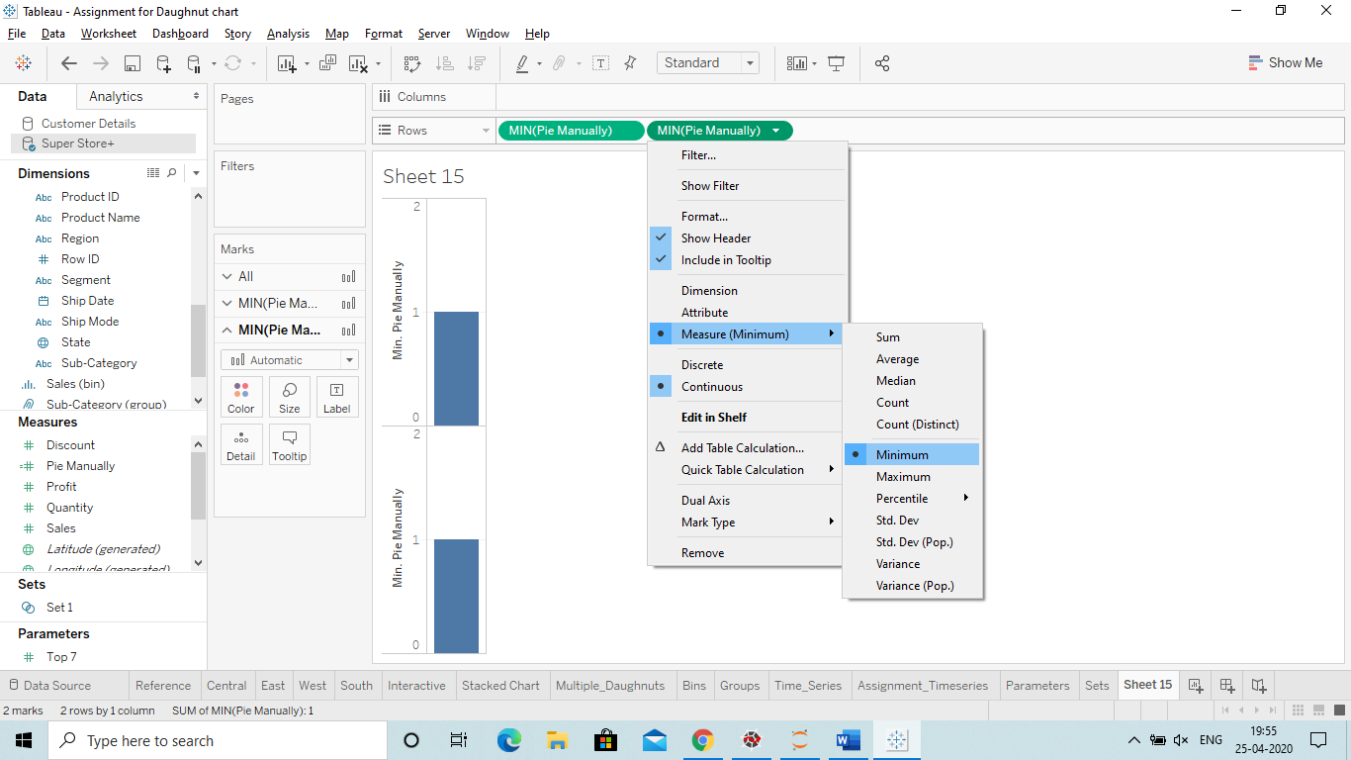
4. Now In the Marks change the first one to Pie chart.
5. Drag the fileds: Sub cat to colour, Sales to Size, Sales to Label and Sales to Angel. 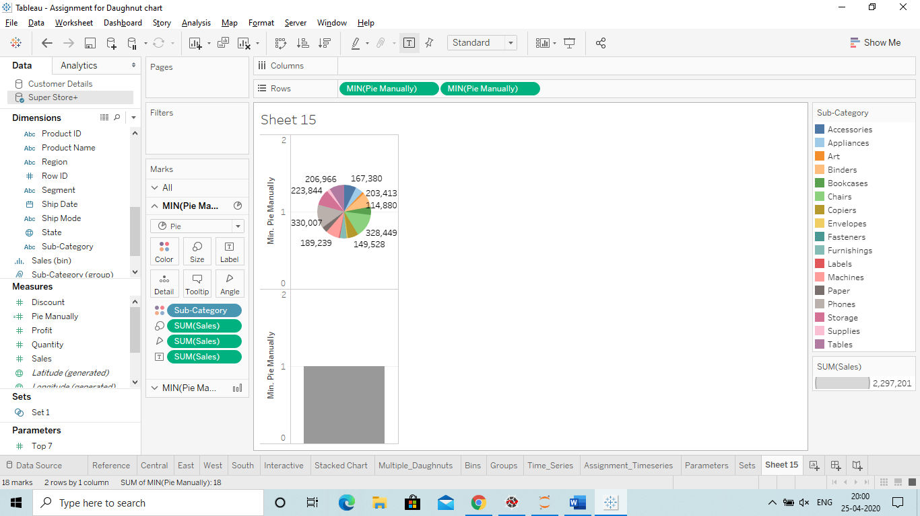
6. Then Drag the Catogery in Filter and select the Furntiure
7. Now go to second = Pie Manually and change it into a circle. Alse change the colour to white.
8. Go to Row: Change that into Dual Axis
9. Decrease the Size of the circle so that we can see as Daughnut chart.
10. Drah the Region to the Columns (To make 4 charts as per region)
11. Drag the Region to the Text so that we can see the Labels in every Chart.
    1. We have change the allignment of the text to centre so that it will be inside the Pie. 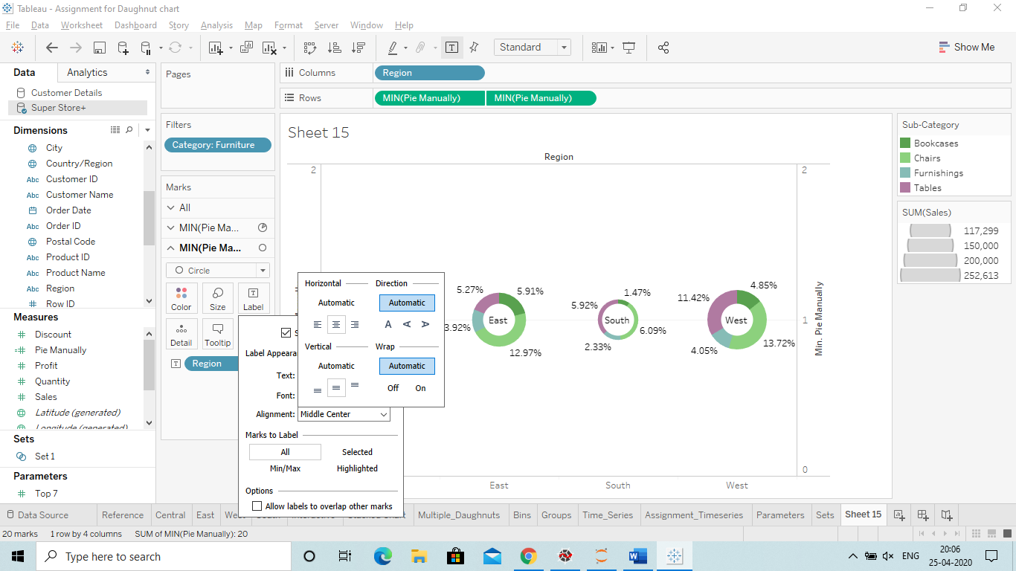

The chart is ready Now: 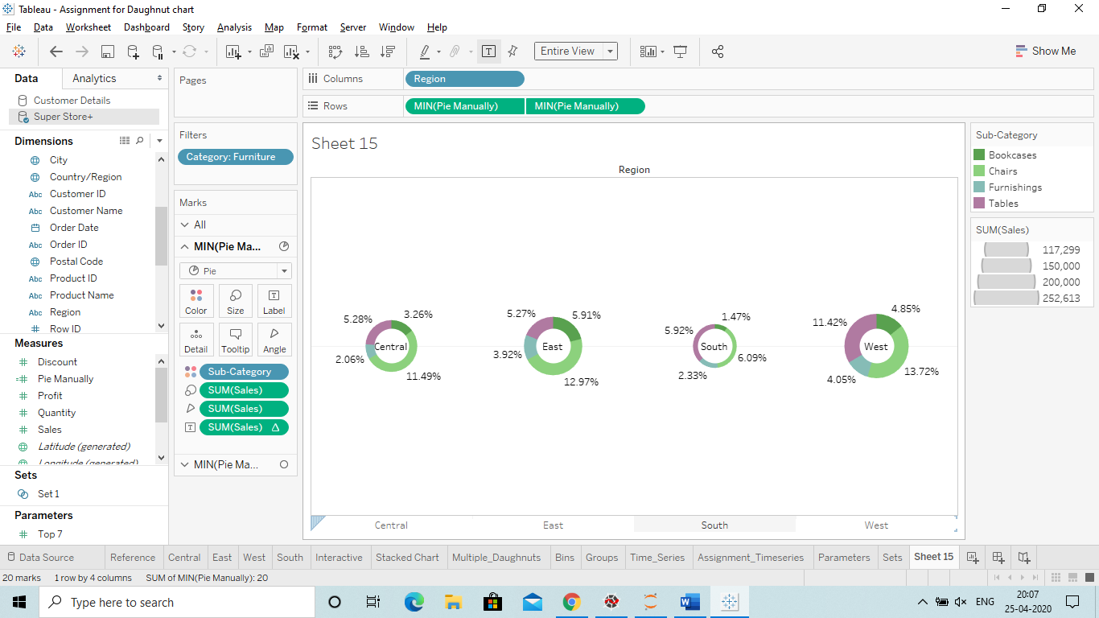

We can also do without calculated field same we make the Daughnut charts.

Q What is BIN?

Ans Bin basically means showing the data catogiracally.

For ex: (0 – 12): Boys, (0-31): Girls

So we have catagrize the data.

Just go to the sales and create - Bin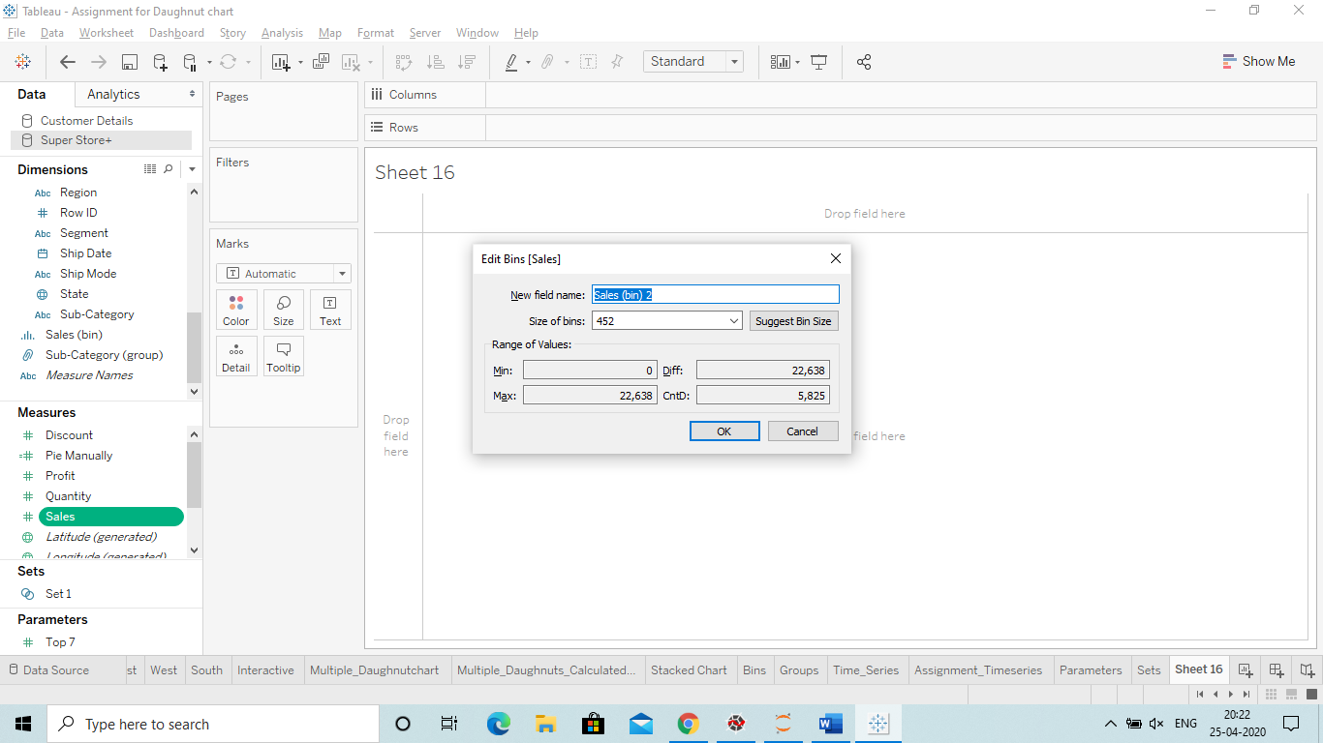

Here in Size means the interwal on Y axis: 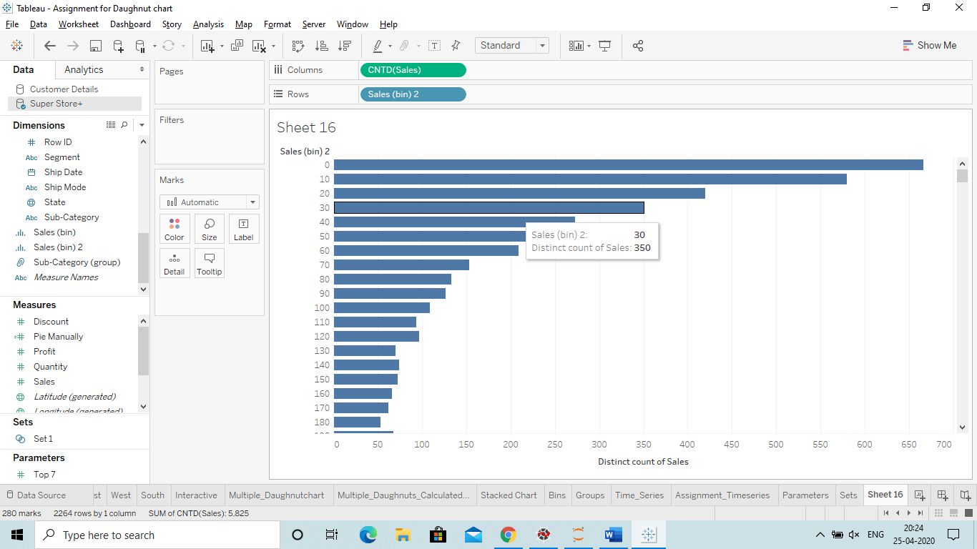

***Then Drag sales into the column and chage its measure to Count.

***Important Interview question:

Q) Difference between Bin and Group by:

1)Bin: we create BIN with Measure value.

2)Autodetect the interval.

1)Group: we create Group by Dimensions.

2)We have to create a group Manually.

Q) Can we define Bins in a Group?

Ans Yes we can define Bins in group.

**Time Series:**

These are very useful and easy steps:

Things to remember: Always check that we have a consistent data available so that the time series chart get created.

Step:

1)Take the Order data to the Columns and expend that into Quarter/ month/week etc as we need.

2)If we need data in Months then Change the Month by selecting the Month to year( 2nd Month)

3)Also change that into Continuous. 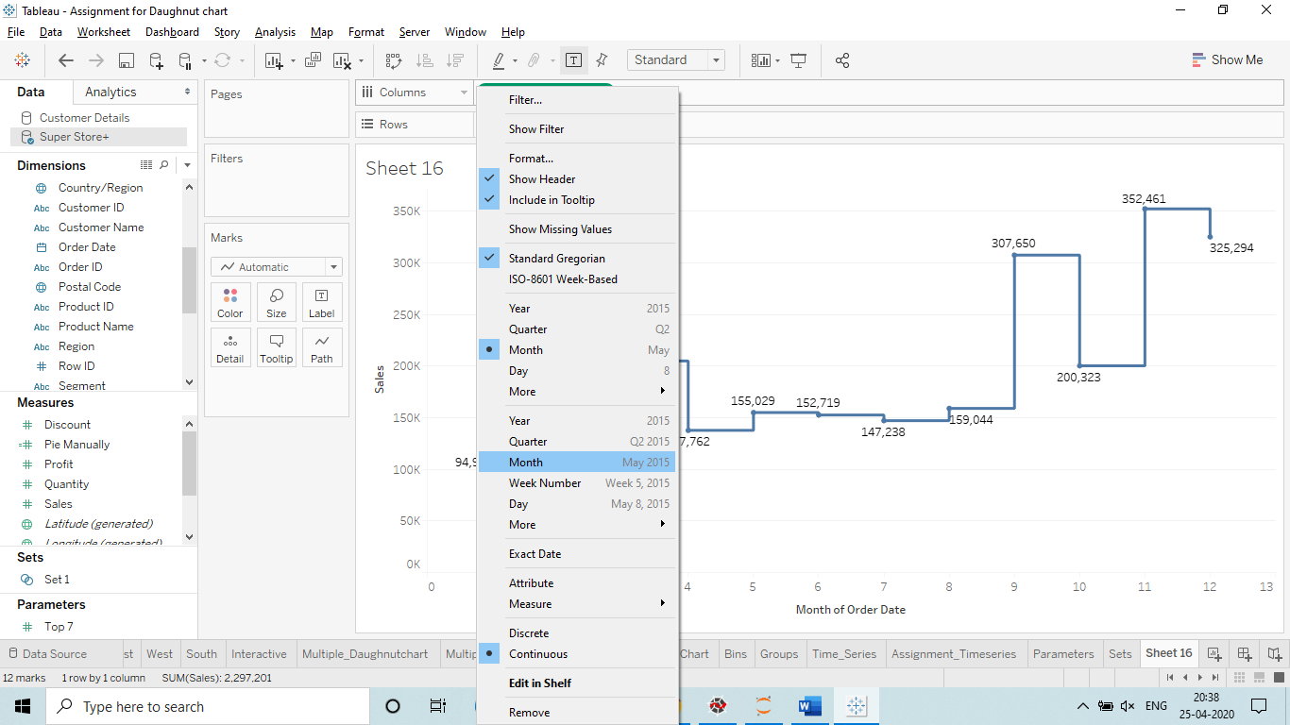

4)Remove the Year and Quarter

5)Just go to Path in Marks and change the select the lines. 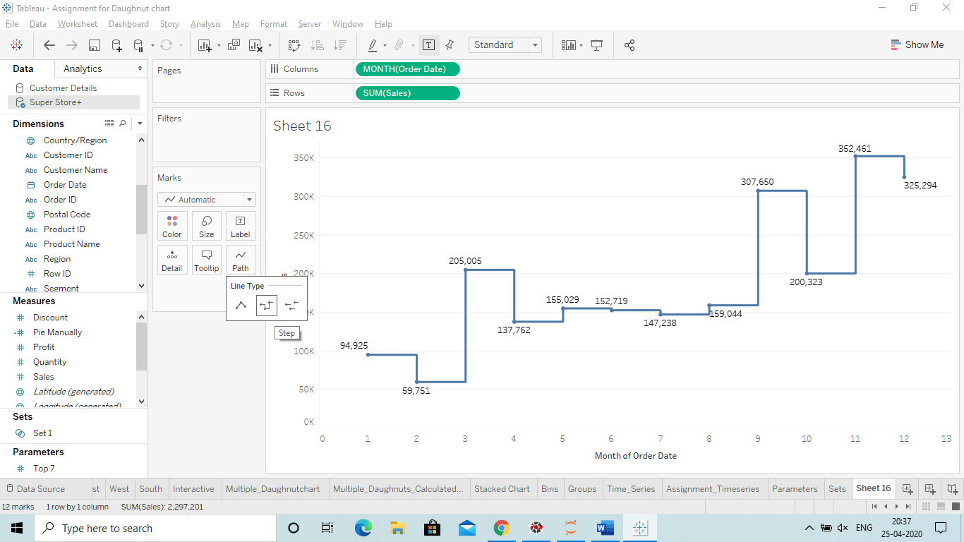

That’s how we create a timeseries.

Q) How we can provide legents at every single point in the line or other chart.

Ans Just select the full chart and right click on one of the point and select **Mark Label – Always.**

**Earlier:**

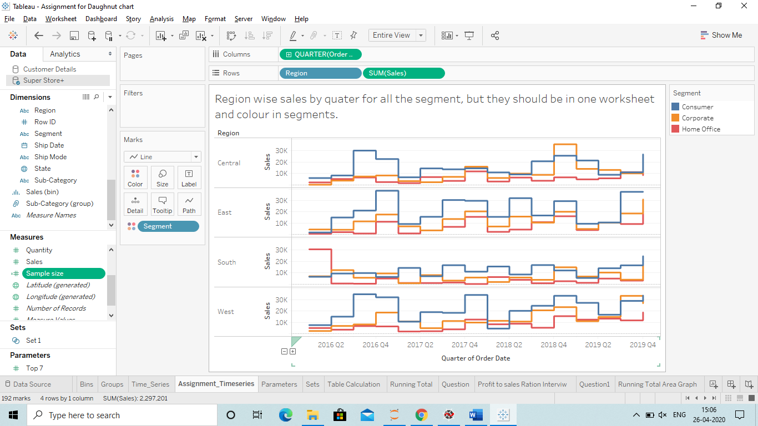

**After:**

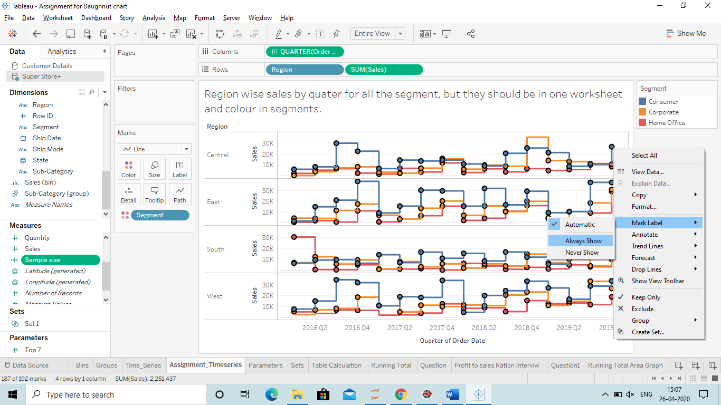

**All labels will be shown at the higlighted Points.**

**Q How to create multiple Time series in a single worksheet:**

Do the same however just Drag the Region to Rows to get 4 region chart.

Also Drag the segment to the colour. 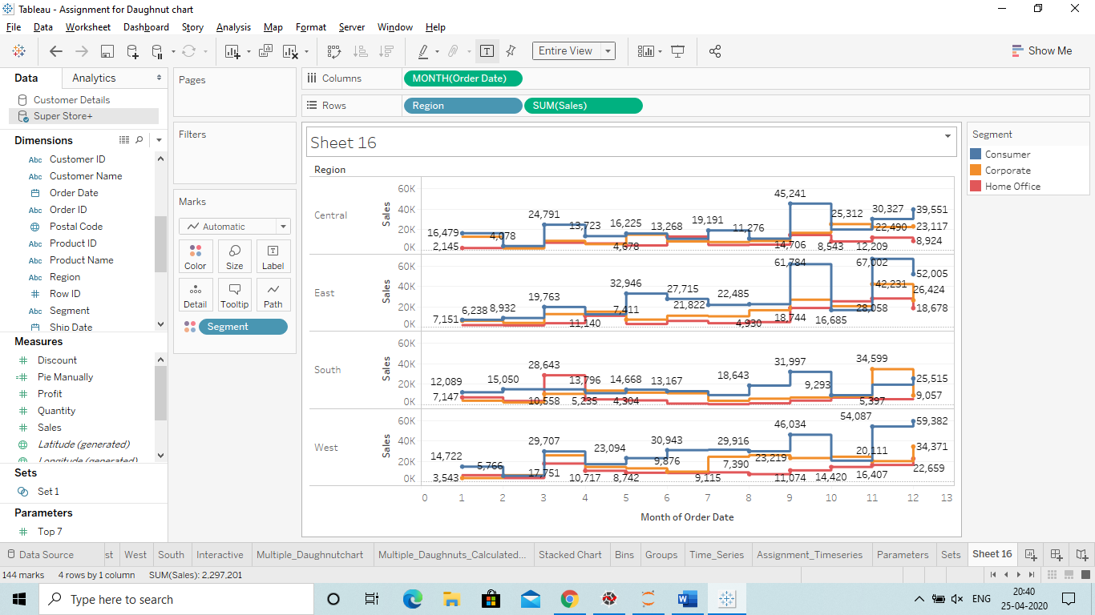

Q) How to create a chart showing the comparision of up and down between last year and current year.

Ans

We have use a formula which is based on LOD(Level of Detail):

**{ FIXED MONTH([Order Date]):SUM(IIF(YEAR([Order Date])=2019,[Sales],NULL))}**

**-**

**{ FIXED MONTH([Order Date]):SUM(IIF(YEAR([Order Date])=2018,[Sales],NULL))}**

In the above formula we have fixed Month(Jan) and then we rae showing sum os sales for year 2019 and 18 in the calculated field.

**Steps**

1)Drag the order date to Colums Shelf and use months for the chart.

2)Take the Calculated field to the Rows columns 2 times and then convert that into dual axis.

3)Then go to Marks and change the first chart into Area chart and second into Line chart

4)Change the colour of the line chart and Drag the Last year sales(Calculated Column) to the Label. 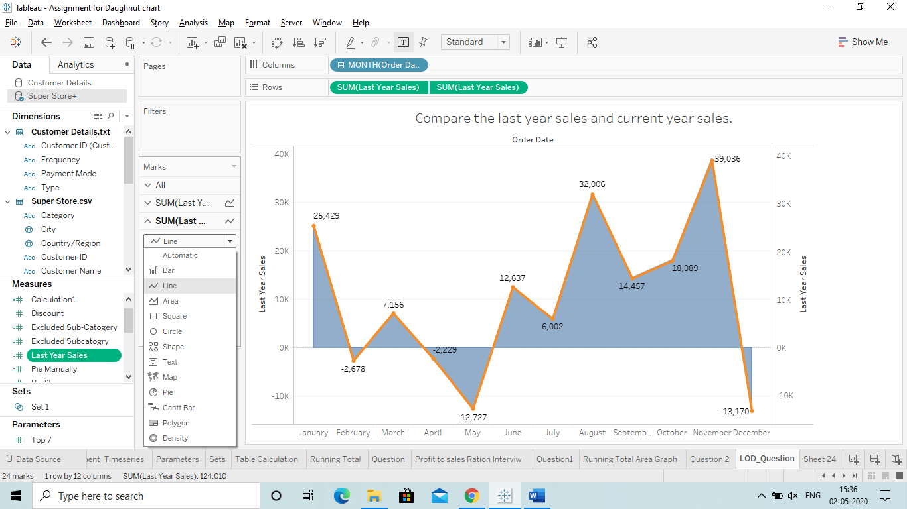

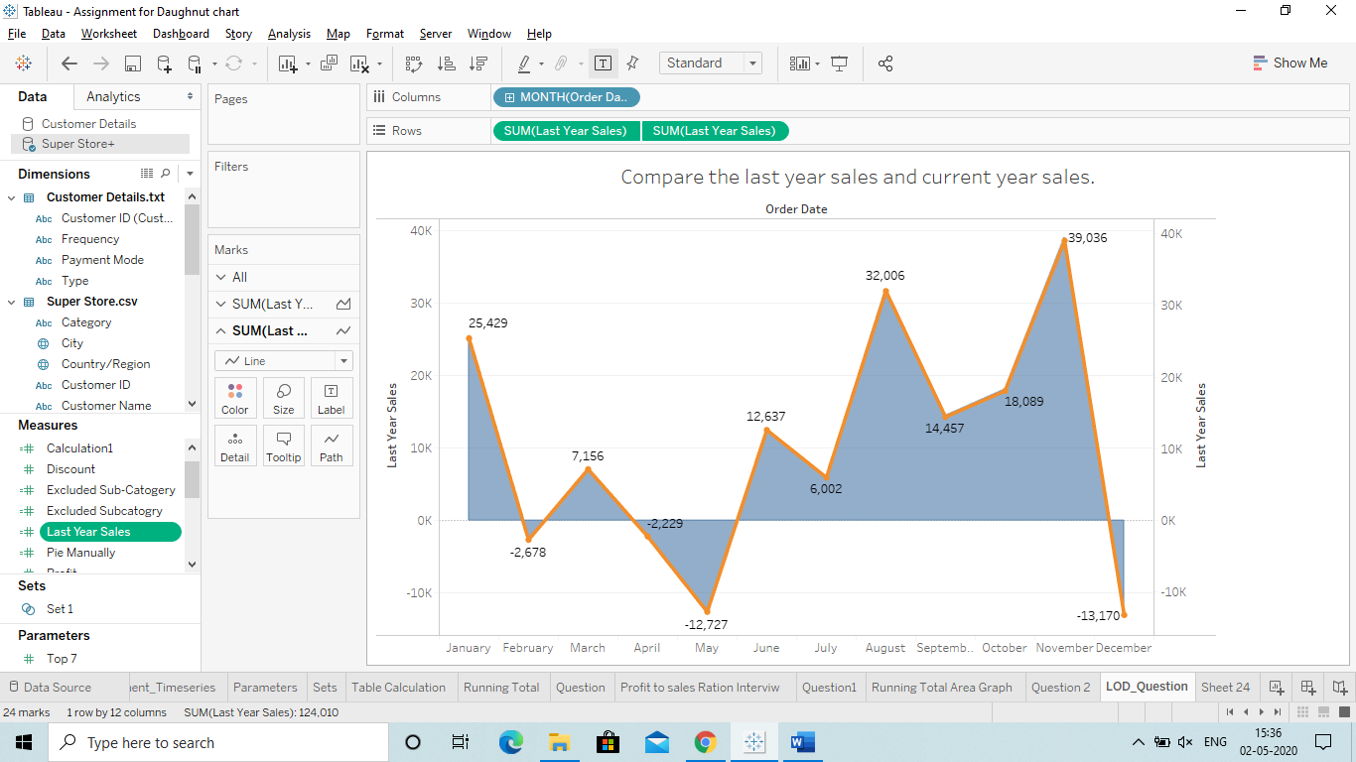

**LOD: Level of Detail**

**Q) Define LOD: LOD expression represent an elegant and powerful way to answer questions involving multiple level of granularity in a single visualization.**

**Type of LOD Expression**

**1)Include**

**2)Fixed**

**3)Exclude**

**Ans.** 

Q) The structure of level of detail:

Ans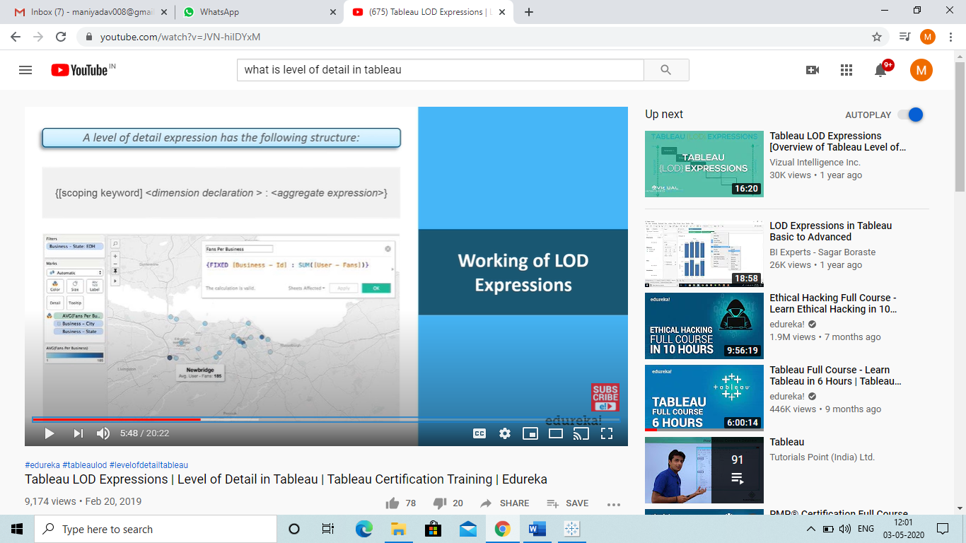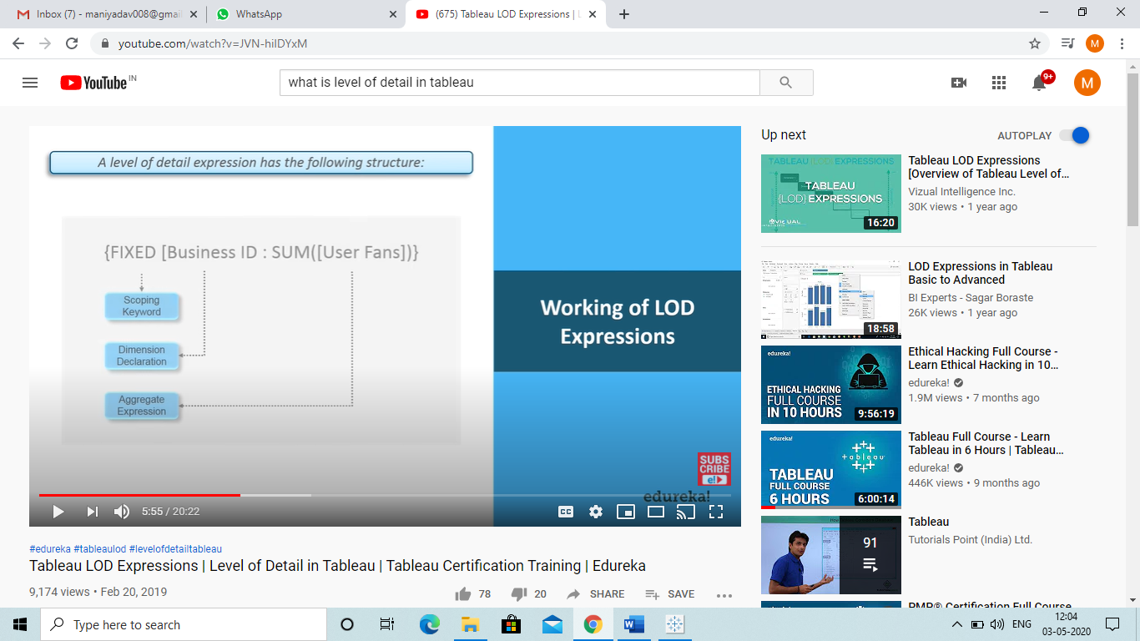

So here we have seen that how we have use a structure to perform LOD.

Scope Keyword: Include, Exclude or Fixed.

Dimension declaration: What Dimension you want to FIX or…

Aggregate Expression: Measure you want to aggregate.

Q) How they work: 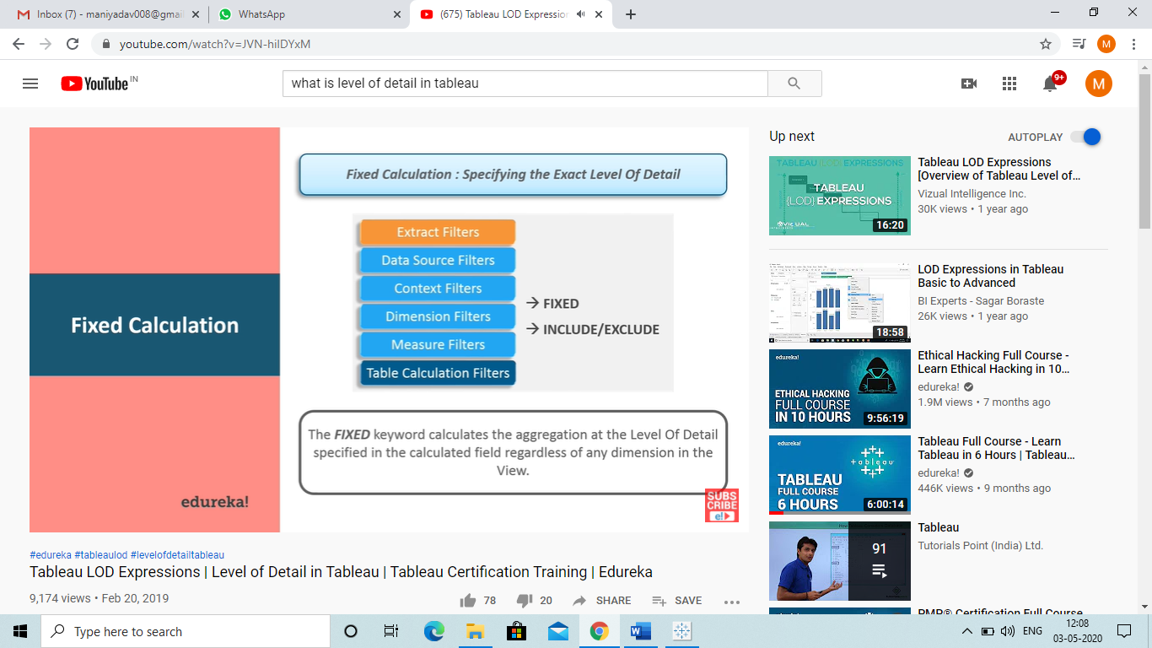

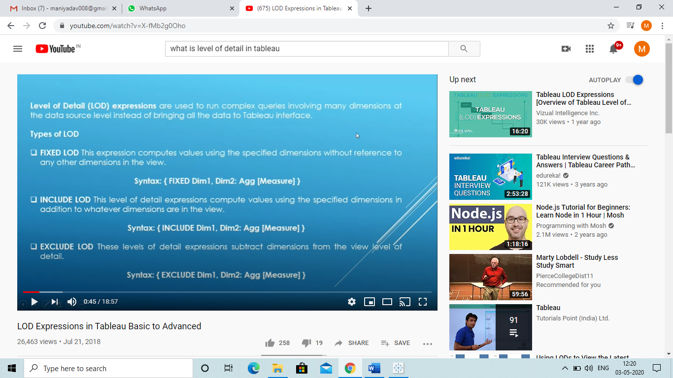

Best Video Link to understand: <https://www.youtube.com/watch?v=X-fMb2g0Oho>

What is Aggregate function: 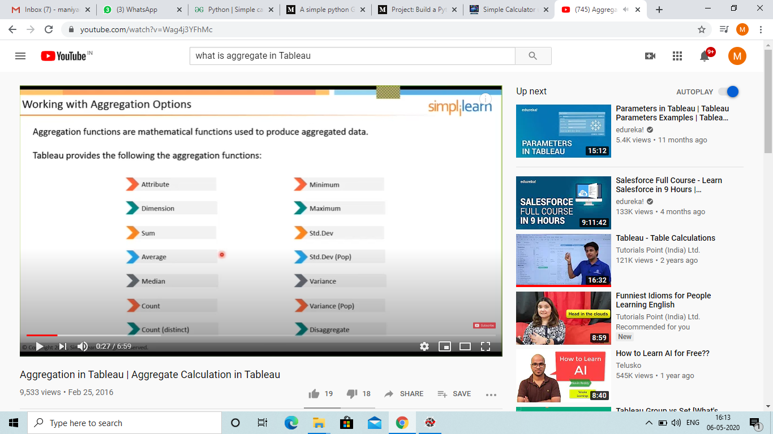

**Q) What is Highlighting and where it is present?**

**Ans Highlighter basically help us to highlight the things we want to when we select the related things.**

For Ex: If we want that only single segment gets highlight if I select a segment.

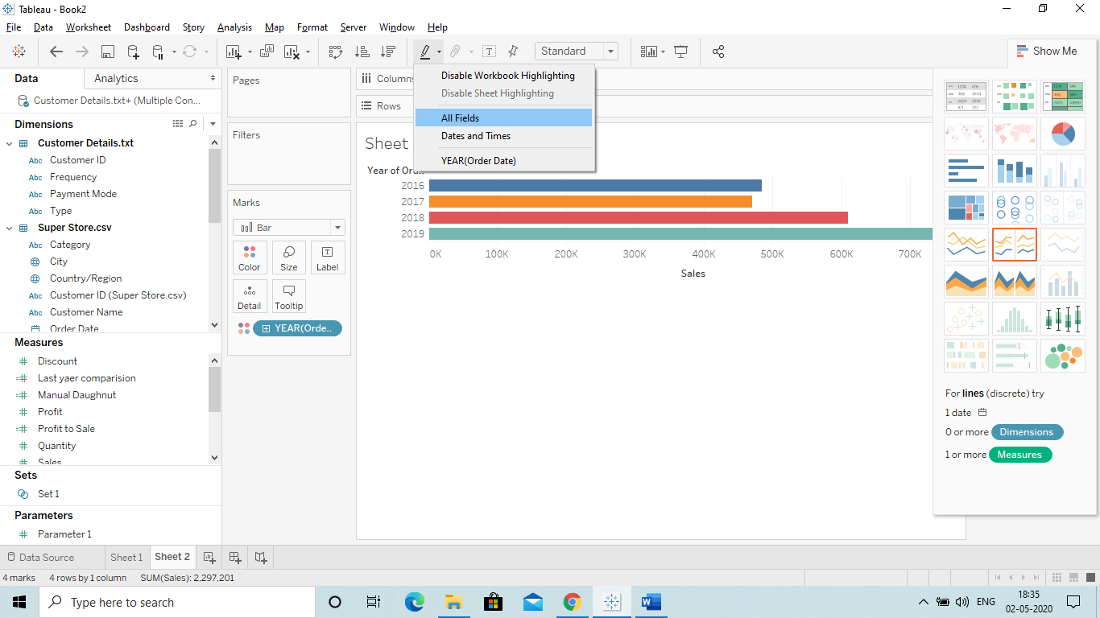

Link: <https://www.youtube.com/watch?v=yIbg04-_PZs&list=PLWPirh4EWFpGXTBu8ldLZGJCUeTMBpJFK&index=75>

Q) What is Action Filter? Link:

Ans So there are 3 type of Actions:

1. Action filter: <https://www.youtube.com/watch?v=BnYCwgX7hZQ&list=PLWPirh4EWFpGXTBu8ldLZGJCUeTMBpJFK&index=76>
   1. When ever we click on a single category then the target or other sheet data will be shown (same field)
2. Action Highlight: <https://www.youtube.com/watch?v=vb2o38S9JWQ&list=PLWPirh4EWFpGXTBu8ldLZGJCUeTMBpJFK&index=77>
3. Action URL: So if we click on something on a chart then a URL will be selected and direct you to that site.
   1. Link: <https://www.youtube.com/watch?v=BRBhBNsfMI8&list=PLWPirh4EWFpGXTBu8ldLZGJCUeTMBpJFK&index=78>

***IMP

We want to get the information about the state and we have all the name of the state.

We will use Action URL to connect it to states information website.

Link to understand it more: <https://www.youtube.com/watch?v=GXh7LTHecIw&list=PLWPirh4EWFpGXTBu8ldLZGJCUeTMBpJFK&index=79>

**Q) How to create a filter in the Dashboard to make it more interactive?**

Ans for that we have to apply a filter on the worksheet:

Below are the steps to do that:

1)Just select one chart and click on more option: 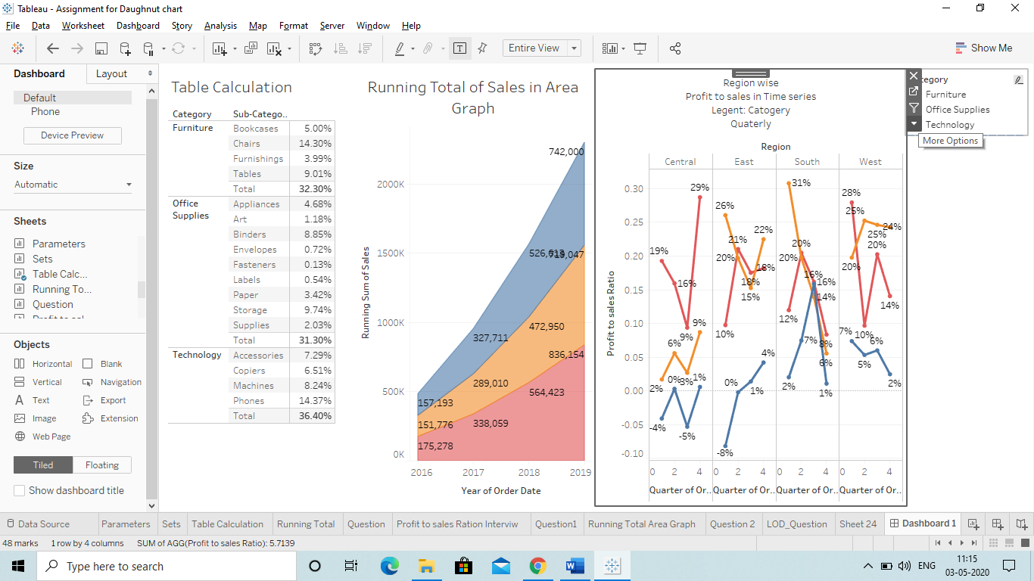

2)Then go to filters and select the field by which you want to apply the filter on that Chart.

(Do remember that the filter is just applied to this chart only and to apply on all we have to make the changes and convert that into worksheet)

3)Then go to that filter which we have created on the left hand side and click on more options. 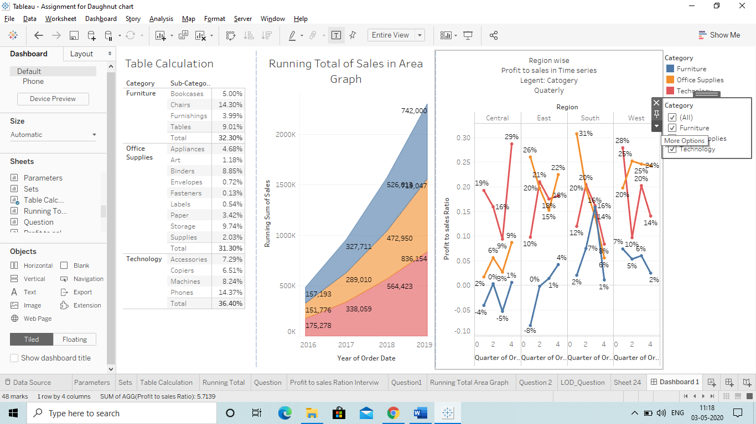

4)Then click on Apply to this worksheet and select “All using this datasource”.

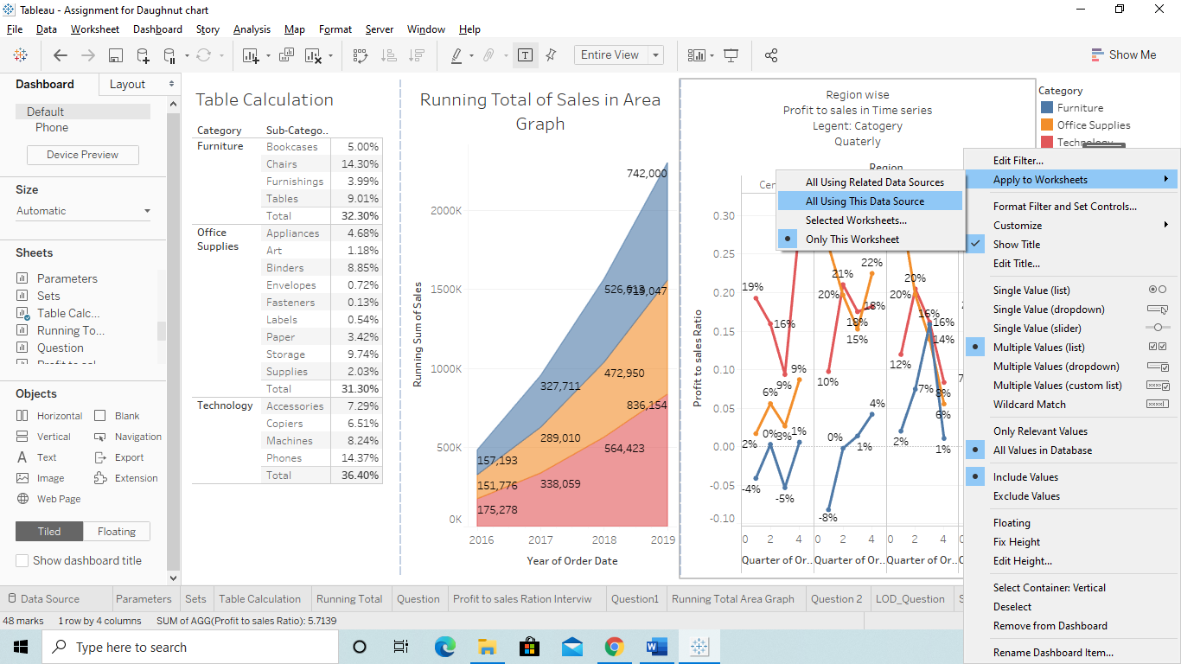

Q) How to check reports online and edit them as per our requirement?

Ans Link: <https://www.youtube.com/watch?v=4vFkW_C3rrI&list=PLWPirh4EWFpGXTBu8ldLZGJCUeTMBpJFK&index=87>

Q) How to create an Action filter so that while selecting a single Region(Dynamic) all the charts or selected charts data change accordingly.

Ans We can do it by Action filter:

Step1) 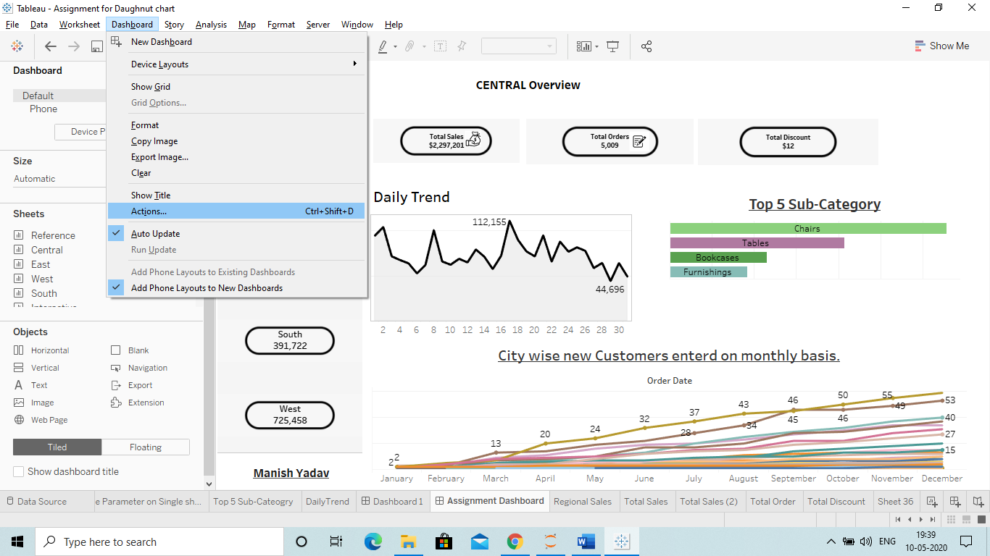

Step 2) Click on Add Action > and select filter: 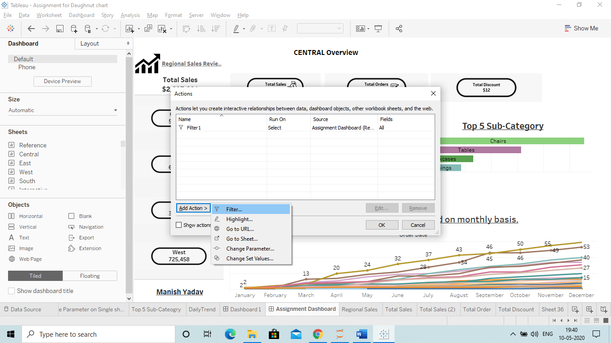

Step 3) 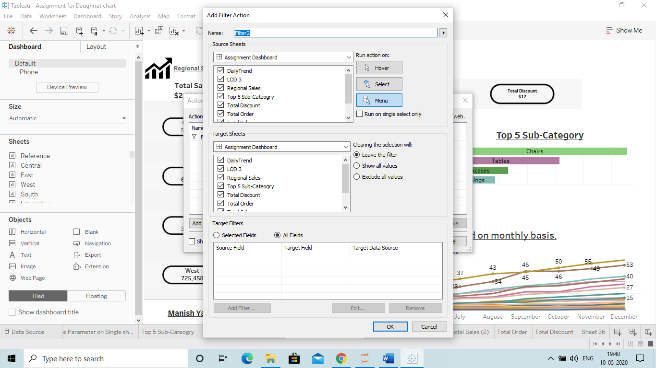

Now here:

* Source Sheet: It means the sheet from which you want to select and other should change accordingly.(Unselect all and select the only sheet you want )
* Target sheet: It means select those sheet on which the filter Should be applied.
* Click on Show all Values so that nothing is hide.
  + Exclude all : Then all charts will be excluded which are not in the filter
* Then Select the All fileds.

**Q) How to show All the Measure Values in as single sheet with the help of Parameters?**

Ans This view will help the user to change the parameter and check the values.

Steps:

1)Create a Parameter you want : Like Sales and Profit. 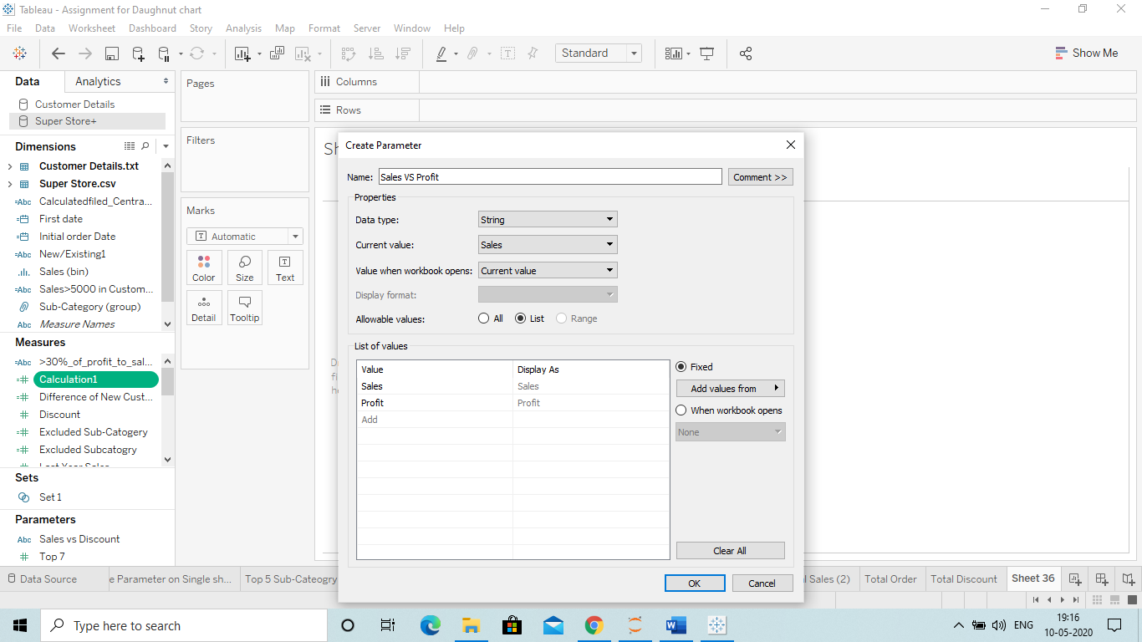

Here we have created sales by writing and we can write as many Measures we need.

Current Value means the value which is showing now since we have selected sales first below.

Select String

2)Create a Calculated Column with formula **“CASE”: (Here we are taking Sales and Profit)**

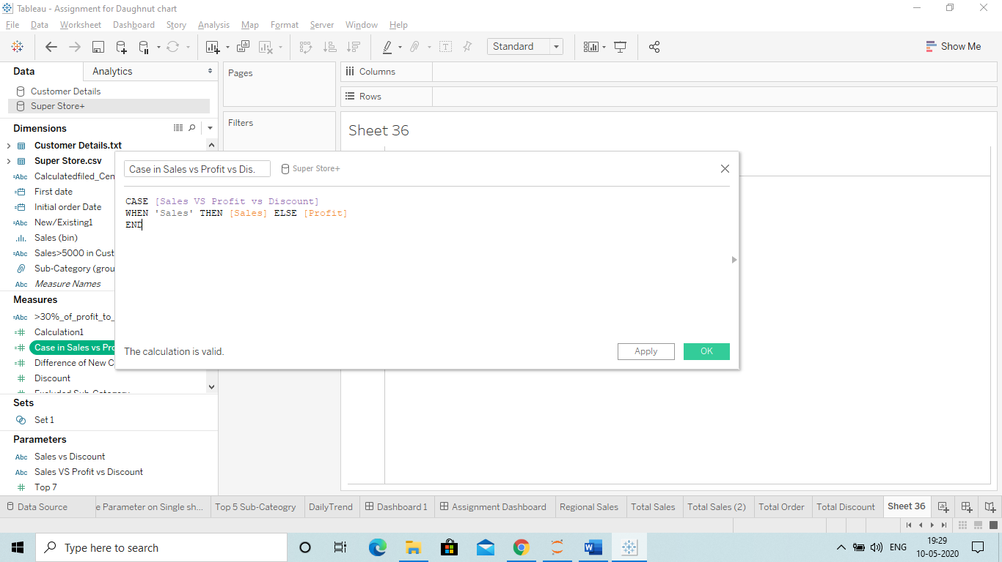

Here Case formula is:

Case [Parameter] where ‘String(the value u want to show first)(sales)’ then sales else profit end.

3)Drag Calculated field to Rows and Region to Column.

4) Then Drag Measure name to the filter and then select the Measures you have selected in Parameter(Sales and Profit). 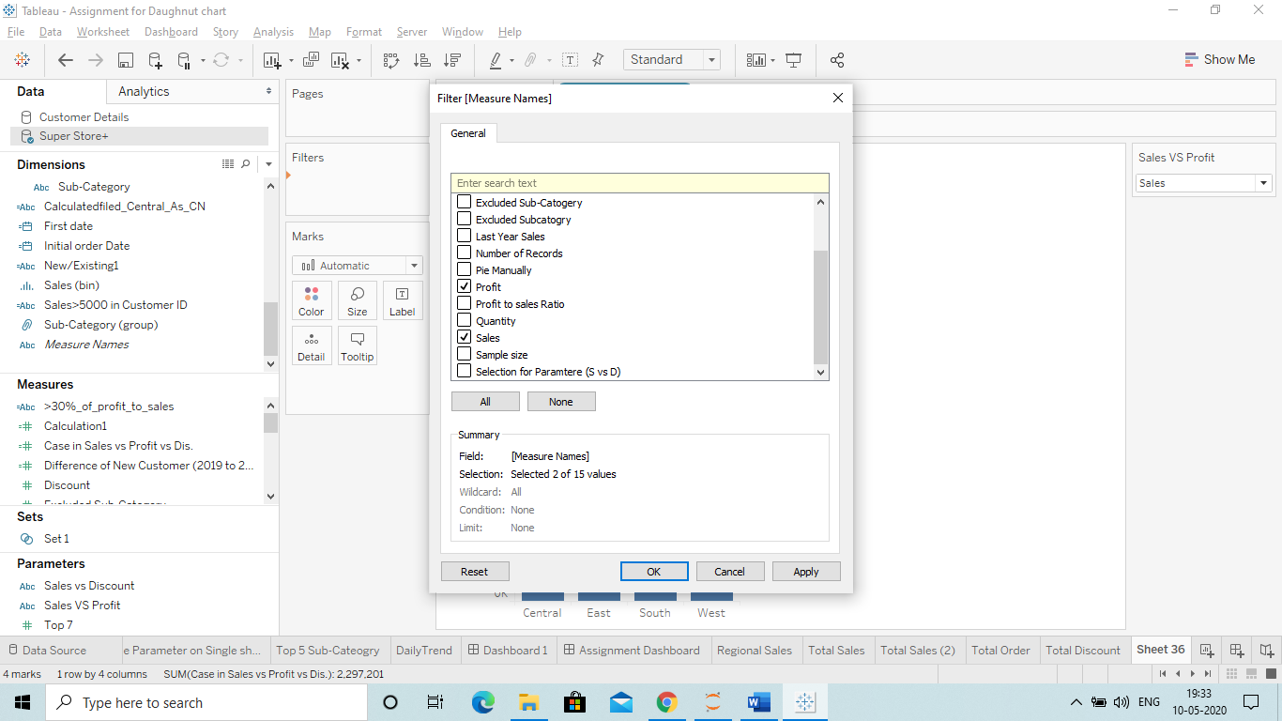

Now we can see that a filter is showing on the right side which shows that we can check the sales and profit view on the single sheet.

**Sales:**

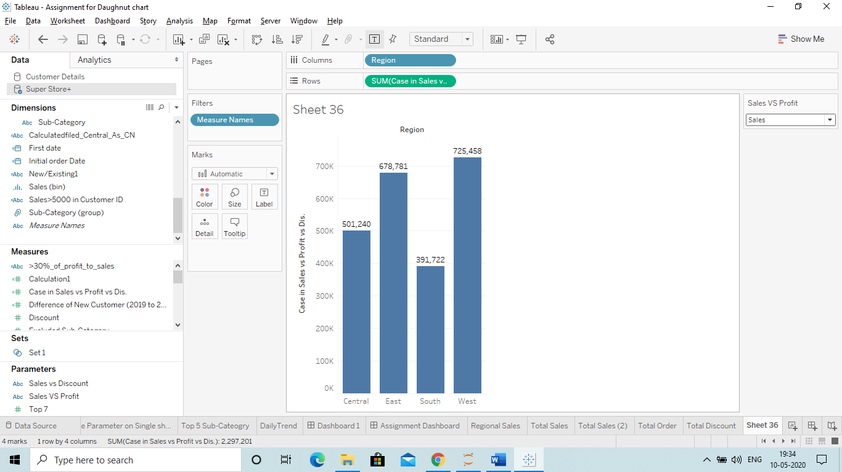

**Profit:**

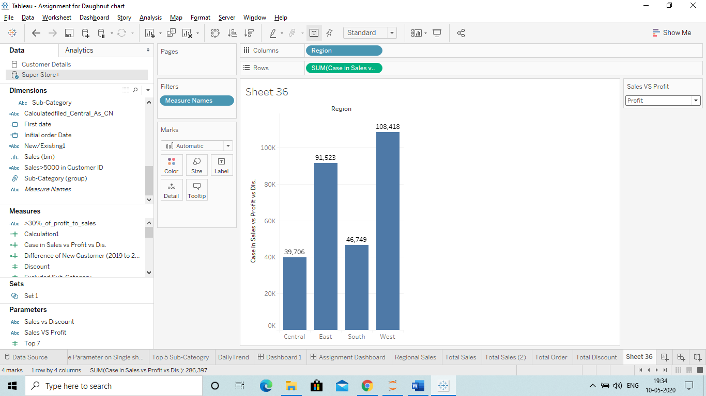

Home Work:

